## ACKNOWLEDGEMENT

### Before commencing for the project I would like to express my thankfulness to few people who have helped me in my efforts to complete the project in scheduled time. Completing any task is never a one-man effort. It is often the result of valuable contribution of a number of individual in a direct or indirect manner that helps in shaping and achieving an objective.

### I express a deep sense of gratitude to Mr. Anand Shrivastava sir and Mr. Santosh Chandrakar sir and Mr. Rekha Awasti mame and Mr. Ashish and Mr. ajay Mishra (wardner of disha hostel) for his efforts in giving his timely advice and interest in my project. Their direction, supervision and constructive criticism were indeed source of inspiration for me.

### There is a large and continuing debt owed by me to the faculty members of our department for their support and encouragement.

### Finally my unending gratefulness towards our parents for their remarkable patience and unending support throughout, thus leading to my project. I believe this endeavor of mine has greatly boosted my self-confidence and will go long on helping me reach further milestones and greater heights.

**PREET SAHU**

**BCA-III**

**CONTENT**

* Main Report
* Objective and Scope of the project
* Theoretical Background of project
* Definition of Problem
* System Analysis & Design
* Methodology adopted & Detail of Hardware & Software Used
* System Maintaince & Evolution
* Cost and Benefit Analysis
* Detailed Life Cycle of the project
* ERD,DFD
* Input & Output Design
* Process involved
* Methodology used for testing
* Test Report, printout of the code sheet
* User / Operational Manual – including security aspects backup, access right ,Controls etc.
* Conclusion
* References
* Soft copy of the project on CD

**Objective and Scope of the Project**

**OBJECTIVE**

As the name specifies “**COLLEGE HOSTEL MANAGEMENT SYSTEM**” is software developed for managing various activities in the hostel. The purpose is to make an autometed system to carry out the various operation of a Hostel. The system will provide the ease of use to the staff of hostel by performing all the work on a computer system rather than following a paper pen approach. This approach helps improving the reliability of the data maintaines and provides a fast and efficient interface for the users of the software.

For the past few years the number of educational institutions is increasing rapidly. Thereby the number of hostels is also increasing for the accommodation of the students studying in this institution. And hence there is a lot of strain on the person who are running the hostel and software’s are not usually used in this context.

This project can improve the efficiency of the system, thus overcome the drawbacks of the existing hostel management system. Less human error, Strength and strain of manual labour can be reduced, High security, Data redundancy can be avoided to some extent, Data consistency, Easy to handle, Easy data updating, Easy record keeping, Backup data can be easily generated.

**SCOPE**

The software product “College Hostel Management System” wiil be an application that wil be used for maintain the records in an organized manner and to replace old paper work system. This project aims at automating the hostel management for smooth working of hostel byautomating almost all the activities, Updation and modifications will be easily achievable and all the calculations and accounting work would be accurate.

Following details mentioned achieved in modules of this project:

* you can check the details of all the current students within few minutes
* The system will help you to check the fees payement bills of every student and the student’s hostel dues.
* The students of the hostel will be recognized from the ID number allocated at the room rental time. The system also covers the billing process and also matains the sales and purchase records.
* The system will have a report consist of summary of all transaction, summary of each stock.
* Attendance of students and employees are keep in records.
* Staff and employee payement will done by their montly attendace wise

**Theoretical Background of Project**

**FRONT END**

**Microsoft Visual Studio 2010(Ultimate)**

**VB.NET Framework 4.0.0.0**

Microsoft released Visual studio 2010. Microsoft had planned to use the dynamic language rum time for that release but shifted to an evolution strategy between VB and sister language C# to bring both languages into closer parity with one another. Visual Basic 2010 is a fully Object-Oriented Programming (OOP) Language, so it has caught up with other OOP languages such as C++, Java, C# and others.

VB.NET 2010 is the most popular object oriented event driven programming language. It revolves around readymade objects; it is event driven i.e. all the activities in a program are triggered by one event or another. The main advantage of VB.NET programming language is that we can concentrate on what we want out program to do, not how to get the programming language to do it. Visual Basic (VB) is a programming language based on the language called BASIC (Beginners' All-purpose Symbolic Instruction Code).

VB.NET 2010 an offshoot of Visual Basic, is an object-oriented programming language based on VB that is implemented using the Microsoft .NET framework. The basic syntax of the Visual Basic language remains unchanged in VB.NET 2010 but includes additional features such as structured exception Handling and short circuited expressions to enhance the infrastructure of the programming language. Developers have found VB.NET to be controversial as some of the software and developmental changes clash with the original language within VB and have caused compatibility issues. Visual Studio .NET is the predominant integrated development environment (IDE) that VB.NET developers employ.

**Object-Oriented**

### As with all .NET languages, VB.NET includes full-blown support for object-oriented concepts, including simple inheritance. Everything in VB.NET is an object, including all of the primitives (Short, Integer, Long, String, Boolean, etc.) as well as types, events, and even assemblies. Everything inherits from the Object base class.

**Event-Driven**

All previous versions of Visual Basic were event-driven, but this feature is heavily enhanced under the .NET framework. Events are no longer recognized because they use a certain naming convention (ObjectName_EventName), but now are declared with a Handles ObjectName.EventName clause. Event handlers can also be declared at runtime using the Add Handler command.

**.NET Framework**

### As the name implies, VB.NET runs on top of Microsoft's .NET framework, meaning the language has full access to all of the supporting classes in the framework. It's also possible to run VB.NET programs on top of Mono, the open-source alternative to .NET, not only under Windows, but even Linux or Mac OSX.

### The Framework Class Library (FCL) is a standard library and one of two core components of Microsoft .net framework. The FCL is a collection of reusable classes, interfaces and value types. The Base Class Library is a part of FCL and provides the most fundamental functionality, which includes classes in namespaces System, System.CodeDom, System.Collections and System.Diagnostics, System.Globalization, System.IO, System.Resources and System.Text.

### **Features of vb.net**

### Powerful Windows-based Applications

### Building Web-based Applications

### Simplified Deployment

### Powerful, Flexible, Simplified Data Access

### Direct Access to the Platform,

### Full Object-Oriented Constructs

### XML Web Services

### Mobile Applications

### COM Interoperability

**ABOUT BACK END TOOL: MICROSOFT ACCESS 2007**

With its Microsoft Office Fluent user interface and interactive design capabilities that do not require deep database knowledge, Microsoft Office Access 2007 helps you track and report information with ease. Access 2007 can collect information through forms in e-mail or import data from external applications. Create and edit detailed reports that display sorted, filtered, and grouped information in a way that helps you make sense of the data for informed decision-making.

Software developers and data architects can use Microsoft Access to develop application software, and "power users" can use it to build software applications. Like other Office applications, Access is supported by Visual Basic for Applications, an object-oriented programming language that can reference a variety of objects including DAO (Data Access Objects), ActiveX Data Objects, and many other ActiveX components. Visual objects used in forms and reports expose their methods and properties in the VBA programming environment, and VBA code modules may declare and call Windows operating-system functions.

This back end tool is widely used by personal computer for database management. The Relational Database is a well defined theoretical model of working with and managing a set of data that specify three things:

* Data Structures,
* Data Integrity, and
* Data Manipulation.

**DEFINITION OF PROBLEM**

Managing a Hostel with plenty of students and employees is such a big problem and difficult to maintain. Problems that may arise in managing any hostel are-

* Manage the records of student and available room to be alloted.
* Employee records and their details like salary, payement details, attendance.
* Student complete details like-Bus details, attendance, check out/in details (visiting details.)
* Daily report of students went for college from hostel.
* Generate bill of payement both for employee and students.
* Maintaing details of visitors.
* Student current status for visitors.
* Expanse of between particular dates from hostel.

To analyze the progress of all processes and the reports are made manually are done previously, which is a time taking process and the burden increases with increase in no. of students, room, staffs to be analyzed. The main problem is to generate the bill for students on the basis of their hostel availability status .

All the above specified problems are solved by making software (Application Software) which will help maintain the records of room and maintain students, visitors, and employee’s details. All the records are maintained in orderly manner. The database can further be used for creating reports, which will help in analysis of the whole daily details as we as annually of the college hostel.

**SYSTEM ANALYSIS AND DESIGN**

**SYSTEM ANALYSIS**

### Systems analysis is a process of collecting factual data, understand the processes involved, identifying problems and recommending feasible suggestions for improving the system functioning. This involves studying the business processes, gathering operational data, understand the information flow, finding out bottlenecks and evolving solutions for overcoming the weaknesses of the system so as to achieve the organizational goals. System Analysis also includes subdividing of complex process involving the entire system, identification of data store and manual processes.

### The major objectives of systems analysis are to find answers for each business process: What is being done How is it being done, who is doing it, when is he doing it, why is it being done and How can it be improved? It is more of a thinking process and involves the creative skills of the System Analyst. It attempts to give birth to a new efficient system that satisfies the current needs of the user and has scope for future growth within the organizational constraints. The result of this process is a logical system design. Systems analysis is an iterative process that continues until a preferred and acceptable solution emerges.

**SYSTEM DESIGN**

**Modules Overview:**

* User login module: provide login facility for authorized user of two type Admin (warden/staff) and local user (gaurd).

*Student Room Allotment module: This module is used to save student’s personal details to database when room is allocated.

*Student Room Depatchet Module:this module is used to depatch particular student from room.

*Student Daily Attendance Module: Information about daily student’s attendance is updated to database

* Room Details: details of particular room along with no. of beds adding a new Room vacant and allocation details are managed using this module.

* Expanses Module: Details of payment related to monthly bill are managed using this module.

* Visiter Entry Module: entry of outcomers and parents and other relative, come to with the student.

* Visiting Details Module: Details of outcomers and parents and other relative, come to with the student.

* Employee Entry Module: Details of works /staffs in hostel. Like guard, mess works, swipper etc.

* Employee Daily Attendance Module: info about presence or absent of employee.

* Student Fess Payment Module: student fees payment and details about payed and remaining fess of college hostel.

* Employee Payement Module: Employee Payement and details about payed and remaining fess of college hostel.

* Bus Details Module:-Maintain the bus details along with route description and driver Details

* ReportCollection:-module contains report of different kind.

**Database Tables**

There is only one database named ‘hms.accdb’ used with the help of a DSN (Data Source Name).

The database has following tables: -

1. LoginUser
2. LoginQuestion
3. RoomAllotment
4. StudentDailyAttendance
5. FeesPayment
6. VisitorsDetails
7. VisitingDetails
8. ExpanseDetails
9. EmployeeDetails
10. EmployeePayment
11. EmployeeAttendance
12. RoomDetail and RoomSpecification
13. BusDetail, RouteDetails and DriverDetails.

**LoginUser and LoginQuestion Table:**

**Description:** The table is used to store login details.

**LoginUser-**

|  |  |
| --- | --- |
| **Field Name** | **Data Type** |
| USER_ID | Number |
| USER_TYPE | Short Text |
| USER_NAME | Short Text |
| uPASSWORD | Short Text |
| uEMAIL_ID | Short Text |
| uContact | Short Text |
| question_id | Number |
| question_ans | Short Text |
| WORK_AS | Short Text |
| EMPLOYEE_ID | Number |

**LogiQuestion-**

|  |  |
| --- | --- |
| **Field Name** | **Data Type** |
| question_id | Number |
| question | Short Text |

**RoomAllotement TABLE: -**

**Description:** The table is used to store information of room allotement for student)

|  |  |
| --- | --- |
| **Field Name** | **Data Type** |
| S_ID | Number |
| DATE | Date/Time |
| FIRST_NAME | Short Text |
| LAST_NAME | Short Text |
| CLASS | Short Text |
| COURSE_YEAR | Short Text |
| BED_ID | Short Text |
| BUS_ID | Short Text |
| PHOTO | OLE Object |
| FATHER'S_NAME | Short Text |
| FATHER_CONTACT | Short Text |
| MOTHER'S_NAME | Short Text |
| MOTHER_CONTACT | Short Text |
| PERMANET_ADDRESS | Short Text |
| LOCAL_GAURDIAN | Short Text |
| LOCAL_GAURDIAN_CONTACT | Short Text |
| LOCAL_GAURDIAN_ADDRESS | Short Text |

**StudentDailyAttendance Table:**

**Description:** The table is used to keep record of attendance of student

|  |  |
| --- | --- |
| **Field Name** | **Data Type** |
| S_ID | Number |
| BUS_ID | Short Text |
| Check_Mode | Short Text |
| Attendance_date | Date/Time |

**FeesPayment Table:**

**Description:** The table stores payment details of hostel fees.

|  |  |
| --- | --- |
| **Field Name** | **Data Type** |
| S_ID | Number |
| Payment_Type | Short Text |
| PAYED_AMOUNT | Number |
| PAYMENT_DATE | Date/Time |
| REMAINING_AMOUNT | Number |
| Check_Number | Short Text |

**VisitingDetails Table:**

**Description:** The table is used to store detais about visitors who comes to meet the student

|  |  |
| --- | --- |
| **Field Name** | **Data Type** |
| S_ID | Number |
| VISITOR_ID | Number |
| VISITING_PURPOSE | Short Text |
| IN_DATE_TIME | Date/time |
| OUT_DATE_TIME | Date/time |
| REMARKS | Short Text |

**VisitorsDetails Table:**

**Description:** The table is used to store detais about visitors who comes to meet the student

|  |  |
| --- | --- |
| **Field Name** | **Data Type** |
| VISITOR_ID | Number |
| VISITORS_NAME | Short Text |
| VISITORS_ADDRESS | Short Text |
| VISITORS_CONTACT | Short Text |

**ExpanseDetails** **Table:**

**Description:** The table is used to record expanses in hostel, like Mess, electricity, maintainance (repairing), transportation, and new purchase of items.

|  |  |
| --- | --- |
| **Field Name** | **Data Type** |
| ITEM_ID | Number |
| Expanse_Date | Date/time |
| Expanse_Category | Short Text |
| DESCRIPTION | Short Text |
| AMOUNT | Number |
| BILL_NUMBER | Short Text |

**EmployeeDetails Table:**

**Description:** The table is used to store the record of workers in hostel

|  |  |
| --- | --- |
| **Field Name** | **Data Type** |
| EMPLOYEE_ID | Number Int |
| EMPLOYEE_NAME | Short Text |
| PHOTO | OLE Object |
| EMPLOYEE_CONTACT | Short Text |
| JOINING _DATE | DATE/time |
| FATHERS_NAME | Short Text |
| HOME_CONTACT | Short Text |
| PERMANENT_ADDRESS | Short Text |
| LOCAL_ADDRESS | Short Text |
| WORK _AS | Short Text |
| WORK_SHIFT | Short Text |
| SALARY | Number |
| BANK_AC_NO | Short Text |
| IFSC_CODE | Short Text |
| ID_PROOF | Short Text |
| ID_DETAILS | Short Text |
| ALLOTED_LEAVE | Number |

**EmployeePayment:**

**Description:** The table is used to store the record payment description of workers.

|  |  |
| --- | --- |
| **Field Name** | **Data Type** |
| EMPLOYEE_ID | Number |
| PAYMENT_MODE | Short Text |
| PAYED_AMOUNT | Number |
| PAYMENT_DATE | Date/Time |
| REMAINING_PAYMENT | Number |
| BANK_AC_NO | Short Text |
| IFSC_CODE | Short Text |

**EmployeeAttendance:**

**Description**: this table contains record of attendace detail of workers

|  |  |
| --- | --- |
| **Field Name** | **Data Type** |
| EMPLOYEE_ID | Number |
| Available | Short Text |
| A_DATE | Date/Time |
| REMARKS | Short Text |

**RoomDetail and RoomSpecification Table:**

**Description:** the table record detail of room (like numberof beds, available beds, lockers etc

RoomDetail-

|  |  |
| --- | --- |
| **Field Name** | **Data Type** |
| ROOM_ID | Short Text |
| BED_ID | Short Text |
| AVAIL | Short Text |

RoomSpecification-

|  |  |
| --- | --- |
| **Field Name** | **Data Type** |
| ROOM_ID | Short Text |
| Specification | Short Text |

**BusDetail, RouteDetails and DriverDetails table:**

**Description:-**contains Details of bus i.e. driver, route, seat details etc.

**BusDetail-**

|  |  |
| --- | --- |
| **Field Name** | **Data Type** |
| BUS_ID | Short Text |
| ROUTE_ID | Short Text |
| DRIVER_ID | Short Text |
| COLLEGE_ARRIVAL_TIME | Date/Time |
| HOSTEL_ARRIVAL_TIME | Date/Time |

**RouteDetails –**

|  |  |
| --- | --- |
| **Field Name** | **Data Type** |
| ROUTE_ID | Short Text |
| ROUTE_DESCRIPTION | Short Text |
| COLLEGE_DISTANCE | Number |
| TRAVEL_TIME | Number |

**DriverDetails-**

|  |  |
| --- | --- |
| **Field Name** | **Data Type** |
| DRIVER_ID | Number |
| DRIVER_NAME | Short Text |
| LICENSE_NUMBER | Number |
| CONTACT_NO | Date/Time |
| BLOOD_GROUP | Number |
| ID_PROOF_TYPE | Short Text |
| ID_PROOF_DETAIL | Short Text |
| DATE_OF_BIRTH | Date/Time |

**METHODOLOGY ADOPTED SYSTEM IMPLEMENTATION AND DETAILS OF HARDWARE AND SOFTWARE USED**

**HYBRID METHODOLOGY:**

The top down methodology may lead to an inefficient decomposition in levels, this ending in a failure. Hence it needs space for backtracking. The bottom-up strategy, on the other hand, needs prior knowledge of the system and its constituting components without which it is impractical to work with this method. To avoid these limitations, designers generally start design the system from middle level of decomposition, moving up for design the system as well as moving down for design atomic units. This becomes practical problems, designers have incomplete but workable to design these components with atomic units and then design the system with these components. This approach is called the hybrid approach. This approach incorporates the benefits of both top-down and bottom-up approaches overcoming most of their drawbacks.



**System Level**

**High Level Module**

**Hybrid**

**Low Level Component**

**SYSTEM IMPLEMENTATION**

The systems implementation process is related to construction and delivery phases of the life cycle. Systems implementation is the construction of the new system and the delivery of that system into production

There are several common implementation strategies:

* **Abrupt cutover** — on a specific date (usually coinciding with some business data, like the start of the new financial year, or a school year) — the old system goes off-line and the new one is placed into operation.
* **Parallel conversion** — both old and new systems are used for a period of time; this is done to ensure that all major problems in the new system have been solved before abandoning the old system.
* **Location conversion** — when the same system will be used in multiple locations, usually one location is selected to start with (to see where the problems are in conversion) and then the conversion is performed on all the other sites.
* **Staged conversion** — each successive version of the new system is converted as it is developed.

Implementation also contains different state like preparing training material, preparing schedule, identifying users, developing system acceptance plan, etc

**DETAILS OF HARDWARE AND SOFTWARE REQUIRED**

**MINIMUM HARDWARE REQUIREMENTS**

### Computer that has a 1.6GHz or faster processor, 32-bit (x86) or 64-bit (x64) processors

### 1 GB (32 Bit) or 2 GB (64 Bit) RAM (Add 512 MB if running in a virtual machine)

### 3GB of available hard disk space.

### 5400 RPM hard disk drive.

### Graphics card that supports DirectX 9.0c, DirectX 9 capable video card running at 1024 x 768 or higher-resolution display.

**MINIMUM SOFTWARE REQUIREMENTS**

### Operating System: Microsoft Windows 7 and above

### Front End tools: Visual Studio 2010

### Back End tools: MS ACCESS 2007

**SYSTEM MAINTENANCE AND EVALUATION**

**MAINTENANCE**

Maintenance is defined as the modification of a software product after delivery to correct faults, to improve performance or other attributes. Software maintenance is a very broad activity that includes error correction, enhancements of capabilities, deletion of obsolete capabilities, and optimization. Because change is inevitable, mechanisms must be developed for evaluation, controlling and making modifications. So any work done to change the software after it is in operation is considered to be maintenance work. The purpose is to preserve the value of software over the time.

Since the software is developed by using modular approach, enhancing the software for future requirements is easy as compared to non modular softwares. The event driven nature of software also helps in identifying the source of problems.

**EVALUATION**

System Evaluation process consist of number of factors which must be taken in account to do proper evaluation of system. Some factors are as follows: -

* Costs of hardware and software - will vary despite identical functionality,
* Speed and capacity of hardware,
* Quality and costs of support

The software uses Visual basic code on front end and Microsoft Access 2007 at back end, so, the speed and capacity of the software is satisfactory on local systems.**COST AND BENEFIT ANALYSIS:**

Basic Cost Benefit Analysis is a relatively simple and widely used technique for deciding whether to make a change. As its name suggests, to use the technique simply add up the value of the benefits of a course of action, and subtract the costs associated with it.

Costs are either one-off, or may be ongoing. Benefits are most often received over time. We build this effect of time into our analysis by calculating a payback period. This is the time it takes for the benefits of a change to repay its costs.

Cost-benefit analyses help you to

* Decide whether to undertake a project or decide which of several projects to undertake.
* Frame appropriate project objectives.
* Develop appropriate before and after measures of project success.

In its simple form, cost-benefit analysis is carried out using only financial costs and financial benefits. For example, a simple cost-benefit analysis of any software would measure the cost of building the software, and subtract this from the economic benefit of improving operations. It would not measure either the cost of data damage or the benefit of quicker and easier data access.

A more sophisticated approach to cost-benefit measurement models is to try to put a financial value on intangible costs and benefits. This can be highly subjective for example - What is the value of stress-free data storage and retrieval? These are all questions that people have to answer, and answers that people have to defend.

You can express some anticipated benefits in monetary equivalents (such as reduced operating costs or increased revenue). For other benefits, numerical measures can approximate some, but not all, aspects. If your project is to improve staff morale, for example, you may consider associated benefits to include reduced turnover, increased productivity, fewer absences, and fewer formal grievances.

Thus, the following two key factors influence the results of a cost-benefit analysis:

* How far into the future you look to identify benefits?
* On which assumptions you base your analysis.

There are tangible and intangible costs and tangible and intangible benefits. Tangibles can be easily calculated whereas intangibles may vary in accordance to person or place.

**Tangible costs:**

1. **Personnel Costs**: This may include salaries of analysts, programmers, consultants, data entry personnel, costs for trainers, etc.
2. **Costs for equipment**: This may include cost for the new system, computer hardware, space/rooms, furniture, etc.
3. **Change over Cost or implementation cost**: This includes cost of converting to new system, designing new processes and procedures, running new and old systems together for a period of time.
4. **Miscellaneous:** This may include stationary used with the system, repairs and other cost not directly related to the system.

**Intangible costs:**

Intangible costs include many things like loss of customer good will, staff distress, supplier confusion when processes changes, etc.

**Intangible benefits:**

Although the costs of intangible benefits cannot be easily calculated, it is very important to identify them. Often intangible benefits may make the difference between a project being funded or not.

Some intangible benefits are

* Improved work practices and employee morale,
* Easier and fast data access,
* Up to date information available every time, etc

**Tangible benefits:**

* Increased productivity,
* Quality improvement,
* Cost reduction through mechanization, etc

**ERD (Entity-Relationship Diagram)**

### **Entity Relationship Diagram (ERD) can express overall logical structure of a database graphically. The components of E-R Diagram are:**

**Entity:**

### **Entity is a thing or object in a Real world that is Distinguishable from all other objects.**

**Attributes:**

### **Descriptive property of an Entity.**

**Relationship:**

### **It is an association among several entities.**

**Link:**

It links attributes to entity sets and Entity.

**ENTITY RELATIONSHIP DIAGRAM**

**DATA FLOW DIAGRAM**

PAYMENT

PAYMENT

SALARY

FessPayment

Employee_attendance

EXPANSES

EmployeeDetail

Attendance

studentAttendance

Allot_room

LOGIN

Manages

Student

### The DFD was first developed by Larry Constiane as a way of expressing system in a graphical form. A DFD also known as BUBBLE Chart., has a purpose of clarifying system requirement and identifying major transformation that will become the programs in the system design .

DFD SYMBOLS

### SQUARE defines a source or the destination of the system data.

### ARROW defines data flow or data in motion. It is a pipeline through which information flow.

### CIRCLE or BUBBLE represents a process transforms incoming data flow into outgoing data flow.

### OPEN RECTANGLE is a data store or data at rest or a temporary rest repository of data.

**CONTEXT LEVEL DFD**

RoomAllot

USERID/Password

StudentDetails

STUDENT

User

**1-LEVEL DFD**

allotement

Maintains allotment

HostelStaff salary

FeesPayment

Expanses

Expanditure

Student Fees

Payment

Visitors_Detail

Employee_detail

Student checkin/out info

UserID/password

HostelStaff data

Invalid

Gaurd

Attendance

User

**Input and Output Screen Design:-**

LoginUserModule:

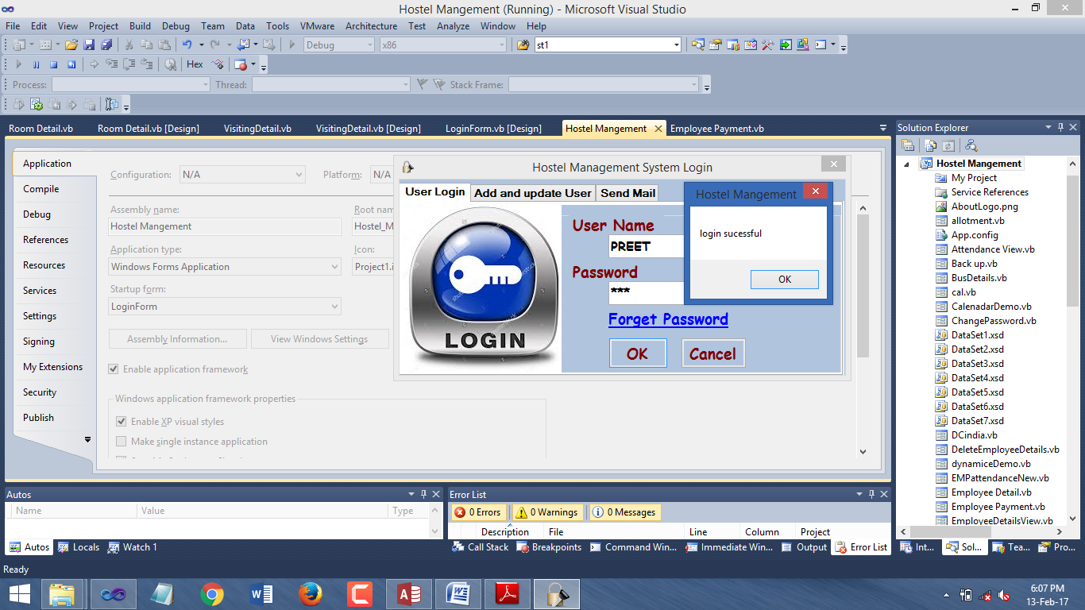

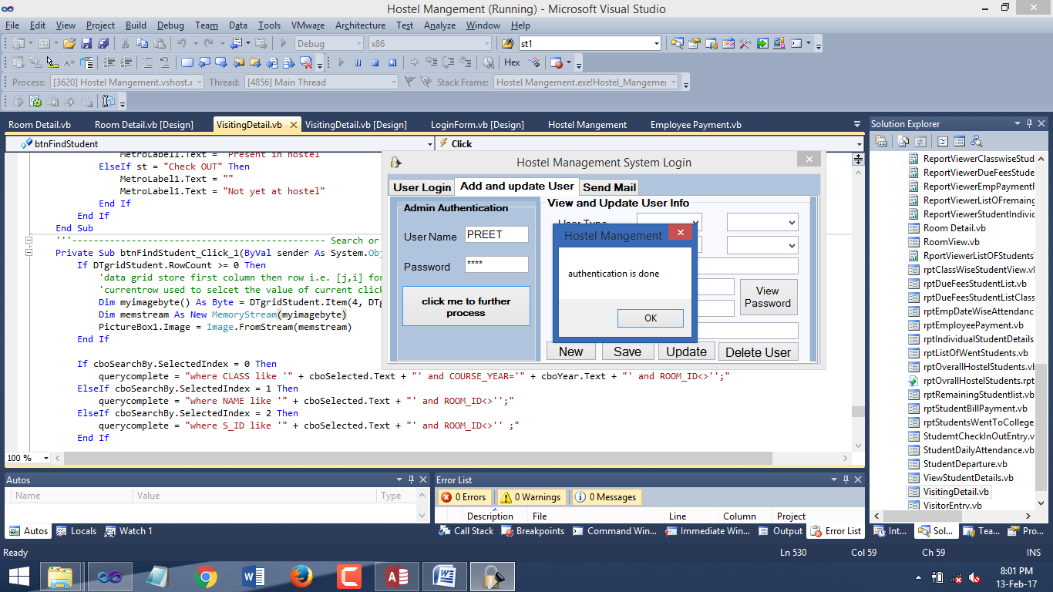Add/update user:

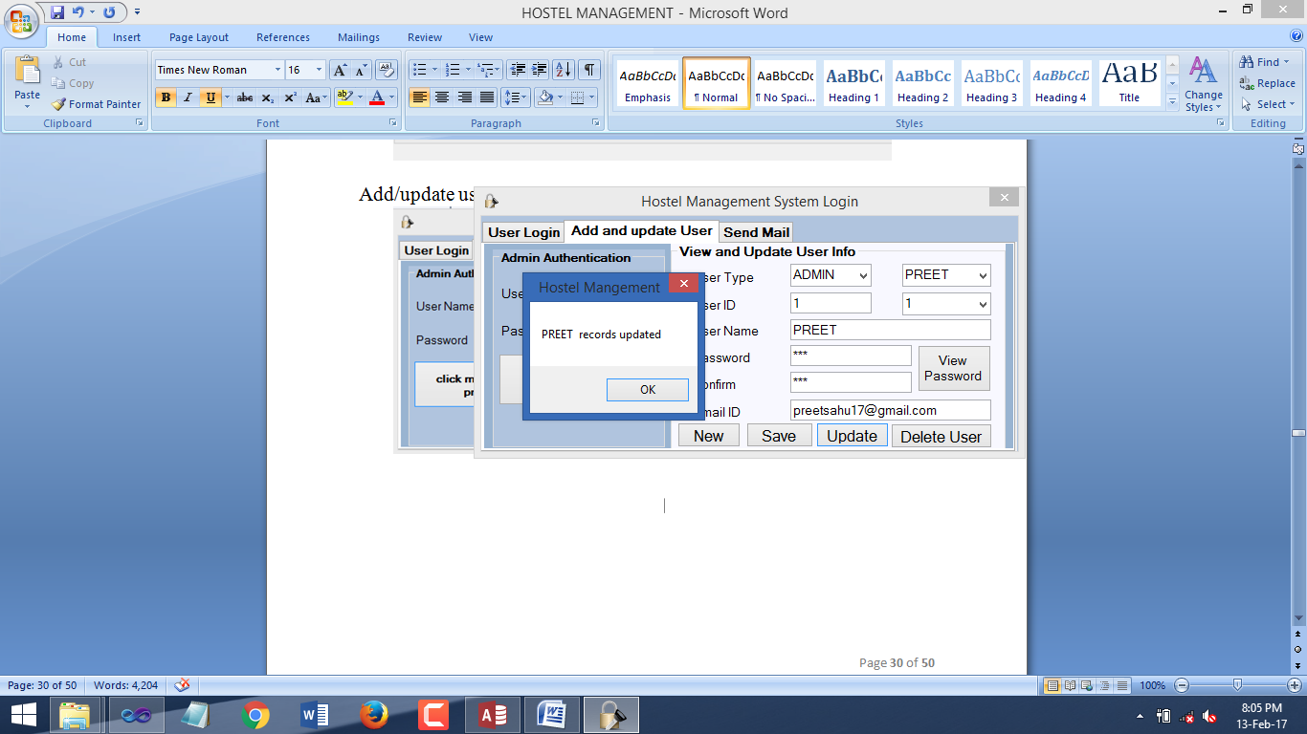

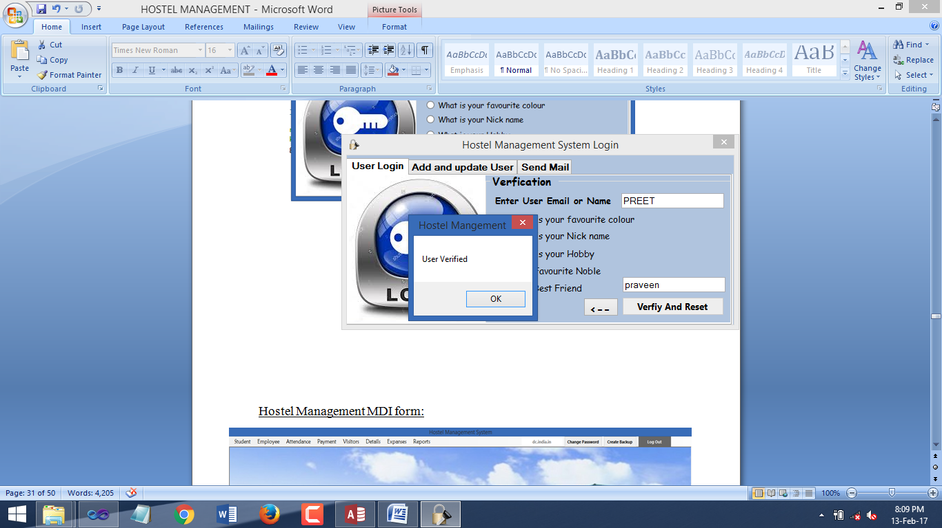ForgetPasswordRetrieval:

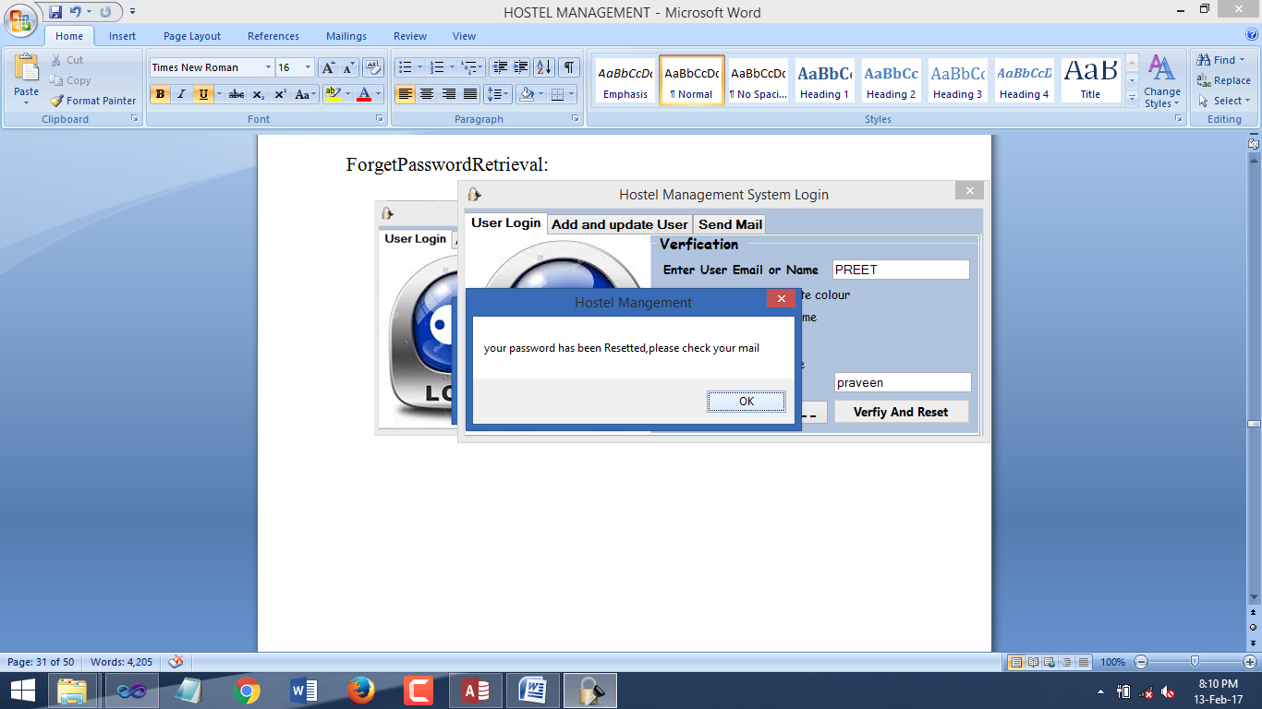

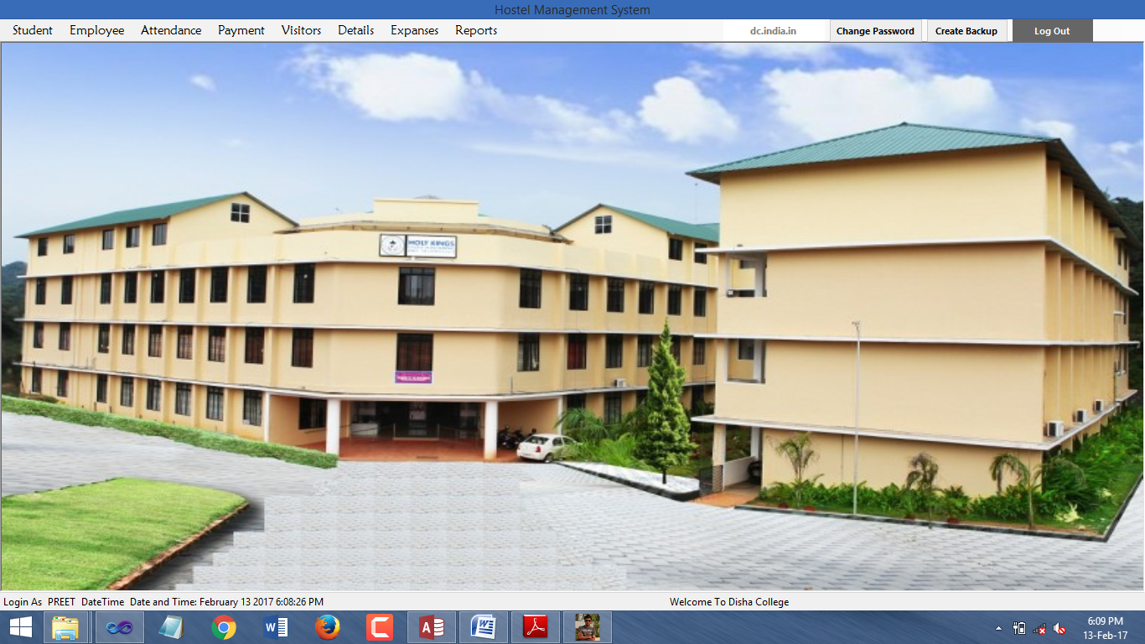Hostel Management MDI form:

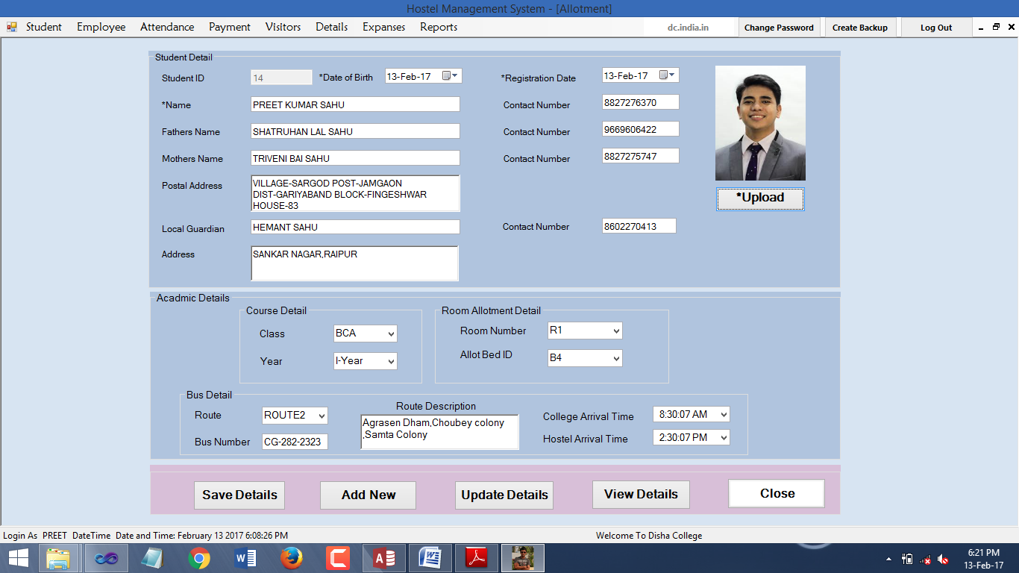StudentRoomAllotment:

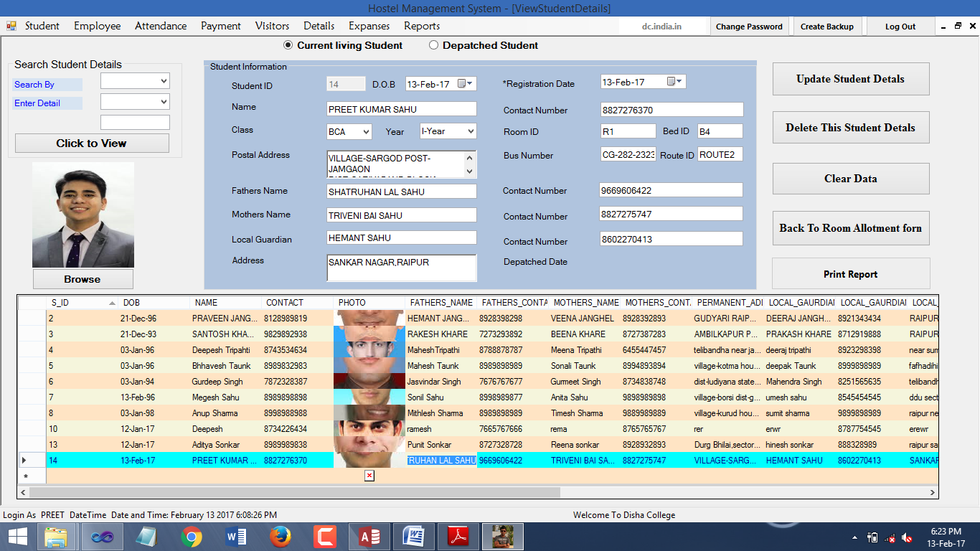ViewStudentDetail:

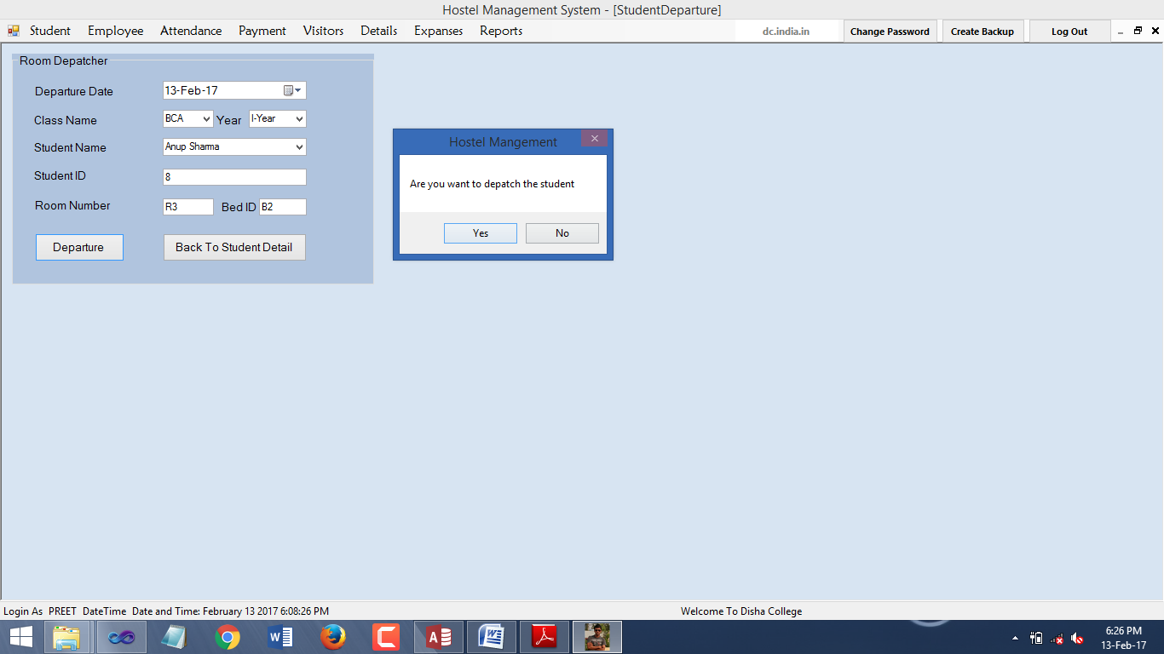StudentRoomDepatcher:

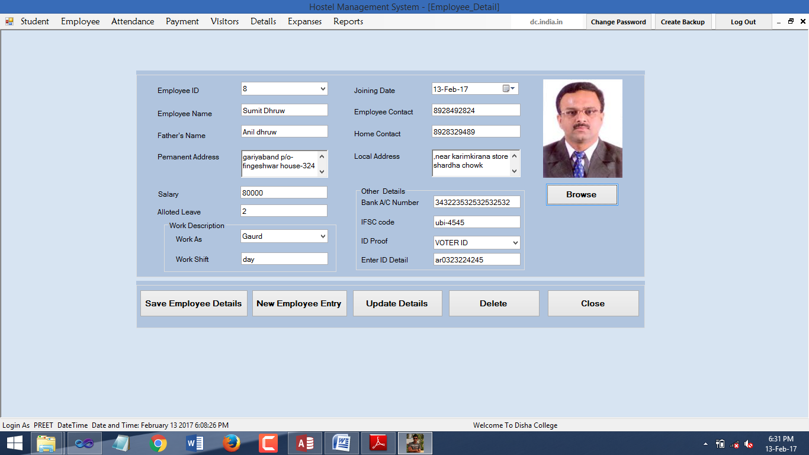EmployeeDetail:

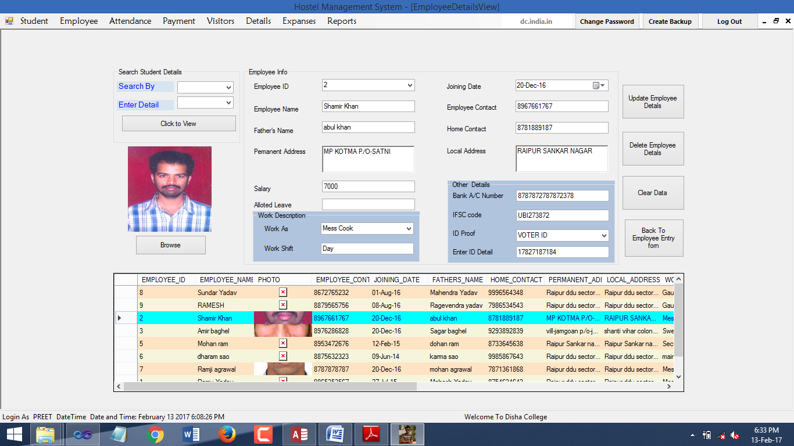EmployeeDetailView:

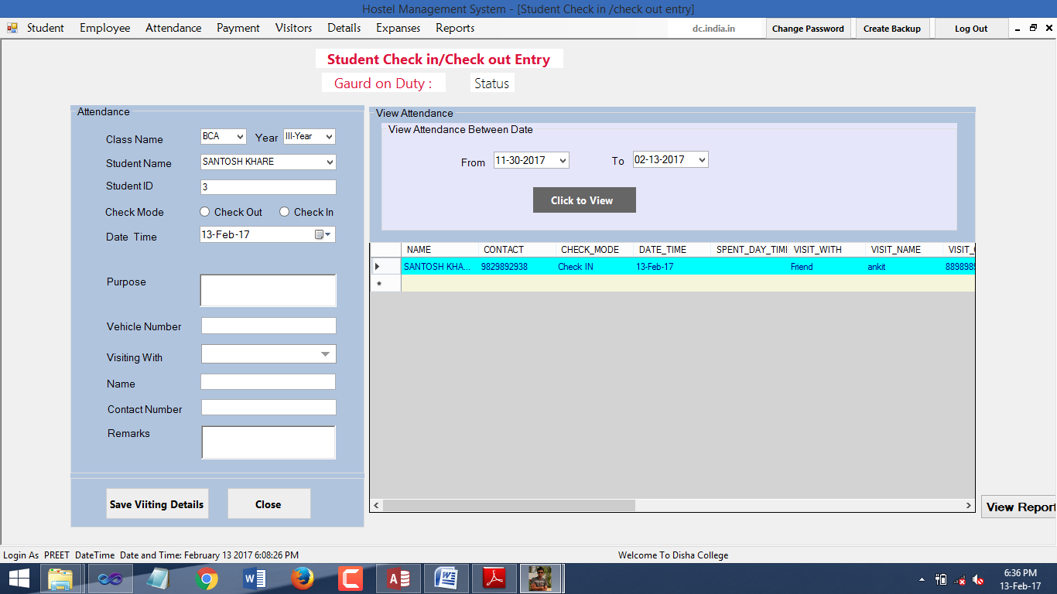StudentCheckIN/OUTEntry:

EmployeeRegion:

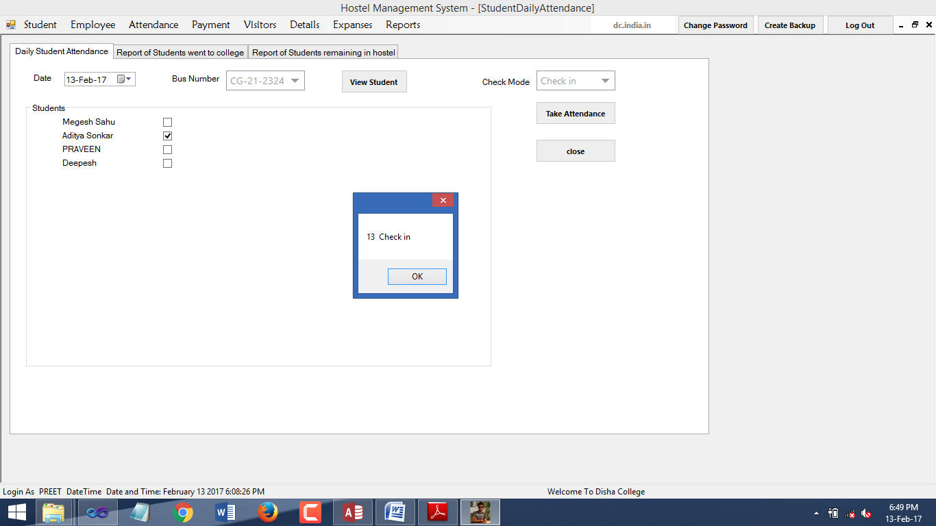StudentBusWiseAttendance:

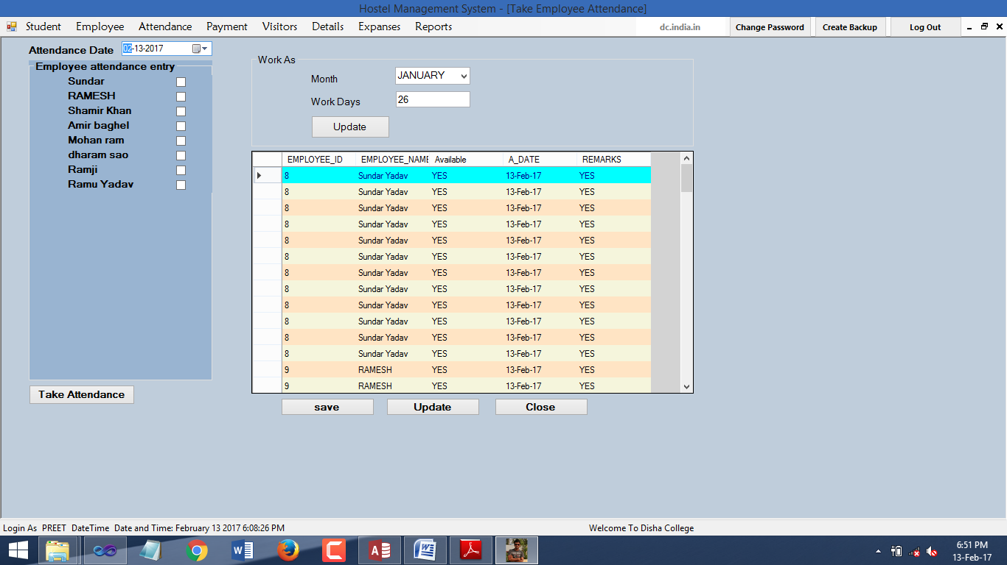EmployeeAttendance:

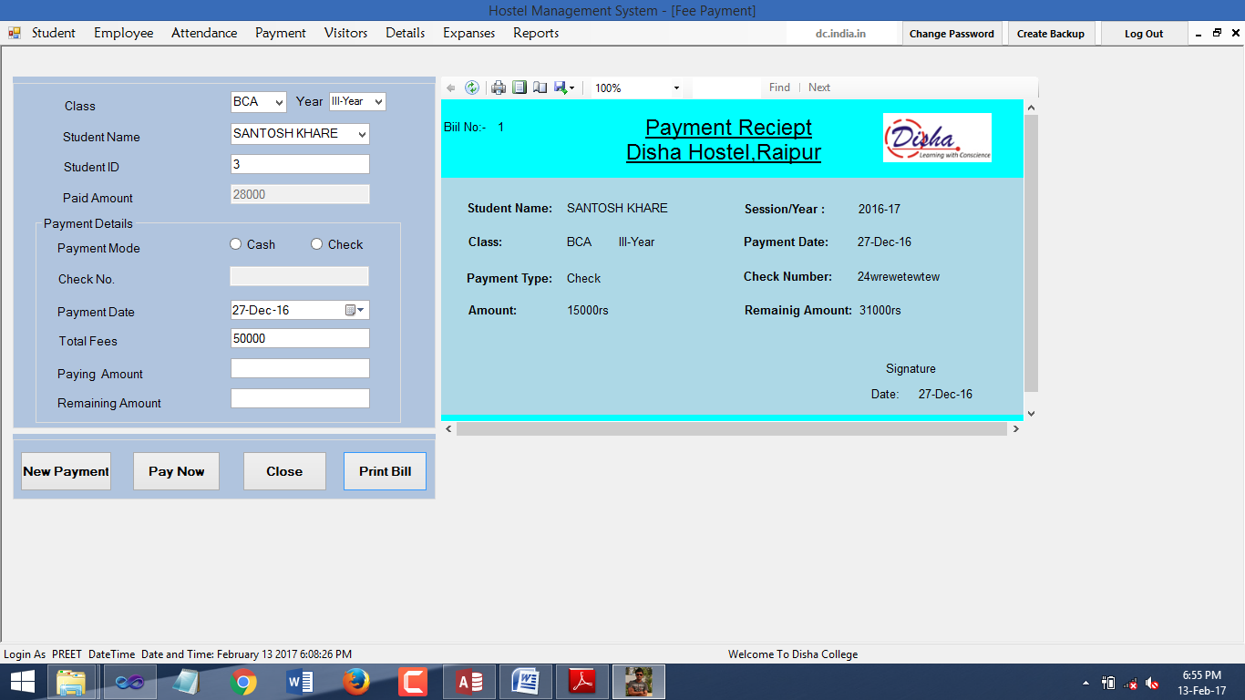StudentFeesPayment:

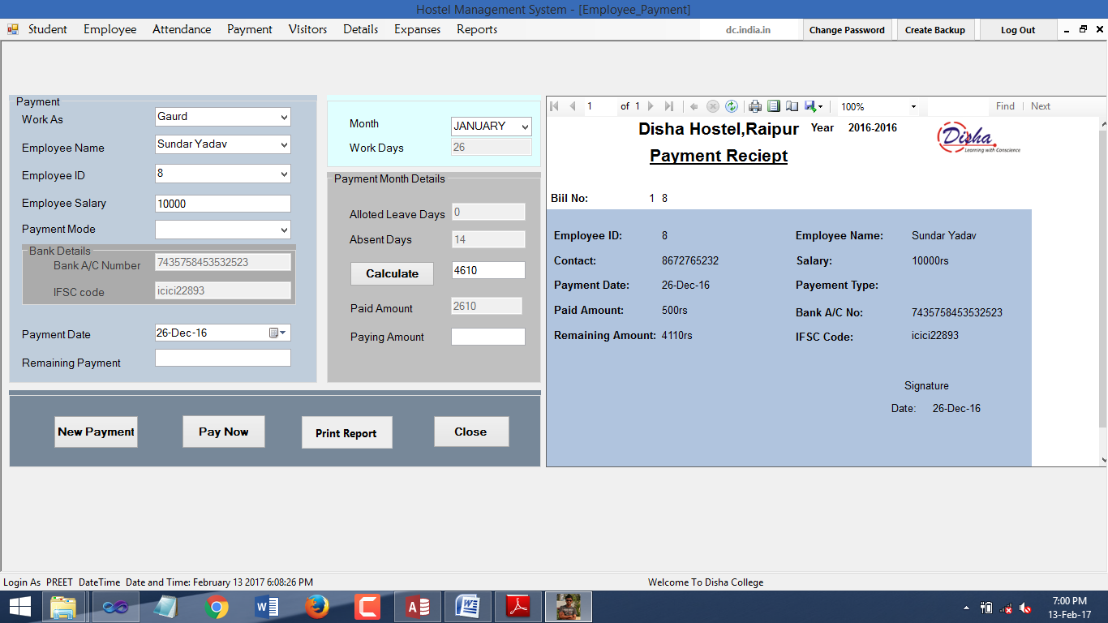EmployeePayment:

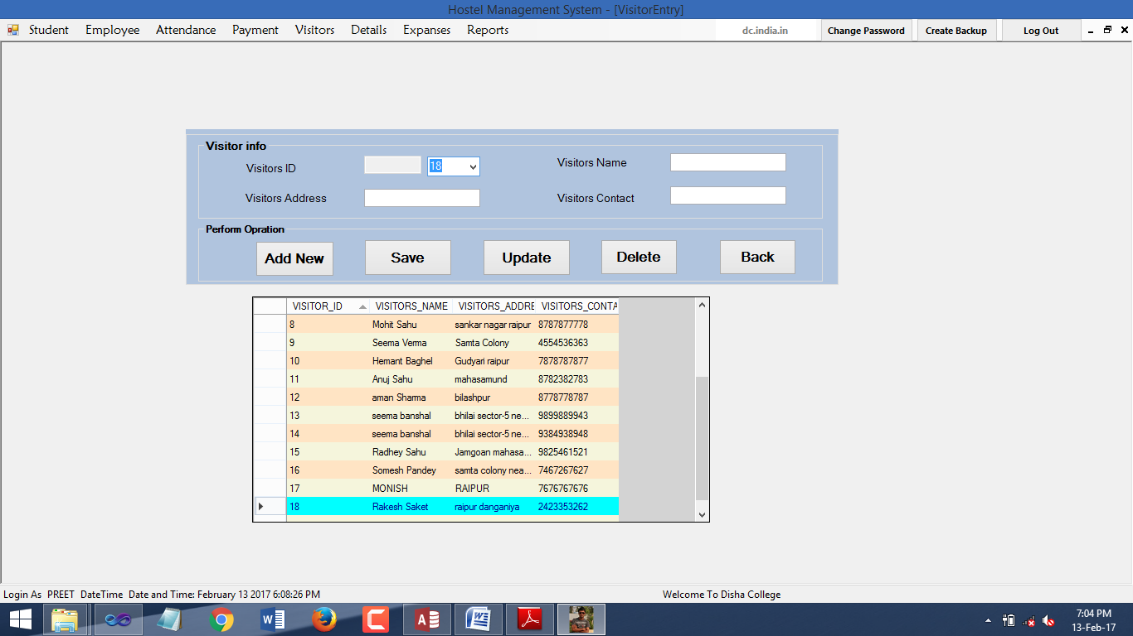VisitorEntry:

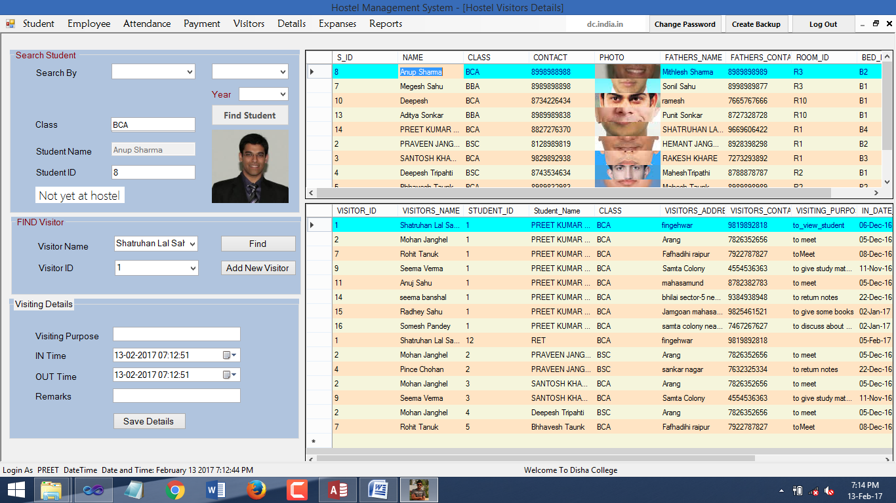VisitingDetails:

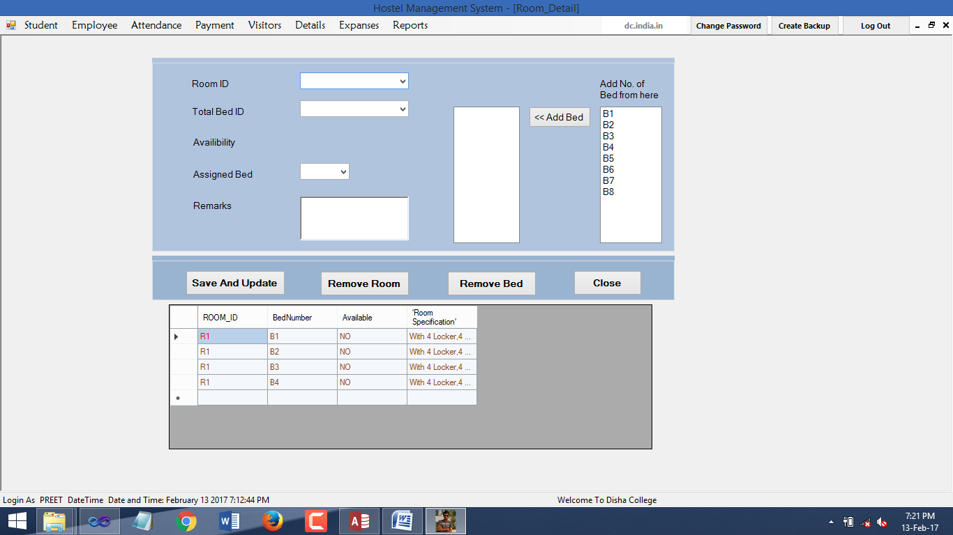RoomDetails:

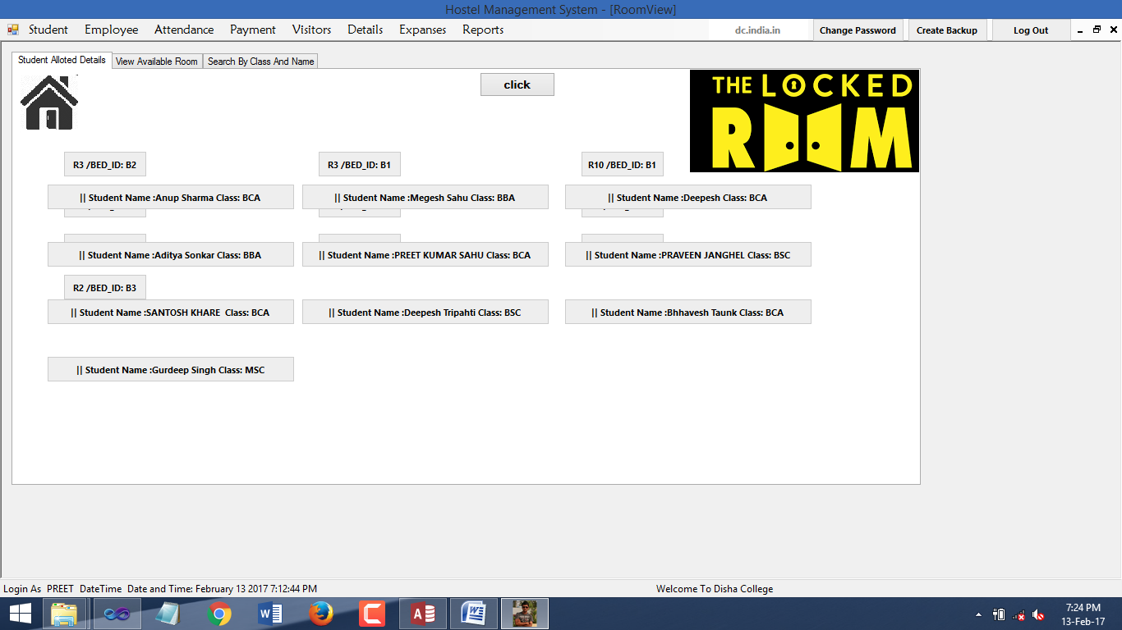ViewRoomStatus:

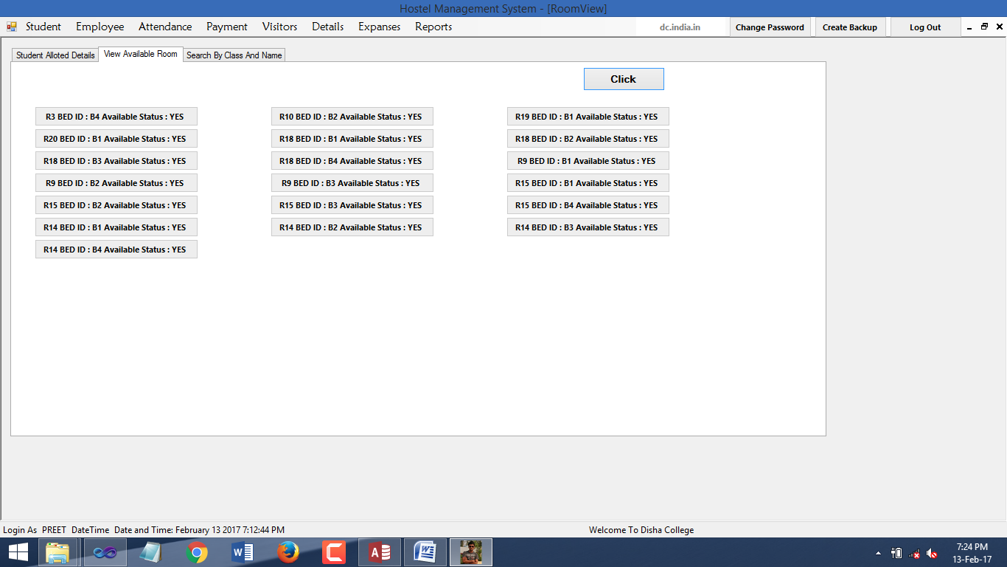ViewRoomStatus:

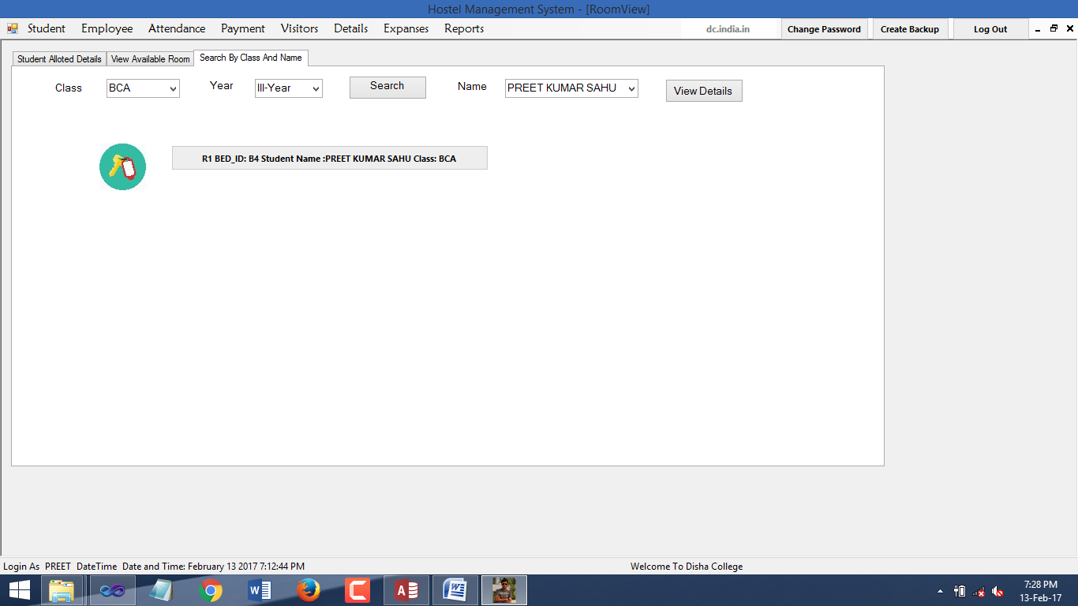

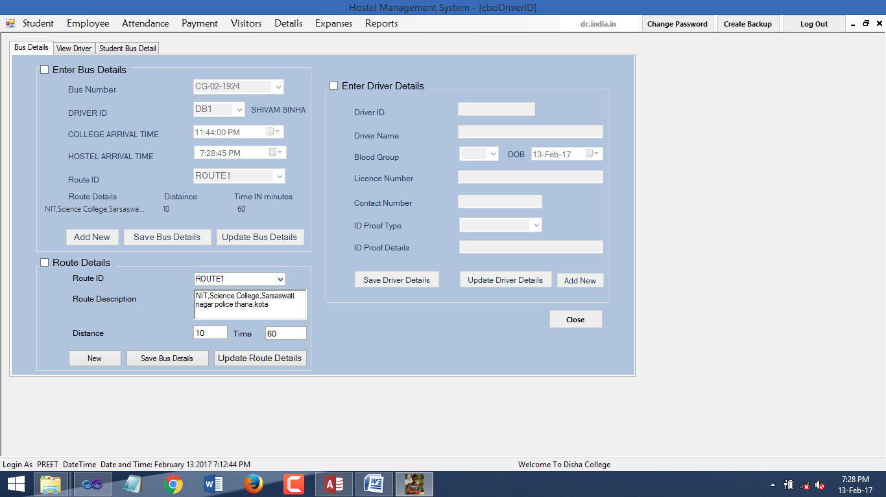BusDetails:

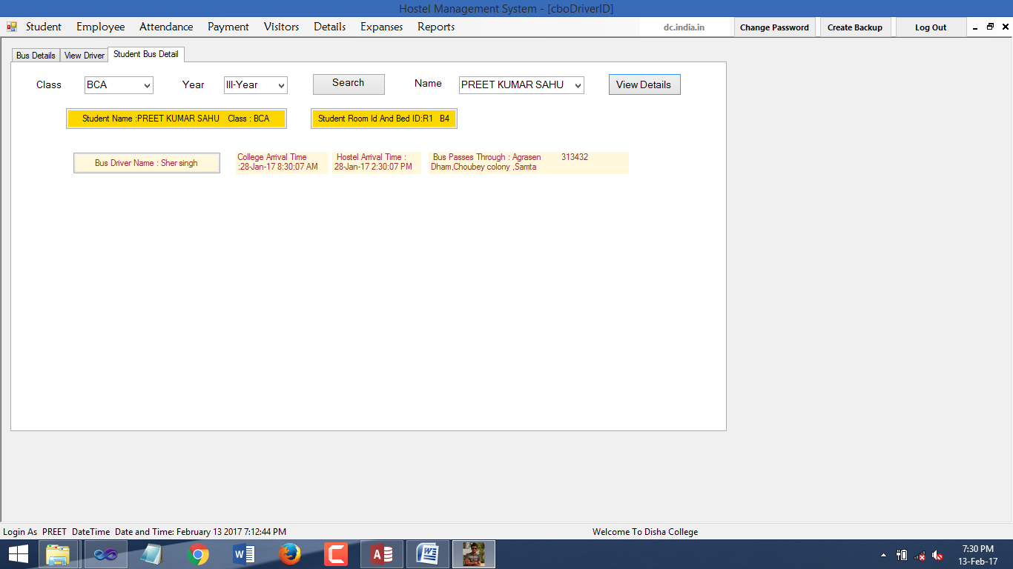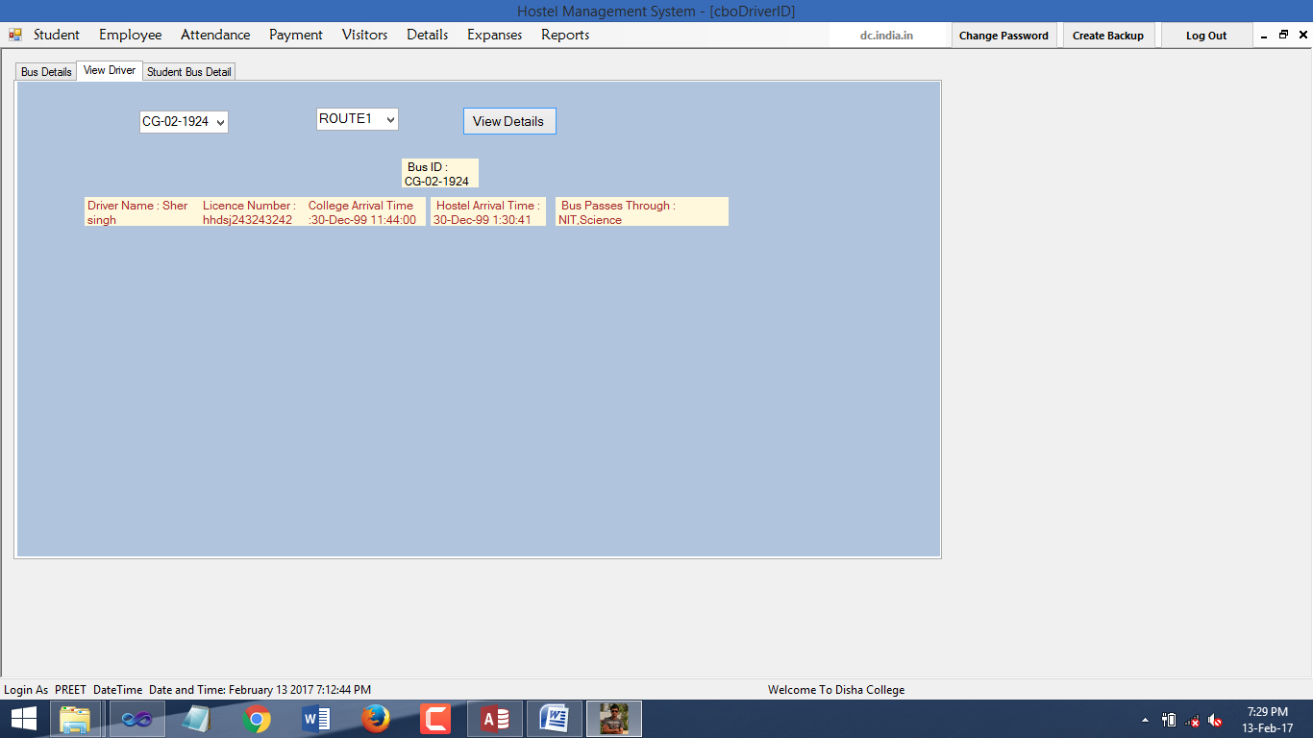

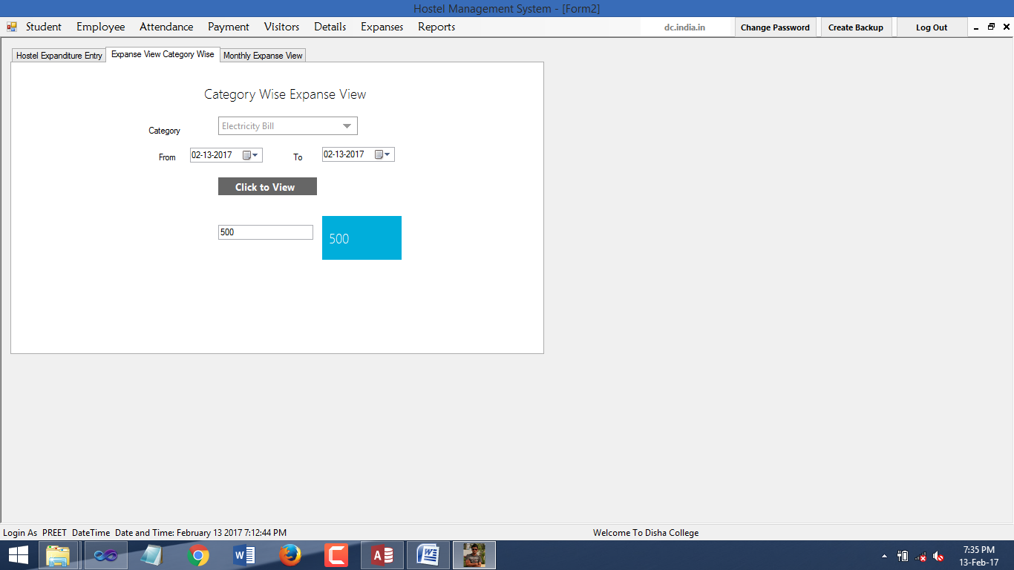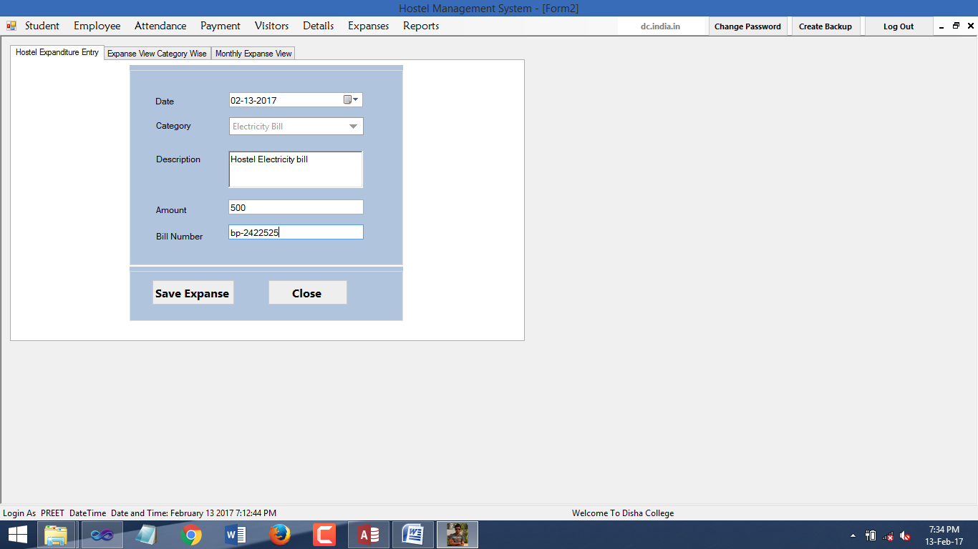

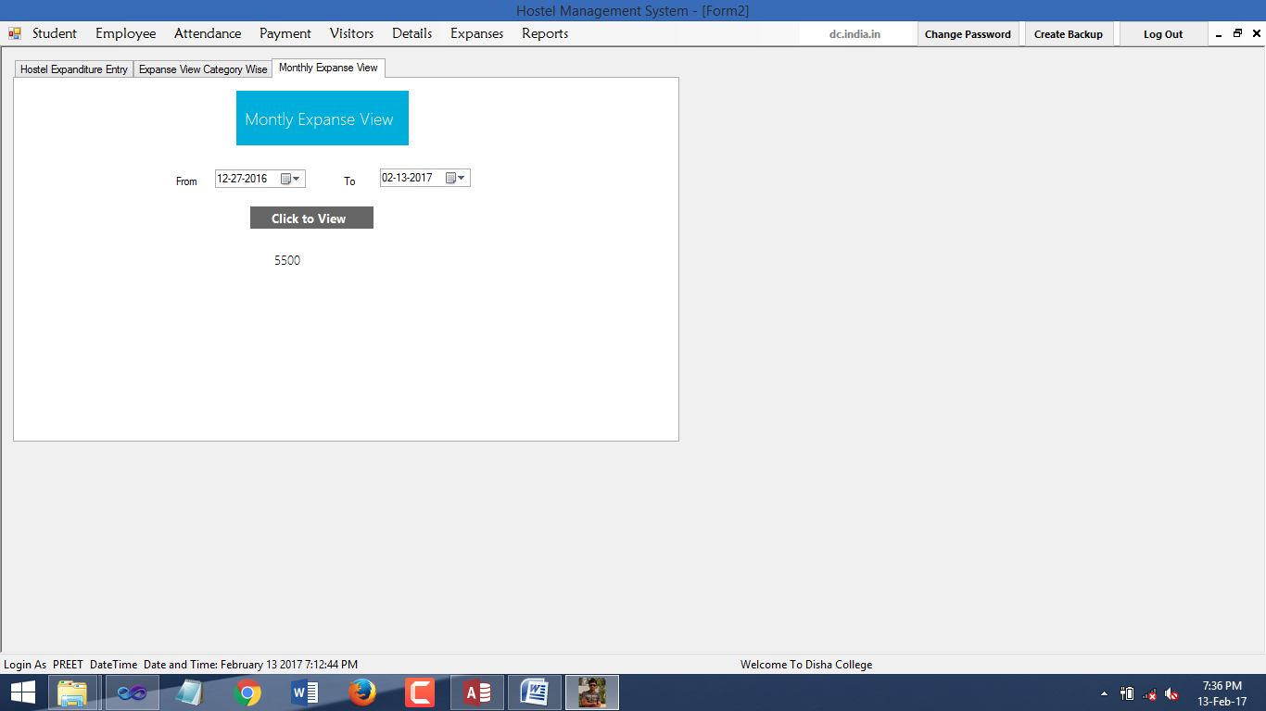

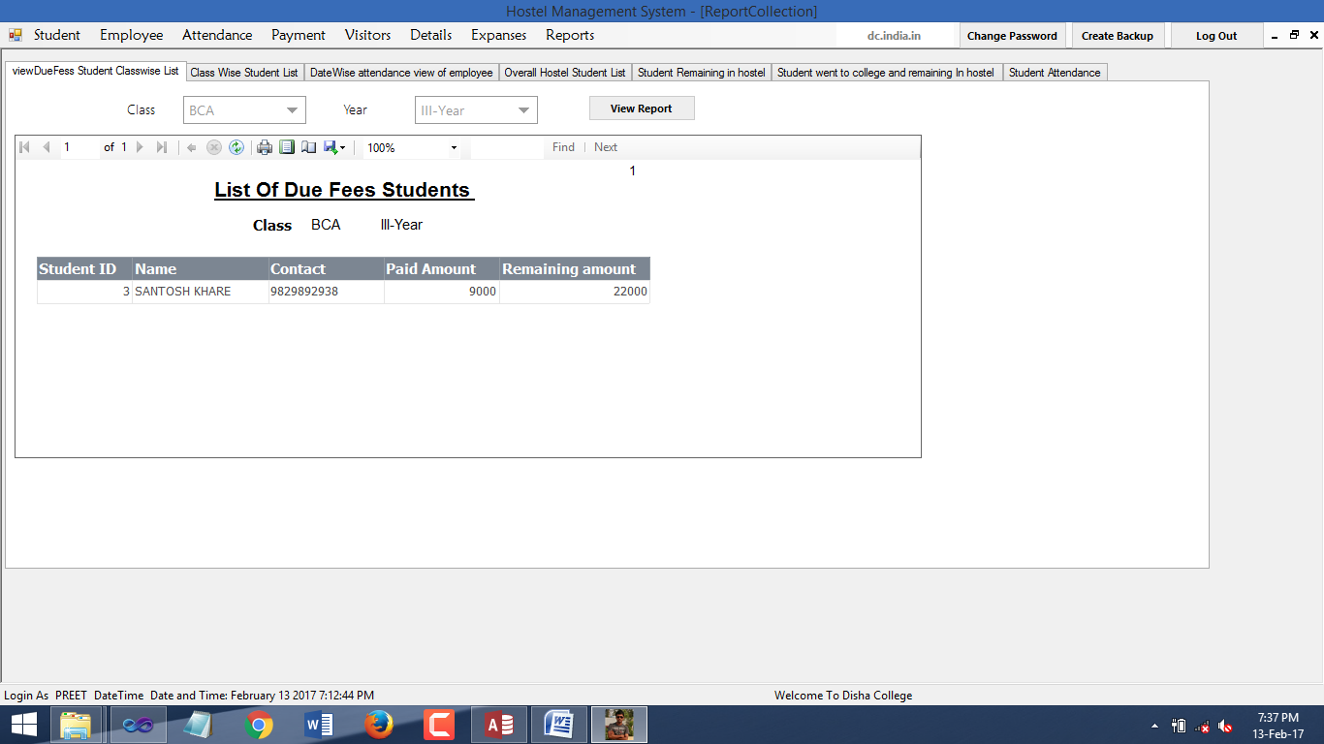ReportCollection:

List of due fees students:

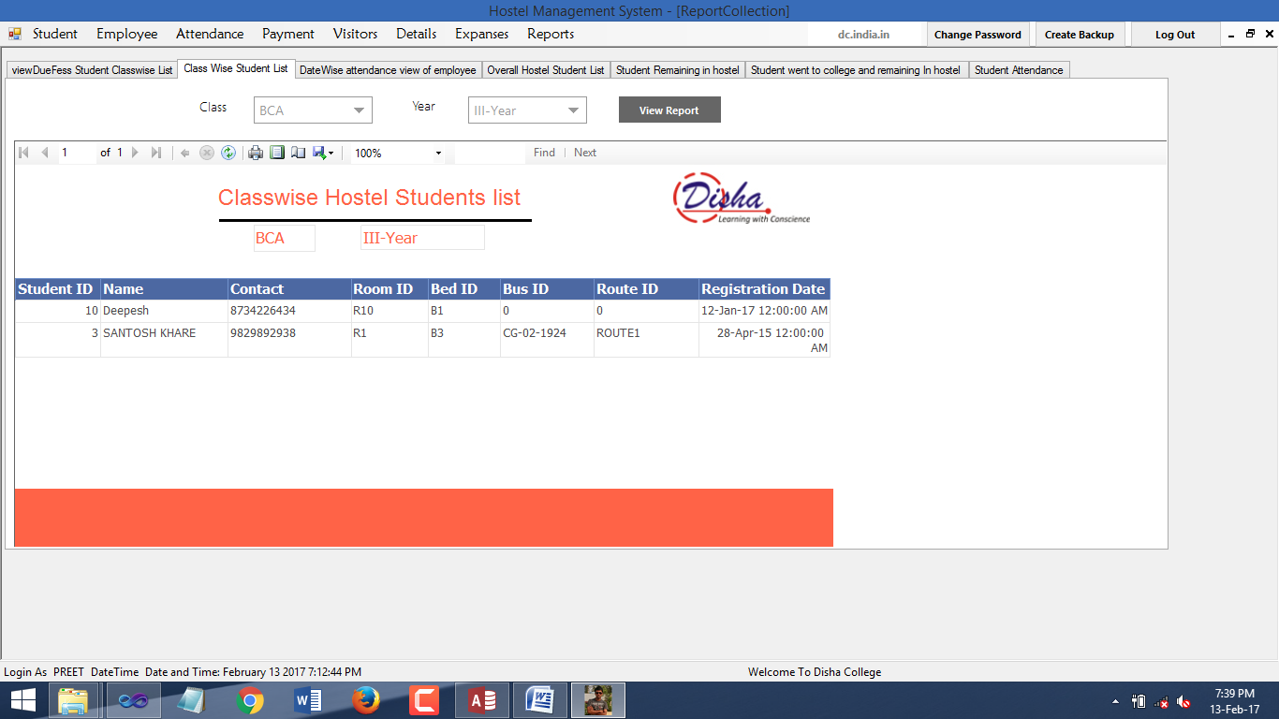List of students classwise:

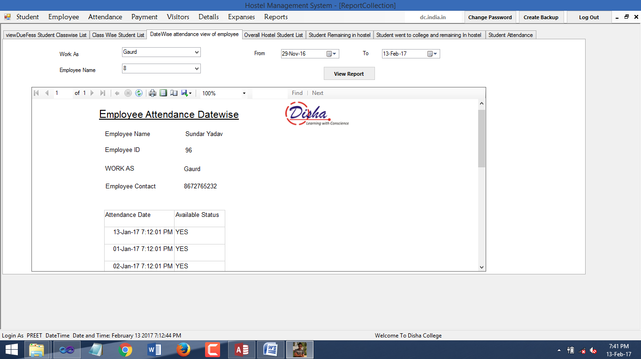DateWise Attendance Report of Employee:

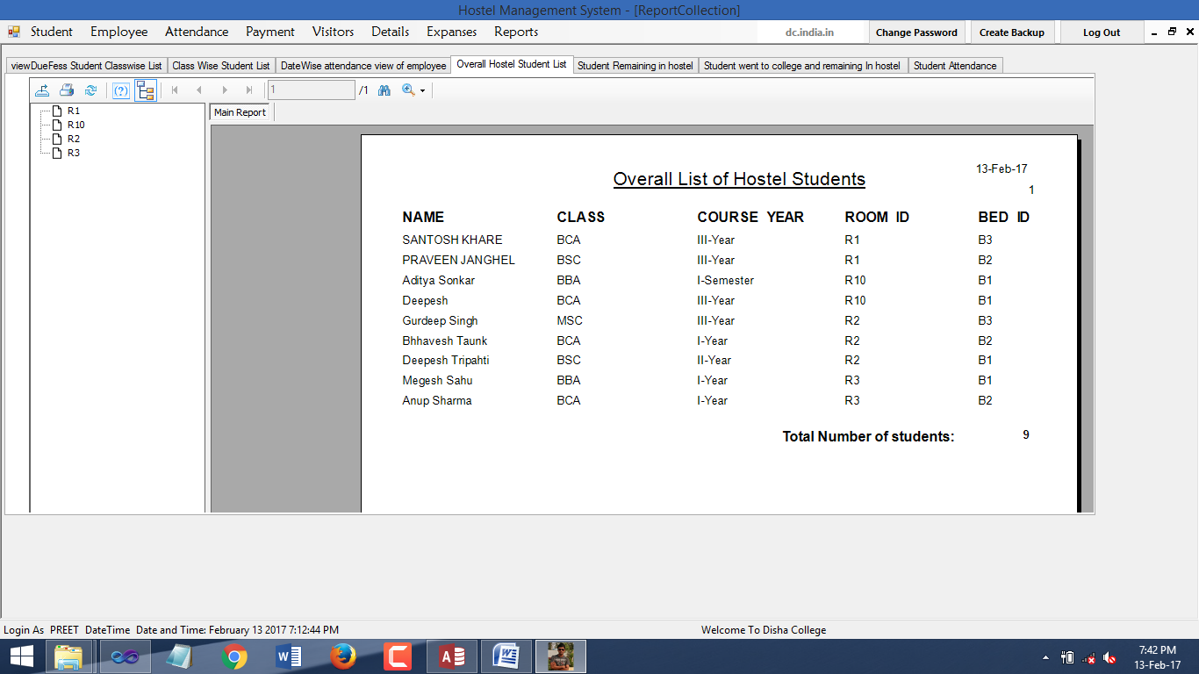Overall list of hostel stuents:

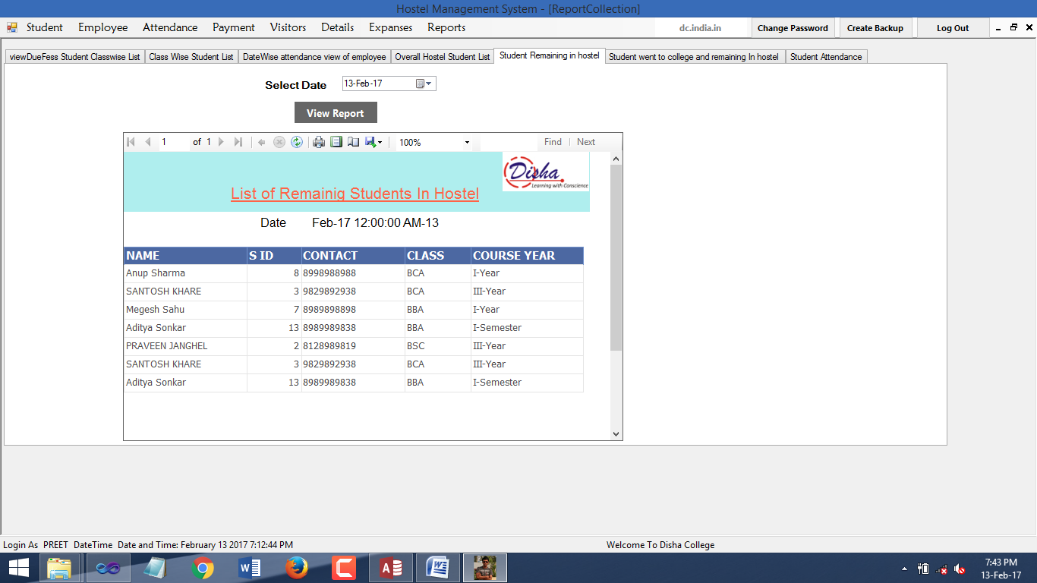List of students Remaining in hostel:

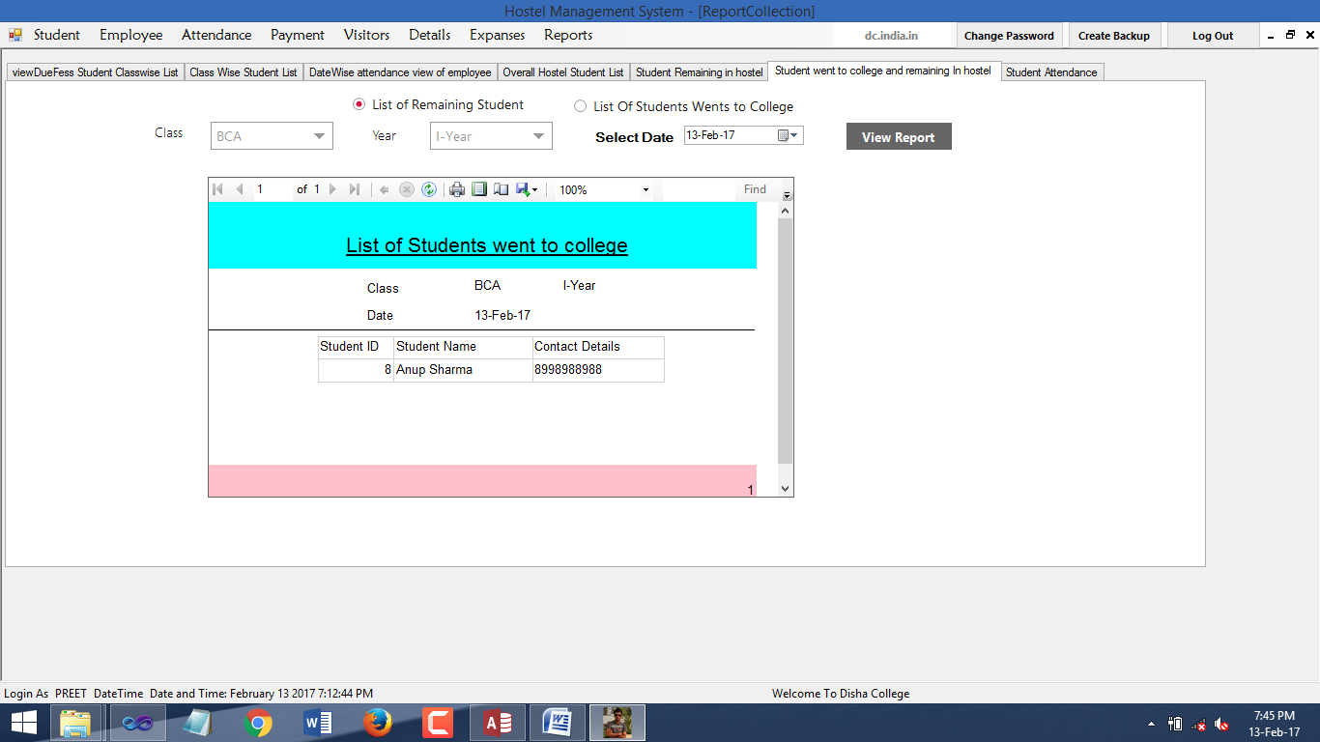List of students Remaining in hostel classwise:

List of students Went to college classwWise:

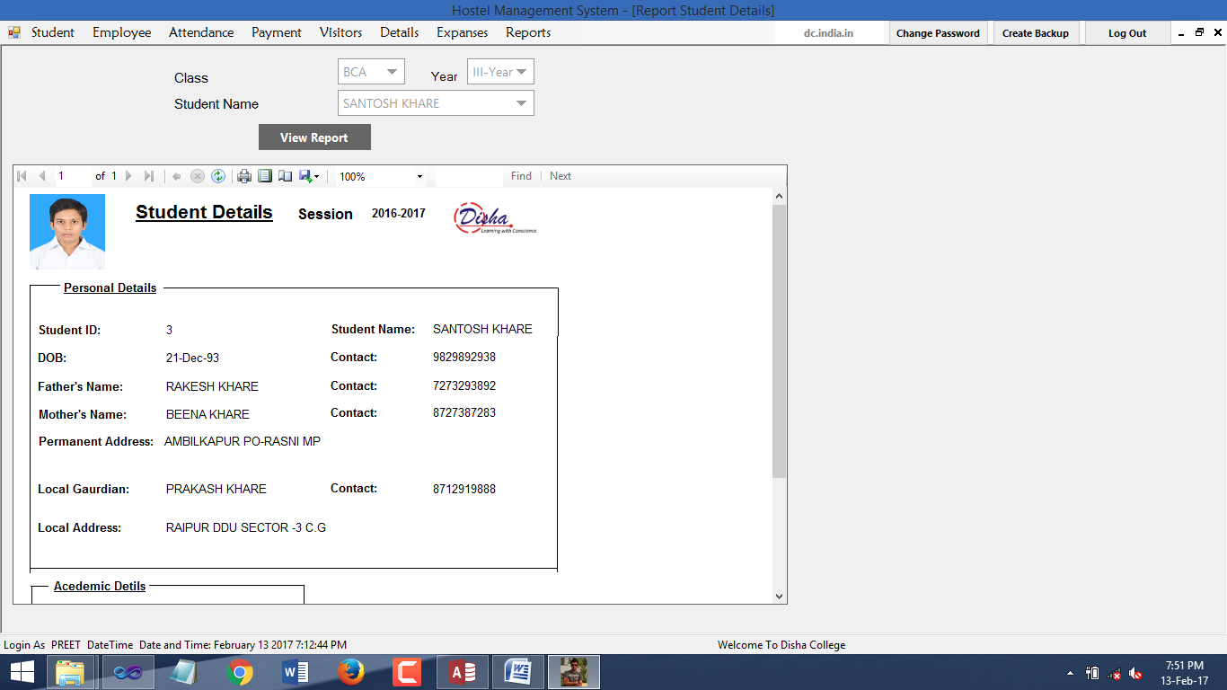StudentDetailReport:

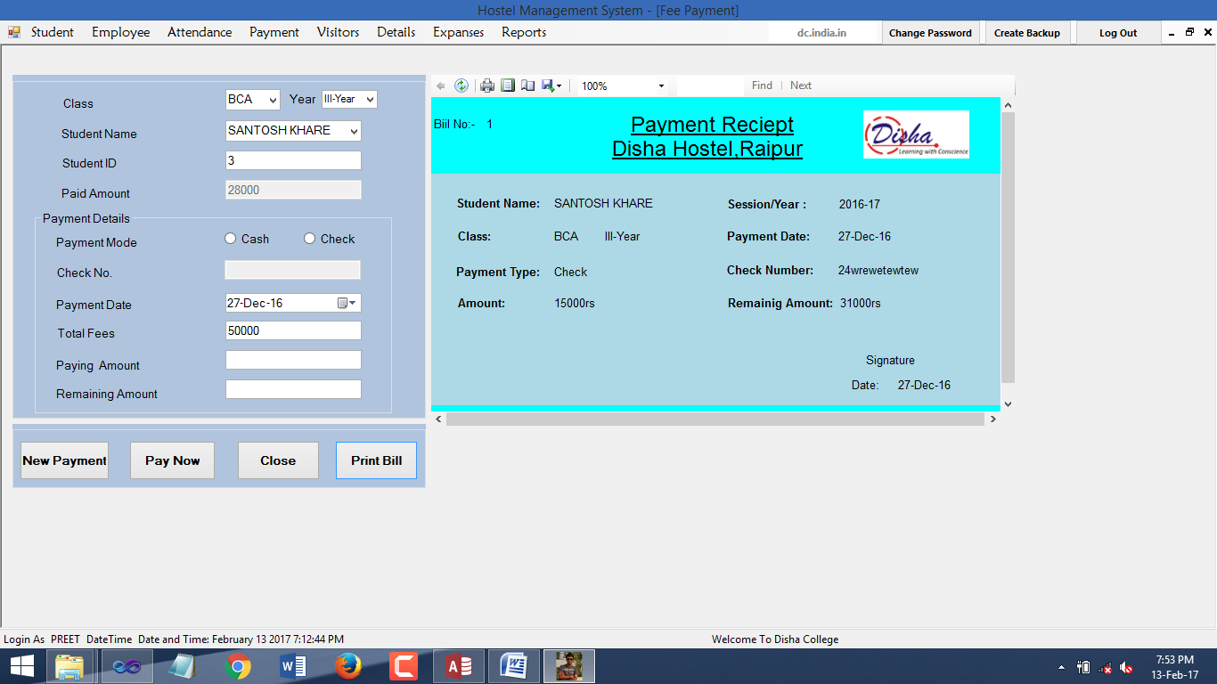StudentPaymentReceipt:

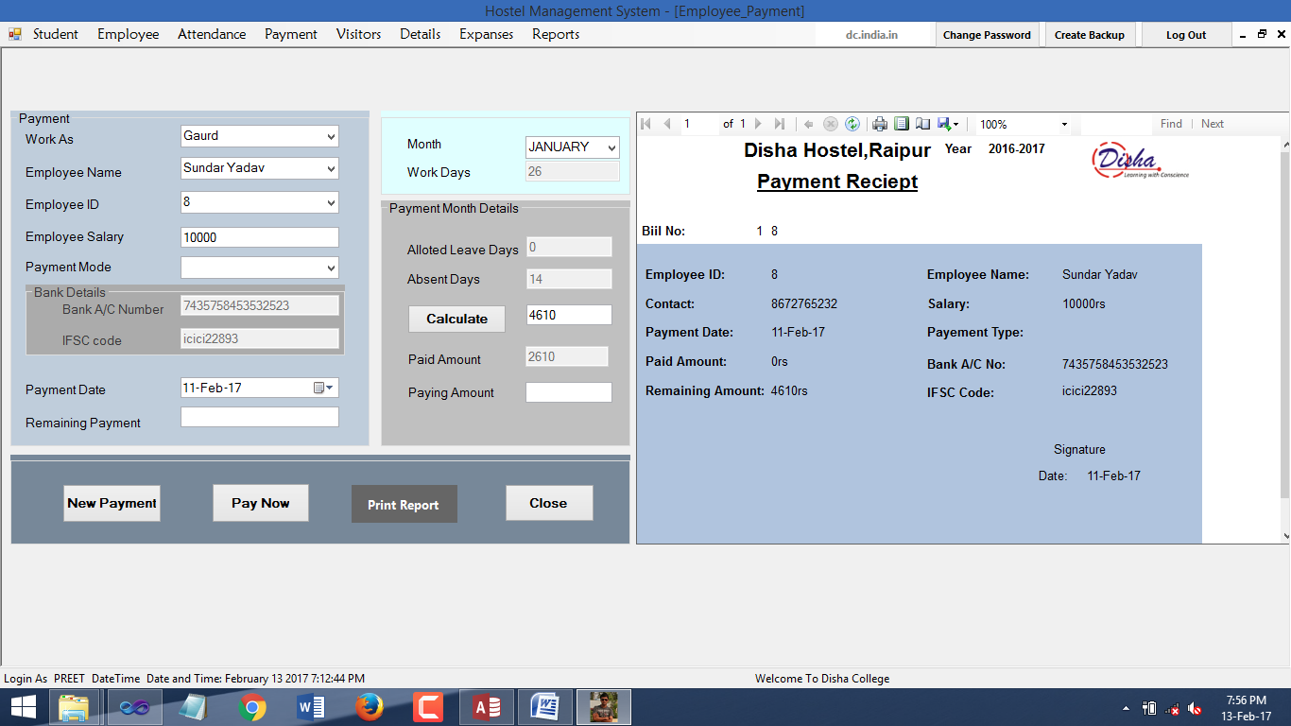EmployeePaymentReceipt:

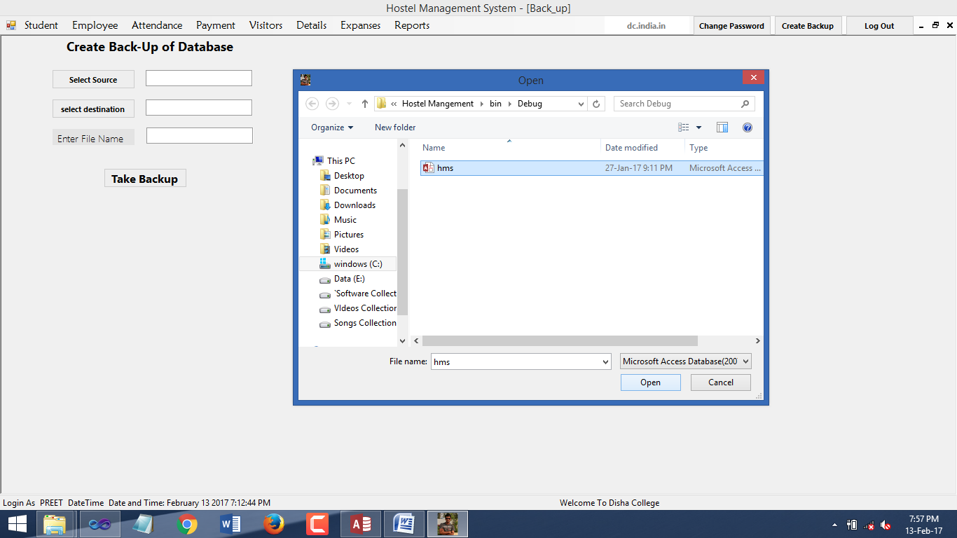CreateBackup:

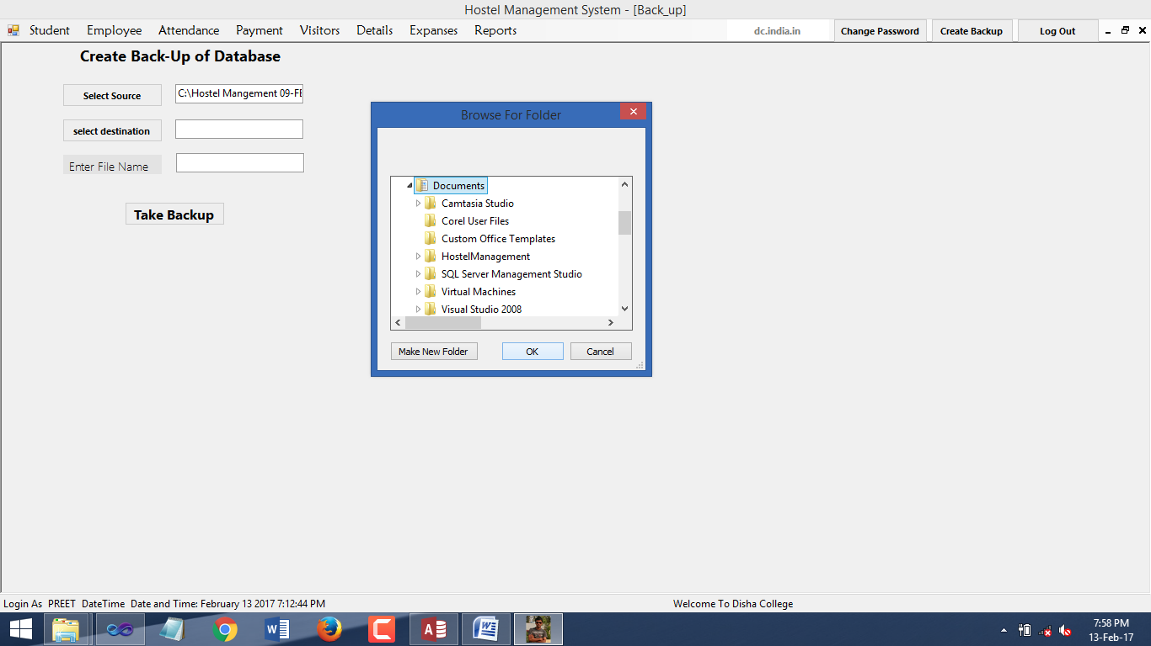

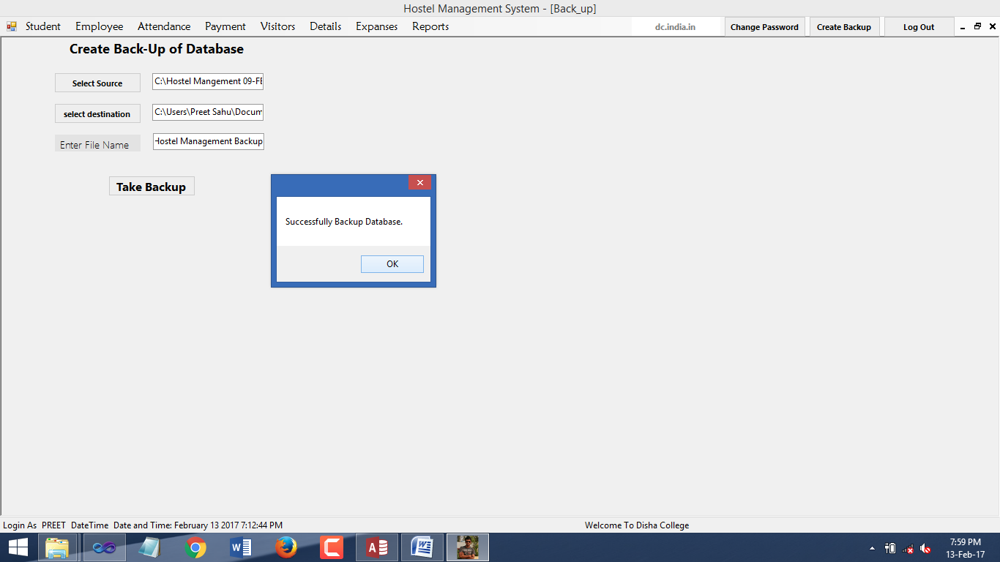

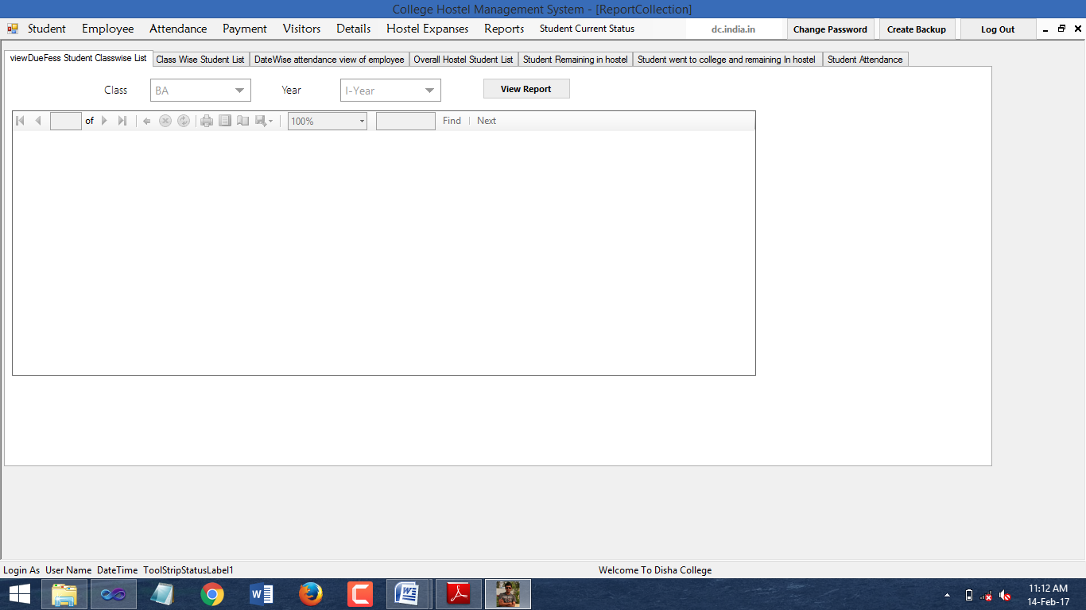**ReportCollection:**

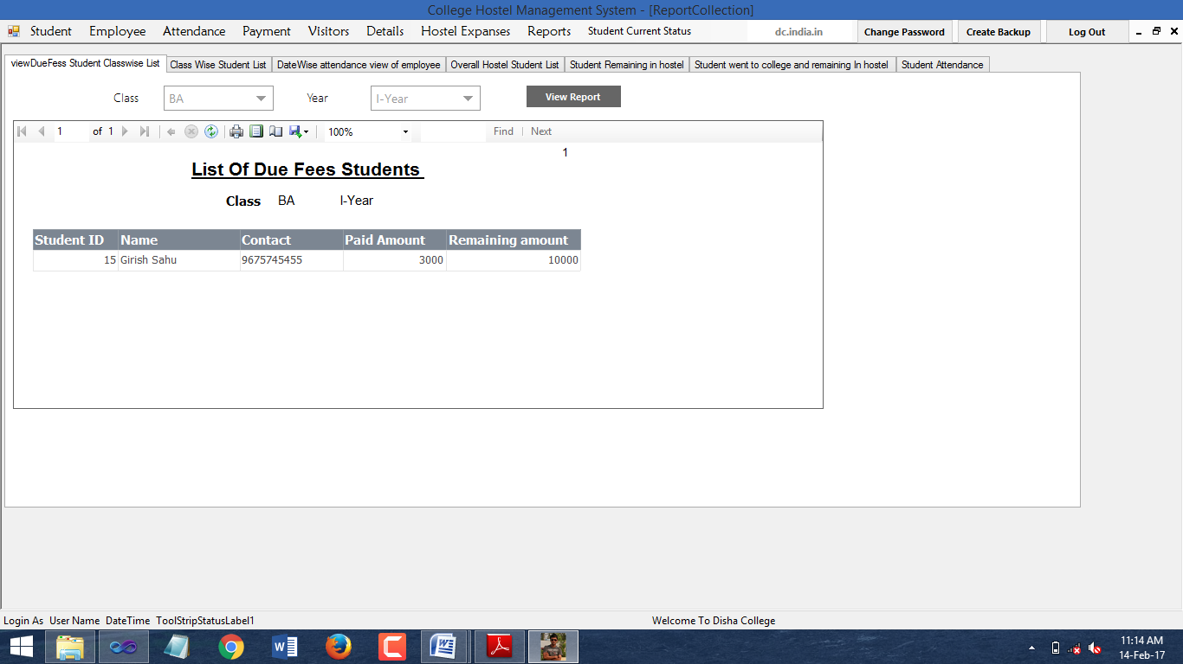ViewDueFeesStudent Tab:

ClassWise list of stuents:

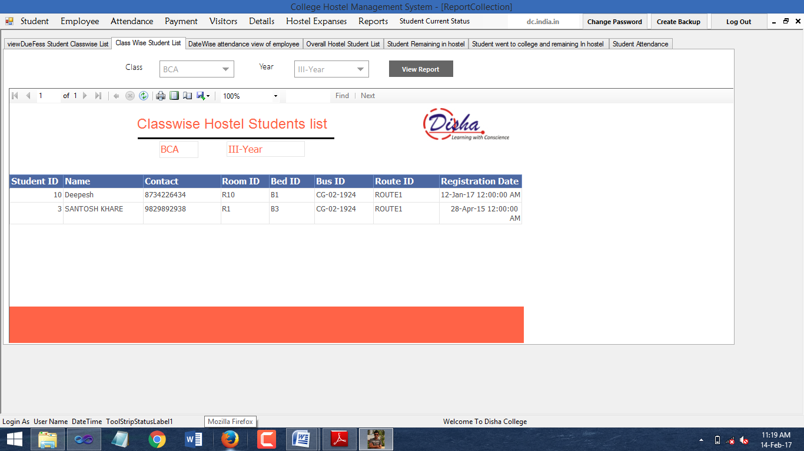

DateWise AttendanceReport of Employees:

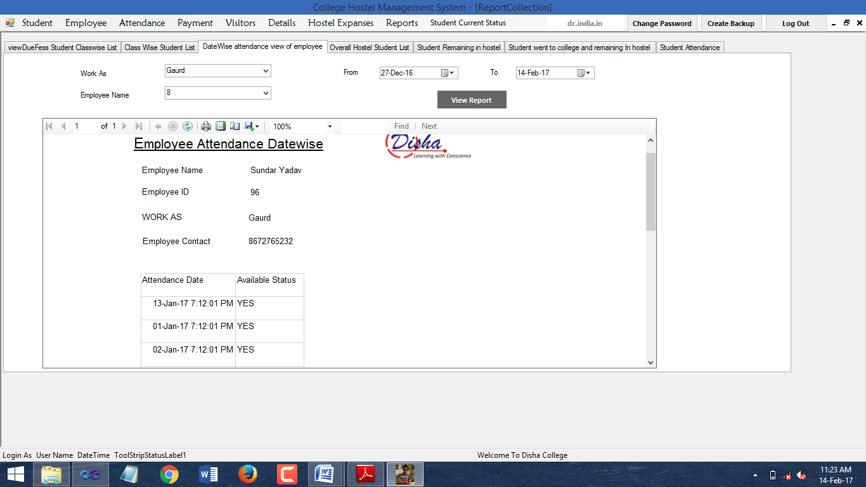

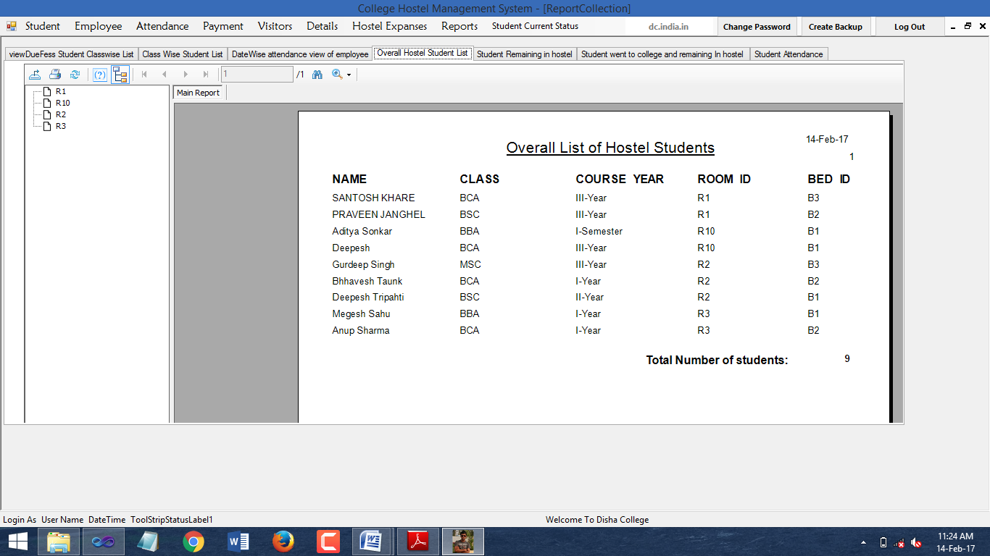Overall Students Students:

List of Students Remaining Tab:

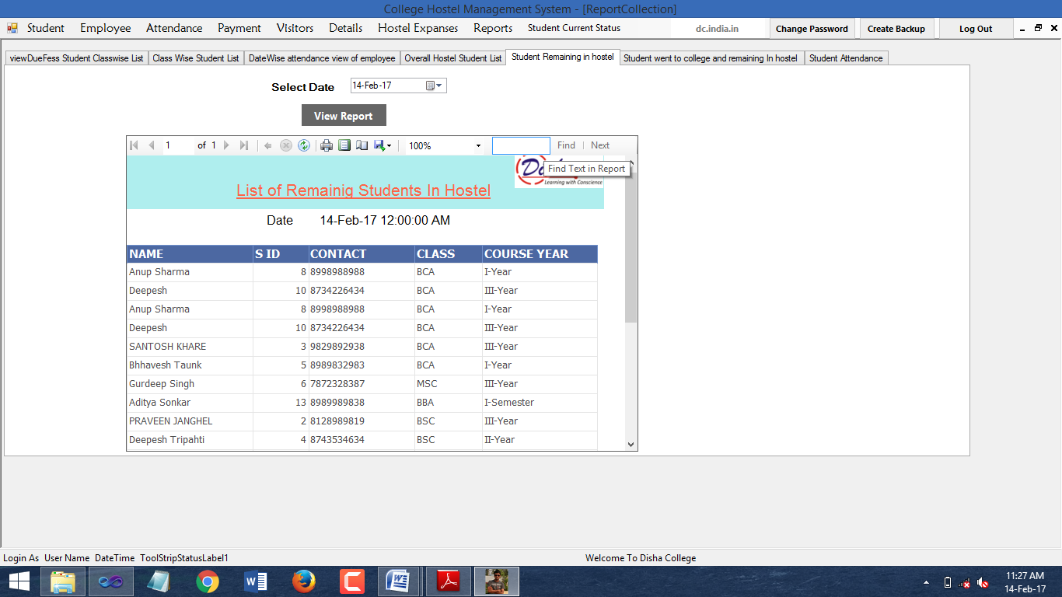

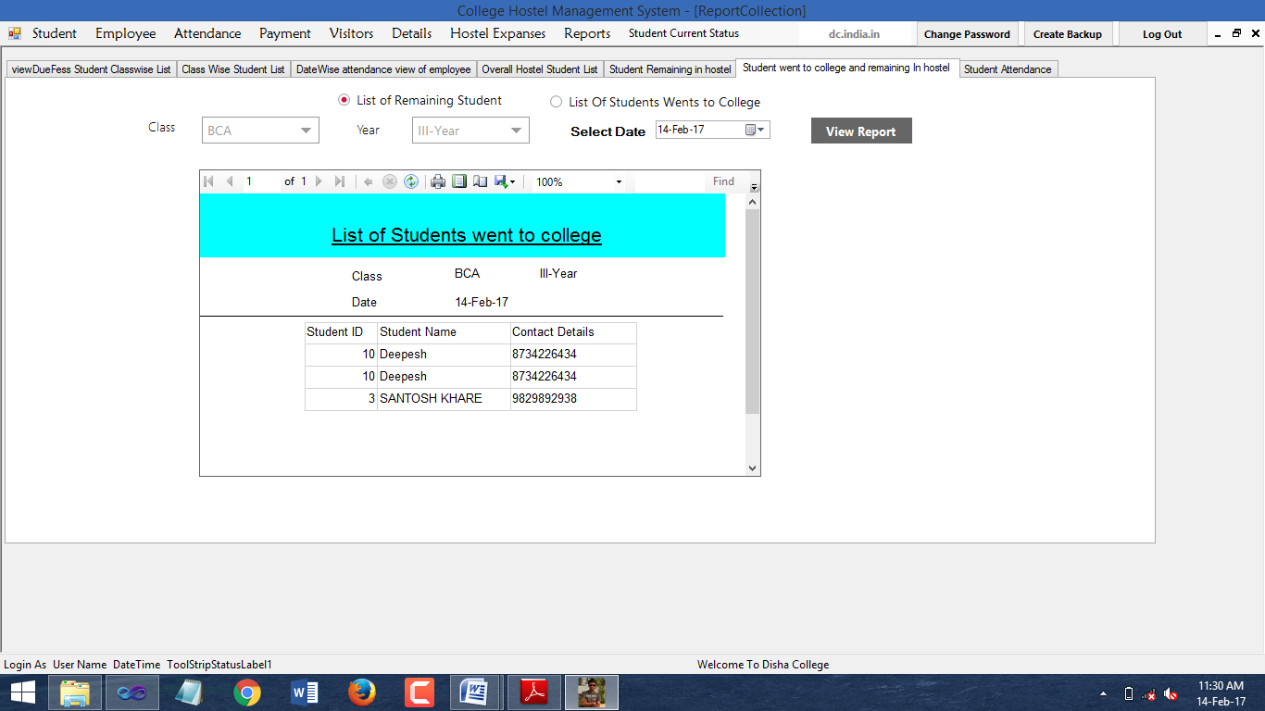List of Students Remaining in Hostel:

List of Students Went to Hostel:

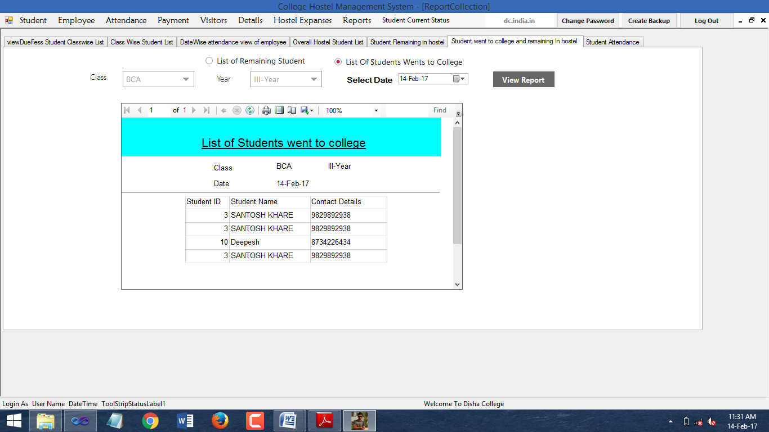

Student Individual Details:

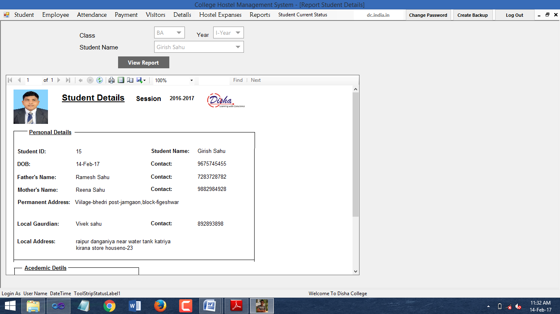

**Codes:-**

Connection Module:

Imports System.Data

Imports System.Data.OleDb

Module Module_Hostel

Private myConnection As OleDb.OleDbConnection

'Private myConnection2 As OleDbConnection

Public cmd As OleDb.OleDbCommand

Public adptr As OleDb.OleDbDataAdapter

Dim reader As OleDb.OleDbDataReader 'variable used to show login authetication befor loading form

Public loginAuthetication As Integer = 0

Public Function connect()

myConnection = New OleDb.OleDbConnection("Provider=Microsoft.ACE.OLEDB.12.0;Data Source=C:\hms\hms\Database1.accdb")

Return myConnection

End Function

LoginModule:-

Imports System.Data.OleDb

Imports System.Text.RegularExpressions

Imports System.Net.Mail

Public Class LoginForm

Dim query As String

Public loginAttempt As Integer

Private Sub OK_Click(ByVal sender As System.Object, ByVal e As System.EventArgs) Handles OK.Click

Dim con As New OleDbConnection

con = connectTOhms()

If txtpassword.Text = "" And txtusername.Text = "" Then

MsgBox("Authentication Failed,please enter your name with password", MsgBoxStyle.Exclamation)

ElseIf txtusername.Text = "" Then

MsgBox("user name missing", MsgBoxStyle.Information)

txtusername.Focus()

ElseIf txtpassword.Text = "" Then

MsgBox("please enter valid password", MsgBoxStyle.Information)

txtpassword.Focus()

Else

Try

con.Open()

query = "SELECT * FROM LoginUser WHERE USER_NAME='" + UCase(txtusername.Text) + "' and uPASSWORD='" + txtpassword.Text + "'"

Dim CMD As New OleDbCommand(query, con)

Dim READER As OleDbDataReader = CMD.ExecuteReader

If READER.Read = False Then

MsgBox("Login Failed!", vbCritical, "Note")

txtusername.Text = ""

txtpassword.Text = ""

txtusername.Focus()

'variable used to show login authetication befor loading form

loginAttempt = loginAttempt + 1

If loginAttempt = 0 Then

MsgBox("sorry login failed")

Else

MsgBox(Convert.ToString(3 - loginAttempt) + " Remaining")

End If

If loginAttempt >= 3 Then

MsgBox("login failed")

Me.Close()

End If

Else

MsgBox("login sucessful")

Dim uType As String = READER(1).ToString

If uType = "ADMIN" Then

Hostel_Management_System.StatusStrip1.Items(1).Text = Trim(UCase(txtusername.Text))

Dim datenow As Date = Now

Hostel_Management_System.StatusStrip1.Items(3).Text = "Date and Time: " & datenow.ToString("MMMM dd yyyy") & " " & TimeOfDay

con.Close()

loginAuthetication = 1

Hostel_Management_System.Show()

Me.Hide()

ElseIf uType = "LOCAL" Then

Gaurd_View.StatusStrip.Items(1).Text = Trim(UCase(txtusername.Text))

Dim datenow As Date = Now

Gaurd_View.StatusStrip.Items(3).Text = datenow.ToString("MMMM dd yyyy") & " " & TimeOfDay

con.Close()

loginAuthetication = 1 'variable used to show login authetication befor loading form

Gaurd_View.Show()

Me.Hide()

End If

End If

CMD.Dispose()

Catch ex As Exception

MsgBox(ex.Message)

End Try

txtusername.Text = ""

txtpassword.Text = ""

End If

End Sub

Private Sub Cancel_Click(ByVal sender As System.Object, ByVal e As System.EventArgs) Handles Cancel.Click

Me.Close()

End

End Sub

Private Sub LinkLabel1_LinkClicked(ByVal sender As System.Object, ByVal e As System.Windows.Forms.LinkLabelLinkClickedEventArgs) Handles LinkLabel1.LinkClicked

Dim con As New OleDbConnection

con = connectTOhms()

grpVerification.Visible = True

GroupBox1.Hide()

txtusername.Text = ""

txtpassword.Text = ""

If txtusername.Text = "" Then

txtusername.Focus()

End If

End Sub

'''''''''''''' random function predefined in Random class ''''''''''''''

Shared random As New Random()

Public Function getRandom()

Dim i As Integer

For i = 0 To 1

i = random.Next(1, 1000000) '

Next

Return i

End Function

'''''''''''''''''''''''''''''''''''''''''''''''''''''''''''''''''''''''''''''''''''''''''

Private Sub LoginForm_Load(ByVal sender As System.Object, ByVal e As System.EventArgs) Handles MyBase.Load

getRandom()

grpUserInfo.Enabled = False

Me.SetDesktopLocation(500, 200)

cboNUserName.Text = ""

Dim con As New OleDbConnection

con = connectTOhms()

Try

con.Open()

query = "select * from LoginUser"

Dim adptr As New OleDbDataAdapter(query, con)

Dim dt As New DataTable

adptr.Fill(dt)

cboNUserName.DataSource = dt

cboNUserName.DisplayMember = "USER_ID"

adptr.Dispose()

txtNUserID.Text = dt.Rows(0)("USER_ID").ToString

cboNUserName.Text = " "

Catch ex As Exception

MsgBox(ex.Message, MsgBoxStyle.Information)

Finally

con.Close()

End Try

End Sub

Private Sub btnShowPassword_Click(ByVal sender As System.Object, ByVal e As System.EventArgs) Handles btnShowPassword.Click

If txtConfirmPassword.Text = " " Or txtNpassword.Text = "" Then

MsgBox("empty password")

Else

Dim p As String = txtNpassword.Text

Dim cp As String = txtConfirmPassword.Text

txtNpassword.PasswordChar = ""

txtNpassword.Text = p

txtConfirmPassword.PasswordChar = ""

txtConfirmPassword.Text = cp

End If

End Sub

Private Sub btnShowPassword_LostFocus(ByVal sender As Object, ByVal e As System.EventArgs) Handles btnShowPassword.LostFocus

txtConfirmPassword.PasswordChar = "*"

txtNpassword.PasswordChar = "*"

End Sub

Dim uname As String

Dim UPASS As String

Dim count As Integer

Dim Querycomplete As String

Dim getQid As Integer = 0

Private Sub btnAutheticateAdmin_Click(ByVal sender As System.Object, ByVal e As System.EventArgs) Handles btnAutheticateAdmin.Click

cboNUserName.Text = ""

txtNUserID.Text = ""

Dim con As New OleDbConnection

con = connectTOhms()

Try

con.Open()

query = "select * from LoginUser where USER_TYPE='ADMIN'"

Dim cmd As New OleDbCommand(query, con)

Dim reader As OleDbDataReader = cmd.ExecuteReader

count = 0

While reader.Read

uname = reader("USER_NAME").ToString

UPASS = reader("uPASSWORD").ToString

If uname = txtAdminUser.Text And UPASS = txtAdminPass.Text Then

MsgBox("authentication is done")

grpUserInfo.Enabled = True

Else

grpUserInfo.Enabled = False

End If

End While

If count >= 3 Then

MsgBox("not login attempt remaining,application is going to shut down")

Me.Close()

End If

Catch ex As Exception

MsgBox(ex.Message)

Finally

con.Close()

End Try

End Sub

Private Sub btnSave_Click_1(ByVal sender As System.Object, ByVal e As System.EventArgs) Handles btnSave.Click

txtNpassword.PasswordChar = ""

Dim con As New OleDbConnection

con = connectTOhms()

If txtConfirmPassword.Text <> txtNpassword.Text Then

MsgBox("Pleaste password doesn't match please chexk again")

txtNpassword.Focus()

txtConfirmPassword.Text = ""

Else

Try

con.Open()

query = "insert into LoginUser (USER_ID,USER_TYPE,USER_NAME,uPASSWORD,uEMAIL_ID) values (?,?,?,?,?)"

Dim cmd As New OleDbCommand(query, con)

cmd.Parameters.AddWithValue("?", txtNUserID.Text)

cmd.Parameters.AddWithValue("?", cboAdduserType.Text)

cmd.Parameters.AddWithValue("?", txtNuserName.Text)

cmd.Parameters.AddWithValue("?", txtNpassword.Text)

cmd.Parameters.AddWithValue("?", txtEmailId.Text)

cmd.ExecuteNonQuery()

cmd.Dispose()

MsgBox("VALUE SAVED")

Catch ex As Exception

MsgBox("The ID alredy exist please insert another Room ID")

txtNUserID.Text = ""

txtNUserID.Focus()

Finally

con.Close()

End Try

txtNpassword.PasswordChar = "*"

End If

End Sub

Private Sub cboNUserID_SelectedIndexChanged(ByVal sender As System.Object, ByVal e As System.EventArgs) Handles cboNUserName.SelectedIndexChanged

Dim con As New OleDbConnection

con = connectTOhms()

Try

con.Open()

query = "select * from LoginUser where USER_NAME like ?"

Dim cmd As New OleDbCommand(query, con)

cmd.Parameters.AddWithValue("?", cboNUserName.Text)

Dim reader As OleDbDataReader = cmd.ExecuteReader

While reader.Read

cboAdduserType.Text = reader("USER_TYPE").ToString

txtEmailId.Text = reader("uEMAIL_ID").ToString

txtNpassword.Text = reader("uPASSWORD").ToString

txtNUserID.Text = reader("USER_ID").ToString

txtNuserName.Text = reader("USER_NAME").ToString

End While

txtNpassword.PasswordChar = "*"

Catch ex As Exception

MessageBox.Show(ex.Message)

Finally

con.Close()

End Try

End Sub

Private Sub clear()

txtNpassword.Text = ""

txtNUserID.Text = ""

txtNuserName.Text = ""

txtEmailId.Text = ""

cboNId.Text = ""

cboAdduserType.Text = ""

cboNUserName.Text = ""

txtConfirmPassword.Text = ""

End Sub

Private Sub btnUpdate_Click(ByVal sender As System.Object, ByVal e As System.EventArgs) Handles btnUpdate.Click

Dim con As New OleDbConnection

con = connectTOhms()

If txtConfirmPassword.Text <> txtNpassword.Text Then

MsgBox("Password doesn't match please check again")

txtNpassword.Focus()

txtConfirmPassword.Text = ""

Else

Try

con.Open()

query = "update LoginUser set USER_NAME = ? , uEMAIL_ID = ? , uPASSWORD = ?, USER_TYPE =? where USER_ID = ?"

Dim CMD As New OleDbCommand(query, con)

CMD.Parameters.AddWithValue("?", txtNuserName.Text)

CMD.Parameters.AddWithValue("?", txtEmailId.Text)

CMD.Parameters.AddWithValue("?", txtNpassword.Text)

CMD.Parameters.AddWithValue("?", cboAdduserType.Text)

CMD.Parameters.AddWithValue("?", Val(cboNId.Text))

CMD.ExecuteNonQuery()

CMD.Dispose()

MsgBox(cboNUserName.Text + " records updated")

Catch ex As Exception

MsgBox(ex.Message)

Finally

con.Close()

clear()

End Try

End If

End Sub

Private Sub cboAdduserType_SelectedIndexChanged(ByVal sender As System.Object, ByVal e As System.EventArgs) Handles cboAdduserType.SelectedIndexChanged

cboNId.Visible = True

cboNUserName.Visible = True

Dim con As New OleDbConnection

con = connectTOhms()

If cboAdduserType.SelectedIndex = 0 Then

Querycomplete = "where USER_TYPE like '" + cboAdduserType.Text + "'"

ElseIf cboAdduserType.SelectedIndex = 1 Then

Querycomplete = "where USER_TYPE like '" + cboAdduserType.Text + "'"

End If

Try

con.Open()

query = "select * from LoginUser " + Querycomplete

Dim adptr As New OleDbDataAdapter(query, con)

Dim dt As New DataTable

adptr.Fill(dt)

cboNUserName.DataSource = dt

cboNUserName.DisplayMember = "USER_NAME"

cboNId.DataSource = dt

cboNId.DisplayMember = "USER_ID"

Catch ex As Exception

MsgBox(ex.Message)

Finally

con.Close()

End Try

End Sub

Private Sub TabControl1_Click(ByVal sender As Object, ByVal e As System.EventArgs) Handles TabControl1.Click

grpUserInfo.Enabled = False

clear()

txtAdminPass.Text = ""

txtAdminUser.Text = ""

End Sub

Dim QueAns As String

Dim Que As String

Dim QueId As Integer

Dim ReUserID As Integer

Dim fupassword As String

Dim funame As String

Dim fuemail As String

Dim fuid As String

Dim fuContact As String

Dim fuserType As String

Private Sub btnReset_Click(ByVal sender As System.Object, ByVal e As System.EventArgs)

Dim con As New OleDbConnection

con = connectTOhms()

Try

con.Open()

query = "update LoginUser set uPASSWORD = ? where USER_ID = ?"

Dim CMD As New OleDbCommand(query, con)

CMD.Parameters.AddWithValue("?", "")

CMD.Parameters.AddWithValue("?", ReUserID)

CMD.ExecuteNonQuery()

CMD.Dispose()

MsgBox(txtVerifyUser.Text + " Password Changed")

Catch ex As Exception

MsgBox(ex.Message)

Finally

con.Close()

clear()

End Try

GroupBox1.Visible = True

End Sub

''''''''mail to user email ''''''''''''''''''''''''''''''''''

Private Sub Button2_Click(ByVal sender As System.Object, ByVal e As System.EventArgs) Handles Button2.Click

Try

Dim smtpserver As New SmtpClient

Dim email As New MailMessage

smtpserver.Credentials = New Net.NetworkCredential(TextBox1.Text, TextBox3.Text)

smtpserver.Port = 587

smtpserver.EnableSsl = True

smtpserver.Host = "smtp.gmail.com"

email = New MailMessage

email.From = New MailAddress("dcbca2@gmail.com", "Admin Disha Hostel Raipur")

email.To.Add(TextBox2.Text)

email.Subject = RichTextBox1.Text

email.Body = TextBox4.Text

smtpserver.Send(email)

MessageBox.Show("Email Sent to :" + TextBox2.Text)

Catch ex As Exception

MessageBox.Show(ex.Message)

Finally

End Try

End Sub

''''''''''''''''''''''''''''''''INPUT VALIDATION''''''''''''''''''''''''''''''''''

Private Sub TextBox3_GotFocus(ByVal sender As Object, ByVal e As System.EventArgs) Handles TextBox3.GotFocus

TextBox3.Text = ""

TextBox3.PasswordChar = "*"

End Sub

Private Sub TextBox3_LostFocus(ByVal sender As Object, ByVal e As System.EventArgs) Handles TextBox3.LostFocus

If TextBox3.Text = "" Then

TextBox3.PasswordChar = ""

TextBox3.Text = "password here"

Else

TextBox3.Text = TextBox3.Text

End If

End Sub

Private Sub txtusername_KeyPress(ByVal sender As Object, ByVal e As System.Windows.Forms.KeyPressEventArgs) Handles txtusername.KeyPress

If Asc(e.KeyChar) < 47 Then

e.Handled = True

End If

If Asc(e.KeyChar) < 58 Then

e.Handled = True

End If

If Asc(e.KeyChar) = 32 Or Asc(e.KeyChar) = 8 Then

e.Handled = False

End If

End Sub

Private Sub txtAdminUser_KeyPress(ByVal sender As Object, ByVal e As System.Windows.Forms.KeyPressEventArgs) Handles txtAdminUser.KeyPress

If Asc(e.KeyChar) < 47 Then

e.Handled = True

End If

If Asc(e.KeyChar) < 58 Then

e.Handled = True

End If

If Asc(e.KeyChar) = 32 Or Asc(e.KeyChar) = 8 Then

e.Handled = False

End If

End Sub

Private Sub txtNUserID_KeyPress(ByVal sender As Object, ByVal e As System.Windows.Forms.KeyPressEventArgs) Handles txtNUserID.KeyPress

If Asc(e.KeyChar) < 47 Or Asc(e.KeyChar) > 58 Then

e.Handled = True

End If

If Asc(e.KeyChar) = 46 Or Asc(e.KeyChar) = 8 Or Asc(e.KeyChar) = 13 Then

e.Handled = False

End If

End Sub

Private Sub cboNId_KeyPress(ByVal sender As Object, ByVal e As System.Windows.Forms.KeyPressEventArgs) Handles cboNId.KeyPress

If Asc(e.KeyChar) < 47 Or Asc(e.KeyChar) > 58 Then

e.Handled = True

End If

If Asc(e.KeyChar) = 46 Or Asc(e.KeyChar) = 8 Or Asc(e.KeyChar) = 13 Then

e.Handled = False

End If

End Sub

Private Sub btnClear_Click(ByVal sender As System.Object, ByVal e As System.EventArgs) Handles btnClear.Click

Dim con As New OleDbConnection

con = connectTOhms()

Try

con.Open()

query = "select max(USER_ID) from LoginUser"

Dim cmd As New OleDbCommand(query, con)

Dim reader As OleDbDataReader = cmd.ExecuteReader

While reader.Read

txtNUserID.Text = reader(0) + 1

End While

Catch ex As Exception

MsgBox(ex.Message)

Finally

con.Close()

End Try

cboNId.Visible = False

cboNUserName.Visible = False

txtNpassword.Text = ""

txtNuserName.Text = ""

txtusername.Text = ""

cboNUserName.Text = ""

txtConfirmPassword.Text = ""

cboNId.Text = ""

txtEmailId.Text = ""

End Sub

Private Sub Button3_Click(ByVal sender As System.Object, ByVal e As System.EventArgs) Handles Button3.Click

GroupBox1.Show()

grpVerification.Hide()

End Sub

Private Sub btnNext_Click(ByVal sender As System.Object, ByVal e As System.EventArgs) Handles btnNext.Click

Dim con As New OleDbConnection

con = connectTOhms()

If qid1.Checked = True Then

getQid = 1

ElseIf qid2.Checked = True Then

getQid = 2

ElseIf qid3.Checked = True Then

getQid = 3

ElseIf qid4.Checked = True Then

getQid = 4

ElseIf qid5.Checked = True Then

getQid = 5

Else

getQid = 0

End If

If txtVerifyUser.Text = "" Or txtVerifyAns.Text = "" Then

MsgBox("please re-enter user name and your Response")

txtVerifyUser.Focus()

ElseIf txtVerifyUser.Text <> "" Then

'''''''''''''''''''''''''''''''''''''''''''''''''''''''''''''''''''

For Each rdo In grpVerification.Controls.OfType(Of RadioButton)()

If rdo.Checked = False Then

ElseIf rdo.Checked = True Then

Try

con.Open()

query = "SELECT lu.USER_ID, lu.USER_TYPE, lu.USER_NAME, lu.uEMAIL_ID, lu.question_id,lq.question, lu.question_ans FROM LoginQuestion lq INNER JOIN LoginUser lu ON lq.question_id =lu.question_id where lu.USER_NAME like '" + txtVerifyUser.Text + "'"

Dim cmd As New OleDbCommand(query, con)

Dim reader As OleDbDataReader = cmd.ExecuteReader

While reader.Read

ReUserID = reader(0)

QueId = reader(4)

Que = reader(5).ToString

QueAns = reader(6).ToString

End While

cmd.Dispose()

Catch ex As Exception

MsgBox(ex.Message)

Finally

con.Close()

End Try

'----------------------------------------------------------------------------------------

If QueAns = txtVerifyAns.Text And QueId = getQid Then

MsgBox("User Verified")

Dim getEmail As String

getEmail = InputBox("enter your Email address:", "Email")

Dim ipass As String = getRandom()''''''''''' get randomly password update password of user ''

Try

con.Open()

query = "update LoginUser set uPassword=? where USER_NAME=? or uEMAIL_ID =?"

Dim CMD As New OleDbCommand(query, con)

CMD.Parameters.AddWithValue("?", ipass)

CMD.Parameters.AddWithValue("?", txtVerifyUser.Text)

CMD.Parameters.AddWithValue("?", txtVerifyUser.Text)

CMD.ExecuteNonQuery()

MsgBox("your password has been Resetted,please check your mail")

Catch ex As Exception

MsgBox(ex.Message)

Finally

con.Close()

End Try

'''''''''''''''''''''''''''''' '''''''''''''''''''''

Try

con.Open()

query = "select * from LoginUser where USER_NAME like ? or uEMAIL_ID like ?"

Dim cmd As New OleDbCommand(query, con)

cmd.Parameters.AddWithValue("?", txtVerifyUser.Text)

cmd.Parameters.AddWithValue("?", txtVerifyUser.Text)

Dim reader As OleDbDataReader = cmd.ExecuteReader

While reader.Read

fuemail = reader(4).ToString

fuContact = reader(5).ToString

fuid = reader(0).ToString

funame = reader(2).ToString

fuserType = reader(1).ToString

fupassword = reader(3).ToString

End While

cmd.Dispose()

Catch ex As Exception

MsgBox(ex.Message)

Finally

con.Close()

End Try

'''''''''''''''''' Mail to user email ''''''''''''''''''''''''''''''''''

Try

Dim smtpserver As New SmtpClient

Dim email As New MailMessage

smtpserver.Credentials = New Net.NetworkCredential("dcbca2@gmail.com", "finalnew")

smtpserver.Port = 587

smtpserver.EnableSsl = True

smtpserver.Host = "smtp.gmail.com"

email = New MailMessage

email.From = New MailAddress("dcbca2@gmail.com", "Admin Disha Hostel Raipur")

email.To.Add(Trim(getEmail))

email.Subject = "Login Password info"

email.Body = "Dear User your password has been changed" + "your password is : " + fupassword

smtpserver.Send(email)

MessageBox.Show("Email Sent to :" + getEmail)

grpVerification.Visible = False

GroupBox1.Visible = True

Catch ex As Exception

MessageBox.Show(ex.Message)

Finally

End Try

ElseIf QueAns <> txtVerifyAns.Text Or QueId <> getQid Then

MsgBox("Enterd Answer doesn't match, or you have selected wrong Question ..please contact Admin to for Password")

End If

End If

Next

End If

End Sub

End Class

**Student Room Allotment codes:**

Imports System.IO

Imports System.Data

Imports System.Data.OleDb

Public Class StudentRoomAllotment

Dim query As String

Dim qc As String

Dim str As String

Dim query1 As String

Dim query2 As String

Private Sub Browse_Click(ByVal sender As System.Object, ByVal e As System.EventArgs) Handles Browse.Click

OpenFileDialog1.Filter = "Picture Files (*)|*.bmp;*.gif;*.jpg"

If OpenFileDialog1.ShowDialog = Windows.Forms.DialogResult.OK Then

PictureBox1.Image = Image.FromFile(OpenFileDialog1.FileName)

End If

End Sub

Private Sub btnsave_Click(ByVal sender As System.Object, ByVal e As System.EventArgs) Handles btnsave.Click

Dim con As OleDbConnection

con = connectTOhms()

For Each ctrl In GroupBox2.Controls.OfType(Of TextBox)()

If ctrl.Text = "" Then

MsgBox("please fill up required fields")

ctrl.Focus()

End If

Next

If txtstudentname.Text = "" Then

MsgBox("please fillup student's name")

txtstudentname.Focus()

ElseIf txtstudentcontact.Text = "" Then

MsgBox("please fillup student's contact")

txtstudentcontact.Focus()

ElseIf txtfathername.Text = "" Then

MsgBox("please fillup father's name")

txtfathername.Focus()

ElseIf txtfathercontact.Text = "" Then

MsgBox("please fillup father's contact")

txtfathercontact.Focus()

ElseIf RichtTxtLaddress.Text = "" Then

MsgBox("please fillup address ")

RichtTxtLaddress.Focus()

ElseIf txtmothername.Text = "" Then

MsgBox("please fillup mother's contact")

txtmothercontact.Focus()

ElseIf txtmothercontact.Text = "" Then

MsgBox("please enter mother's contact")

txtmothercontact.Focus()

ElseIf RichTxtPaddress.Text = "" Then

MsgBox("please fillup permanent address")

RichTxtPaddress.Focus()

ElseIf txtlocalguardian.Text = "" Then

MsgBox("please fillup local gaurdian's name")

txtlocalguardian.Focus()

ElseIf txtlocalguardiancontact.Text = "" Then

MsgBox("please fillup local gaurdian's contact")

txtlocalguardian.Focus()

ElseIf RichtTxtLaddress.Text = "" Then

MsgBox("please fillup local gaurdian's address")

RichtTxtLaddress.Focus()

ElseIf cboclass.Text = "" Then

MsgBox("please select student class:")

cboclass.Focus()

ElseIf cboyear.Text = "" Then

MsgBox("please select course year")

cboyear.Focus()

ElseIf cboRoomID.Text = "" Then

MsgBox("please select room ")

cboRoomID.Focus()

ElseIf cboAllotBedID.Text = "" Then

MsgBox("please assign a bed_id to student name")

cboAllotBedID.Focus()

ElseIf cboRouteID.Text = "" Then

MsgBox("please select route of bus")

cboRouteID.Focus()

ElseIf txtbusid.Text = "" Then

MsgBox("please fillup bus id")

txtbusid.Focus()

ElseIf cboRoomID.Text <> "" And cboAllotBedID.Text = "" Then

MsgBox("please select another room ,their is no free bed")

cboRoomID.Focus()

ElseIf cboRoomID.Text = "" And cboAllotBedID.Text = "" Then

MsgBox("please select room and bed")

cboRoomID.Focus()

ElseIf cboRoomID.Text = "" And cboAllotBedID.Text <> "" Then

MsgBox("please select the room")

cboRoomID.Focus()

Else

Try

Dim myfile As New FileStream(OpenFileDialog1.FileName, FileMode.Open, FileAccess.Read)

Dim myFilereader As New BinaryReader(myfile)

Dim mybyteImage(myfile.Length) As Byte

myFilereader.Read(mybyteImage, 0, myfile.Length)

myFilereader.Close()

myfile.Close()

con.Open()

query = "insert into RoomAllotment (S_ID,DOB,NAME,CONTACT,PHOTO,FATHERS_NAME,FATHERS_CONTACT,MOTHERS_NAME,MOTHERS_CONTACT,PERMANENT_ADDRESS,LOCAL_GAURDIAN,LOCAL_GAURDIAN_CONTACT,LOCAL_GAURDIAN_ADDRESS,CLASS,COURSE_YEAR,ROOM_ID,BED_ID,BUS_ID,ROUTE_ID,REGISTRATION_DATE) values (?,?,?,?,?,?,?,?,?,?,?,?,?,?,?,?,?,?,?,?)"

Dim cmd As New OleDbCommand(query, con)

cmd.Parameters.AddWithValue("@sid", Val(txtstudentid.Text))

cmd.Parameters.AddWithValue("@date", Convert.ToDateTime(DateTimePicker1.Text))

cmd.Parameters.AddWithValue("@name", txtstudentname.Text)

cmd.Parameters.AddWithValue("@Scontact", txtstudentcontact.Text)

cmd.Parameters.AddWithValue("@photo", mybyteImage)

cmd.Parameters.AddWithValue("@fathername", txtfathername.Text)

cmd.Parameters.AddWithValue("@Fcontact", txtfathercontact.Text)

cmd.Parameters.AddWithValue("@mothername", txtmothername.Text)

cmd.Parameters.AddWithValue("@Mcontact", txtmothercontact.Text)

cmd.Parameters.AddWithValue("@Padd", RichTxtPaddress.Text)

cmd.Parameters.AddWithValue("@localgaurdian", txtlocalguardian.Text)

cmd.Parameters.AddWithValue("@Lcontact", txtlocalguardiancontact.Text)

cmd.Parameters.AddWithValue("@Ladd", RichtTxtLaddress.Text)

cmd.Parameters.AddWithValue("@class", cboclass.Text)

cmd.Parameters.AddWithValue("@year", cboyear.Text)

cmd.Parameters.AddWithValue("@roomID", cboRoomID.Text)

cmd.Parameters.AddWithValue("@bedID", cboAllotBedID.Text)

cmd.Parameters.AddWithValue("@BusID", txtbusid.Text)

cmd.Parameters.AddWithValue("@routeID", cboRouteID.Text)

cmd.Parameters.AddWithValue("@RegDate", Convert.ToDateTime(DateTimePicker1.Text))

cmd.ExecuteNonQuery()

cmd.Dispose()

MsgBox("Bed Number :" + cboAllotBedID.Text + " of Room Number :" + cboRoomID.Text + " is Alloted To Student :" + txtstudentname.Text)

Catch ex As Exception

MsgBox("The Student id must be unique,please click Add new Button for another Entry")

Finally

con.Close()

End Try

''''''''''''''''''''''''''''''''''update ROOM Details '''''''''''''''''''''''''''''''''''''''''''''''''''''''''

Try

con.Open()

query2 = "update newRoomDetail set AVAIL=? where ROOM_ID =? and BED_ID=?"

Dim cmd As New OleDbCommand(query2, con)

cmd.Parameters.AddWithValue("?", "NO")

cmd.Parameters.AddWithValue("?", cboRoomID.Text)

cmd.Parameters.AddWithValue("?", cboAllotBedID.Text)

cmd.ExecuteNonQuery()

cmd.Dispose()

MsgBox("Room Number : " + cboRoomID.Text + " Bed ID :" + cboAllotBedID.Text + " available status is : No")

Catch ex As Exception

MsgBox(ex.Message)

Finally

con.Close()

End Try

End If

End Sub

Private Sub allotment_Load(ByVal sender As Object, ByVal e As System.EventArgs) Handles Me.Load

'''''''''''''''''''''''''coding for autocompletion textbox from database''''''''''';'''''''''''''''

txtstudentname.AutoCompleteMode = AutoCompleteMode.Suggest

Dim datacollection As New AutoCompleteStringCollection()

getdata(datacollection)

txtstudentname.AutoCompleteCustomSource = datacollection

''''''''''''''''''''''''''''''''''''''''''''''''''''''''''''''''''''''''''''''''''''''

Dim con As New OleDbConnection

con = connectTOhms()

Try

con.Open()

query = "Select distinct[ROOM_ID] from newRoomDetail"

adptr = New OleDbDataAdapter(query, con)

Dim dt As New DataTable

adptr.Fill(dt)

cboRoomID.DataSource = dt

cboRoomID.DisplayMember = "ROOM_ID"

adptr.Dispose()

Catch ex As Exception

MsgBox(ex.Message)

Finally

con.Close()

End Try

Try

con.Open()

query = "select distinct[COURSE_NAME] from CourseDetails"

Dim adptr As New OleDbDataAdapter(query, con)

Dim dt As New DataTable

adptr.Fill(dt)

cboclass.DataSource = dt

cboclass.DisplayMember = "COURSE_NAME"

adptr.Dispose()

Catch ex As Exception

MsgBox(ex.Message, MsgBoxStyle.Information)

Finally

con.Close()

End Try

cboyear.Text = ""

'''''''''''''''''''''''''''''''''''''''''''''''''''''''''''''''''''''''''''''''''''''''''''''

''''''used to count number of records in roomallotment table for sid inputs

Dim sid As Integer

Try

If con.State = ConnectionState.Open Then

con.Close()

End If

con.Open()

Dim dt1 As New DataTable

Dim query As String

query = "Select max(S_ID) from RoomAllotment "

Dim cmd As New OleDbCommand(query, con)

Dim reader As OleDbDataReader = cmd.ExecuteReader

While reader.Read

sid = reader(0)

txtstudentid.Text = sid + 1

End While

cmd.Dispose()

Catch ex As Exception

MsgBox(ex.Message)

Finally

con.Close()

End Try

'----------------------------------- CboRouteID filling --------------------------------

Try

con.Open()

query = "select distinct[ROUTE_ID] from RouteDetails"

Dim adptr As New OleDbDataAdapter(query, con)

Dim dt2 As New DataTable

adptr.Fill(dt2)

cboRouteID.DataSource = dt2

cboRouteID.DisplayMember = "ROUTE_ID"

adptr.Dispose()

Catch ex As Exception

MsgBox(ex.Message)

Finally

con.Close()

End Try

cboRouteID.Text = ""

cboRoomID.Text = ""

txtbusid.Text = ""

txtRichRouteDes.Text = ""

cboAllotBedID.Text = ""

End Sub

Private Sub getdata(ByVal datacollection As AutoCompleteStringCollection)

Dim con As New OleDbConnection

con = connectTOhms()

Try

con.Open()

query = "select DISTINCT[NAME] from RoomAllotment"

Dim adptr As New OleDbDataAdapter(query, con)

Dim ds As New DataSet

adptr.Fill(ds)

Dim i As Integer = 0

For i = 0 To ds.Tables(0).Rows.Count - 1

datacollection.Add(ds.Tables(0).Rows(i)("NAME").ToString())

Next

adptr.Dispose()

Catch ex As Exception

MsgBox(ex.Message, MsgBoxStyle.Information)

Finally

con.Close()

End Try

End Sub

Private Sub Btnnew_Click(ByVal sender As System.Object, ByVal e As System.EventArgs) Handles Btnnew.Click

txtstudentid.Text = Val(txtstudentid.Text) + 1

txtstudentname.Text = ""

txtstudentcontact.Text = ""

PictureBox1.Image = Nothing

txtfathername.Text = ""

txtfathercontact.Text = ""

txtmothername.Text = ""

txtmothercontact.Text = ""

txtlocalguardian.Text = ""

RichTxtPaddress.Text = ""

txtlocalguardiancontact.Text = ""

RichtTxtLaddress.Text = ""

cboclass.Text = ""

cboyear.Text = ""

cboRoomID.Text = ""

cboAllotBedID.Text = ""

txtbusid.Text = ""

cboRouteID.Text = ""

txtRichRouteDes.Text = ""

End Sub

Private Sub Btnclose_Click(ByVal sender As System.Object, ByVal e As System.EventArgs) Handles Btnclose.Click

Me.Close()

End Sub

Private Sub Btnnext_Click(ByVal sender As System.Object, ByVal e As System.EventArgs) Handles Btnnext.Click

ViewStudentDetails.dtGridViewStudentDetail.Refresh()

ViewStudentDetails.Show()

ViewStudentDetails.MdiParent = Hostel_Management_System

End Sub

Private Sub Btnupdate_Click(ByVal sender As System.Object, ByVal e As System.EventArgs) Handles Btnupdate.Click

ViewStudentDetails.Show()

ViewStudentDetails.MdiParent = Hostel_Management_System

Me.Hide()

Me.Refresh()

End Sub

Private Sub cboRouteID_SelectedIndexChanged_1(ByVal sender As System.Object, ByVal e As System.EventArgs) Handles cboRouteID.SelectedIndexChanged

Dim con As New OleDbConnection

con = connectTOhms()

Try

con.Open()

query = "SELECT BD.BUS_ID, BD.COLLEGE_ARRIVAL_TIME, BD.HOSTEL_ARRIVAL_TIME, RD.ROUTE_DESCRIPTION, DD.DRIVER_NAME, DD.DRIVER_ID FROM (BusDetail AS BD INNER JOIN DriverDetails AS DD ON BD.DRIVER_ID =DD.DRIVER_ID) INNER JOIN RouteDetails AS RD ON BD.ROUTE_ID = RD.ROUTE_ID WHERE RD.ROUTE_ID=?"

Dim cmd As New OleDbCommand(query, con)

cmd.Parameters.AddWithValue("?", cboRouteID.Text)

Dim reader As OleDbDataReader = cmd.ExecuteReader

While reader.Read

txtbusid.Text = reader(0).ToString

dtPickerACtime.Text = reader(1).ToString

dtPickerAHtime.Text = reader(2).ToString

txtRichRouteDes.Text = reader(3).ToString

End While

cmd.Dispose()

Catch ex As Exception

MsgBox(ex.Message)

Finally

con.Close()

End Try

End Sub

Private Sub cboRoomID_KeyPress1(ByVal sender As Object, ByVal e As System.Windows.Forms.KeyPressEventArgs) Handles cboRoomID.KeyPress

If Asc(e.KeyChar) = 8 Or Asc(e.KeyChar) = 46 And Asc(e.KeyChar) = 32 Then

e.Handled = True

' MsgBox("not possible to edit", MsgBoxStyle.Information)

End If

If Asc(e.KeyChar) < 47 Then

e.Handled = True

End If

If Asc(e.KeyChar) < 58 Then

e.Handled = True

End If

If Asc(e.KeyChar) >= 58 And Asc(e.KeyChar) <= 128 Then

e.Handled = True

End If

End Sub

Private Sub cboRoomID_SelectedIndexChanged_1(ByVal sender As System.Object, ByVal e As System.EventArgs) Handles cboRoomID.SelectedIndexChanged

cboAllotBedID.Text = ""

Dim con As New OleDbConnection

con = connectTOhms()

Try

con.Open()

query = "select * from newRoomDetail where ROOM_ID like '" + cboRoomID.Text + "' and AVAIL='YES'"

Dim adptr As New OleDbDataAdapter(query, con)

Dim dt As New DataTable

adptr.Fill(dt)

cboAllotBedID.DataSource = dt

cboAllotBedID.DisplayMember = "BED_ID"

adptr.Dispose()

Catch ex As Exception

MsgBox(ex.Message)

Finally

con.Close()

End Try

End Sub

Private Sub cboclass_SelectedIndexChanged(ByVal sender As System.Object, ByVal e As System.EventArgs) Handles cboclass.SelectedIndexChanged

Dim con As New OleDbConnection

con = connectTOhms()

Try

con.Open()

query = "SELECT CD.COURSE_ID,CD.COURSE_NAME,CS.COURSE_SPECIFICATION FROM CourseDetails CD INNER JOIN CourseSpecification CS ON CD.COURSE_ID =CS.COURSE_ID WHERE CD.COURSE_NAME='" + cboclass.Text + "'"

Dim adptr As New OleDbDataAdapter(query, con)

Dim dt As New DataTable

adptr.Fill(dt)

cboyear.DataSource = dt

cboyear.DisplayMember = "COURSE_SPECIFICATION"

adptr.Dispose()

Catch ex As Exception

' MsgBox(ex.Message, MsgBoxStyle.Information)

Finally

con.Close()

End Try

cboyear.Text = ""

End Sub

'-------------------------------------- Validation ----------------------------------

Private Sub txtfathercontact_KeyPress(ByVal sender As Object, ByVal e As System.Windows.Forms.KeyPressEventArgs) Handles txtfathercontact.KeyPress

If Asc(e.KeyChar) < 47 Or Asc(e.KeyChar) > 58 Then

e.Handled = True

End If

If Asc(e.KeyChar) = 46 Or Asc(e.KeyChar) = 8 Or Asc(e.KeyChar) = 13 Then

e.Handled = False

End If

End Sub

Private Sub txtmothercontact_KeyPress(ByVal sender As Object, ByVal e As System.Windows.Forms.KeyPressEventArgs) Handles txtmothercontact.KeyPress

If Asc(e.KeyChar) < 47 Or Asc(e.KeyChar) > 58 Then

e.Handled = True

End If

If Asc(e.KeyChar) = 46 Or Asc(e.KeyChar) = 8 Or Asc(e.KeyChar) = 13 Then

e.Handled = False

End If

End Sub

Private Sub txtstudentcontact_KeyPress(ByVal sender As Object, ByVal e As System.Windows.Forms.KeyPressEventArgs) Handles txtstudentcontact.KeyPress

If Asc(e.KeyChar) < 47 Or Asc(e.KeyChar) > 58 Then

e.Handled = True

End If

If Asc(e.KeyChar) = 46 Or Asc(e.KeyChar) = 8 Or Asc(e.KeyChar) = 13 Then

e.Handled = False

End If

End Sub

Private Sub txtlocalguardiancontact_KeyPress(ByVal sender As Object, ByVal e As System.Windows.Forms.KeyPressEventArgs) Handles txtlocalguardiancontact.KeyPress

If Asc(e.KeyChar) < 47 Or Asc(e.KeyChar) > 58 Then

e.Handled = True

End If

If Asc(e.KeyChar) = 46 Or Asc(e.KeyChar) = 8 Or Asc(e.KeyChar) = 13 Then

e.Handled = False

End If

End Sub

Private Sub cboclass_KeyPress(ByVal sender As Object, ByVal e As System.Windows.Forms.KeyPressEventArgs) Handles cboclass.KeyPress

If Asc(e.KeyChar) = 8 Or Asc(e.KeyChar) = 46 Then

e.Handled = True

End If

End Sub

Private Sub cboyear_KeyPress(ByVal sender As Object, ByVal e As System.Windows.Forms.KeyPressEventArgs) Handles cboyear.KeyPress

If Asc(e.KeyChar) = 8 Or Asc(e.KeyChar) = 46 And Asc(e.KeyChar) = 32 Then

e.Handled = True

End If

If Asc(e.KeyChar) < 47 Then

e.Handled = True

End If

If Asc(e.KeyChar) < 58 Then

e.Handled = True

End If

If Asc(e.KeyChar) >= 58 And Asc(e.KeyChar) <= 128 Then

e.Handled = True

End If

End Sub

Private Sub txtbedid_KeyPress(ByVal sender As Object, ByVal e As System.Windows.Forms.KeyPressEventArgs)

If Asc(e.KeyChar) < 47 Or Asc(e.KeyChar) > 58 Then

e.Handled = True

End If

If Asc(e.KeyChar) = 46 Or Asc(e.KeyChar) = 8 Or Asc(e.KeyChar) = 13 Then

e.Handled = False

End If

End Sub

Private Sub txtbusid_KeyPress(ByVal sender As Object, ByVal e As System.Windows.Forms.KeyPressEventArgs)

If Asc(e.KeyChar) < 47 Or Asc(e.KeyChar) > 58 Then

e.Handled = True

End If

If Asc(e.KeyChar) = 46 Or Asc(e.KeyChar) = 8 Or Asc(e.KeyChar) = 13 Then

e.Handled = False

End If

End Sub

Private Sub txtrouteid_KeyPress(ByVal sender As Object, ByVal e As System.Windows.Forms.KeyPressEventArgs)

If Asc(e.KeyChar) < 47 Or Asc(e.KeyChar) > 58 Then

e.Handled = True

End If

If Asc(e.KeyChar) = 46 Or Asc(e.KeyChar) = 8 Or Asc(e.KeyChar) = 13 Then

e.Handled = False

End If

End Sub

Private Sub cboRoomID_KeyPress(ByVal sender As Object, ByVal e As System.Windows.Forms.KeyPressEventArgs)

If Asc(e.KeyChar) = 8 Or Asc(e.KeyChar) = 46 Then

e.Handled = True

MsgBox("not possible to edit", MsgBoxStyle.Information)

End If

End Sub

Private Sub txtstudentname_KeyPress(ByVal sender As Object, ByVal e As System.Windows.Forms.KeyPressEventArgs) Handles txtstudentname.KeyPress

If Asc(e.KeyChar) < 47 Then

'MsgBox("enter alphabet only")

e.Handled = True

End If

If Asc(e.KeyChar) < 58 Then

e.Handled = True

End If

If Asc(e.KeyChar) = 32 Or Asc(e.KeyChar) = 8 Then

e.Handled = False

End If

End Sub

Private Sub txtstudentname_MouseEnter(ByVal sender As Object, ByVal e As System.EventArgs) Handles txtstudentname.MouseEnter

txtstudentname.BackColor = Color.Cyan

txtstudentname.ForeColor = Color.DeepPink

End Sub

Private Sub txtstudentname_MouseLeave(ByVal sender As Object, ByVal e As System.EventArgs) Handles txtstudentname.MouseLeave

txtstudentname.BackColor = Color.White

txtstudentname.ForeColor = Color.Black

End Sub

Private Sub btnsave_MouseEnter(ByVal sender As Object, ByVal e As System.EventArgs) Handles btnsave.MouseEnter

btnsave.BackColor = Color.CadetBlue

btnsave.ForeColor = Color.Black

End Sub

Private Sub btnsave_MouseLeave(ByVal sender As Object, ByVal e As System.EventArgs) Handles btnsave.MouseLeave

btnsave.BackColor = Color.White

btnsave.ForeColor = Color.Black

End Sub

Private Sub Btnclose_MouseEnter(ByVal sender As Object, ByVal e As System.EventArgs) Handles Btnclose.MouseEnter

Btnclose.BackColor = Color.CadetBlue

Btnclose.ForeColor = Color.Black

End Sub

Private Sub Btnclose_MouseLeave(ByVal sender As Object, ByVal e As System.EventArgs) Handles Btnclose.MouseLeave

Btnclose.BackColor = Color.White

Btnclose.ForeColor = Color.Black

End Sub

Private Sub txtfathername_KeyPress(ByVal sender As Object, ByVal e As System.Windows.Forms.KeyPressEventArgs) Handles txtfathername.KeyPress

If Asc(e.KeyChar) < 47 Then

' MsgBox("enter alphabet only")

e.Handled = True

End If

If Asc(e.KeyChar) < 58 Then

e.Handled = True

End If

If Asc(e.KeyChar) = 32 Or Asc(e.KeyChar) = 8 Then

e.Handled = False

End If

End Sub

Private Sub txtmothername_KeyPress(ByVal sender As Object, ByVal e As System.Windows.Forms.KeyPressEventArgs) Handles txtmothername.KeyPress

If Asc(e.KeyChar) < 47 Then

' MsgBox("enter alphabet only")

e.Handled = True

End If

If Asc(e.KeyChar) < 58 Then

e.Handled = True

End If

If Asc(e.KeyChar) = 32 Or Asc(e.KeyChar) = 8 Then

e.Handled = False

End If

End Sub

Private Sub txtlocalguardian_KeyPress(ByVal sender As Object, ByVal e As System.Windows.Forms.KeyPressEventArgs) Handles txtlocalguardian.KeyPress

If Asc(e.KeyChar) < 47 Then

' MsgBox("enter alphabet only")

e.Handled = True

End If

If Asc(e.KeyChar) < 58 Then

e.Handled = True

End If

If Asc(e.KeyChar) = 32 Or Asc(e.KeyChar) = 8 Then

e.Handled = False

End If

End Sub

Private Sub cboRouteID_KeyPress(ByVal sender As Object, ByVal e As System.Windows.Forms.KeyPressEventArgs) Handles cboRouteID.KeyPress

If Asc(e.KeyChar) = 8 Or Asc(e.KeyChar) = 46 And Asc(e.KeyChar) = 32 Then

e.Handled = True

' MsgBox("not possible to edit", MsgBoxStyle.Information)

End If

If Asc(e.KeyChar) < 47 Then

e.Handled = True

End If

If Asc(e.KeyChar) < 58 Then

e.Handled = True

End If

If Asc(e.KeyChar) >= 58 And Asc(e.KeyChar) <= 128 Then

e.Handled = True

End If

End Sub

Private Sub cboAllotBedID_KeyPress(ByVal sender As Object, ByVal e As System.Windows.Forms.KeyPressEventArgs) Handles cboAllotBedID.KeyPress

If Asc(e.KeyChar) = 8 Or Asc(e.KeyChar) = 46 And Asc(e.KeyChar) = 32 Then

e.Handled = True

' MsgBox("not possible to edit", MsgBoxStyle.Information)

End If

If Asc(e.KeyChar) < 47 Then

e.Handled = True

End If

If Asc(e.KeyChar) < 58 Then

e.Handled = True

End If

If Asc(e.KeyChar) >= 58 And Asc(e.KeyChar) <= 128 Then

e.Handled = True

End If

End Sub

Private Sub txtRichRouteDes_KeyPress(ByVal sender As Object, ByVal e As System.Windows.Forms.KeyPressEventArgs) Handles txtRichRouteDes.KeyPress

If Asc(e.KeyChar) = 8 Or Asc(e.KeyChar) = 46 And Asc(e.KeyChar) = 32 Then

e.Handled = True

' MsgBox("not possible to edit", MsgBoxStyle.Information)

End If

If Asc(e.KeyChar) < 47 Then

e.Handled = True

End If

If Asc(e.KeyChar) < 58 Then

e.Handled = True

End If

If Asc(e.KeyChar) >= 58 And Asc(e.KeyChar) <= 128 Then

e.Handled = True

End If

End Sub

End Class

**ViewStudentDetails codes:**

Imports System.Data.OleDb

Imports System.IO

Public Class ViewStudentDetails

Dim query As String

Dim ds As New DataSet

Dim querycomplete As String

Dim cmd As OleDbCommand

'''''''''''''''''''''''''' cell click '''''''''''''''''''''''''''''''''''''''

Private Sub SubroutineCellClick()

Try

If dtGridViewStudentDetail.RowCount >= 0 Then

Dim myimagebyte() As Byte = dtGridViewStudentDetail.Item(4, dtGridViewStudentDetail.CurrentRow.Index).Value

Dim memStream As New MemoryStream(myimagebyte)

PictureBox1.Image = Image.FromStream(memStream) 'load picture for memory stream

End If

Dim row As DataGridViewRow = dtGridViewStudentDetail.CurrentRow

txtstudentid.Text = row.Cells("S_ID").Value.ToString

txtstudentname.Text = row.Cells("NAME").Value.ToString

dtPickerDOB.Value = row.Cells("DOB").Value

txtstudentcontact.Text = row.Cells("CONTACT").Value.ToString

cboclass.Text = row.Cells("CLASS").Value.ToString

cboyear.Text = row.Cells("COURSE_YEAR").Value.ToString

txtRoomID.Text = row.Cells("ROOM_ID").Value.ToString

txtbedid.Text = row.Cells("BED_ID").Value.ToString

txtbusid.Text = row.Cells("BUS_ID").Value.ToString

txtrouteid.Text = row.Cells("ROUTE_ID").Value.ToString

txtfathername.Text = row.Cells("FATHERS_NAME").Value.ToString

txtfathercontact.Text = row.Cells("FATHERS_CONTACT").Value.ToString

txtmothername.Text = row.Cells("MOTHERS_NAME").Value.ToString

txtmothercontact.Text = row.Cells("MOTHERS_CONTACT").Value.ToString

richTxtpermanentaddress.Text = row.Cells("PERMANENT_ADDRESS").Value.ToString

txtlocalguardian.Text = row.Cells("LOCAL_GAURDIAN").Value.ToString

txtlocalguardiancontact.Text = row.Cells("LOCAL_GAURDIAN_CONTACT").Value.ToString

richTxtLocalAddress.Text = row.Cells("LOCAL_GAURDIAN_ADDRESS").Value.ToString

DateTimePicker1.Text = row.Cells("Depatcher_Date").Value.ToString

DtcurrentDate.Text = row.Cells("REGISTRATION_DATE").Value.ToString

Catch ex As Exception

MsgBox(ex.Message, MsgBoxStyle.Information)

End Try

End Sub

''''''''''''''''''' update datagrid updation ''''''''''''''''''''''''''''''''''''''''

Private Sub dtgridviewRefresh()

Dim con As New OleDbConnection

con = connectTOhms()

Try

con.Open()

query = "SELECT * FROM RoomAllotment WHERE BED_ID <> '' AND ROOM_ID <> '' ;"

Dim adptr As New OleDbDataAdapter(query, con)

Dim dt As New DataTable

adptr.Fill(dt)

dtGridViewStudentDetail.DataSource = dt

dtGridViewStudentDetail.Sort(dtGridViewStudentDetail.Columns(0), System.ComponentModel.ListSortDirection.Ascending)

adptr.Dispose()

Catch ex As Exception

MessageBox.Show(ex.Message)

Finally

con.Close()

End Try

End Sub

''''''''''''''''''' grid format '''''''''''''''''''''''''''''''''''''''''''''

Private Sub gridFormat()

dtGridViewStudentDetail.GridColor = Color.Aqua

dtGridViewStudentDetail.BackgroundColor = Color.LightGray

dtGridViewStudentDetail.CellBorderStyle = DataGridViewCellBorderStyle.None

dtGridViewStudentDetail.SelectionMode = DataGridViewSelectionMode.FullRowSelect 'formatting datagrid

dtGridViewStudentDetail.DefaultCellStyle.SelectionBackColor = Color.Cyan

dtGridViewStudentDetail.DefaultCellStyle.SelectionForeColor = Color.DarkBlue

dtGridViewStudentDetail.RowsDefaultCellStyle.BackColor = Color.Bisque

dtGridViewStudentDetail.AllowUserToResizeRows = False

dtGridViewStudentDetail.AlternatingRowsDefaultCellStyle.BackColor = Color.Beige

End Sub

' ------------------------------ load ------------------------------------------------

Private Sub ViewStudentDetails_Load(ByVal sender As System.Object, ByVal e As System.EventArgs) Handles MyBase.Load

cboSelected.Text = ""

dtgridviewRefresh()

gridFormat()

DateTimePicker1.Visible = True

'''''''''''''''''''''''''' LOADING COMBO DISTICT VALUSE ''''''''''''''''''''

Dim CON As New OleDbConnection

CON = connectTOhms()

Try

CON.Open()

query = "select distinct[COURSE_NAME] from CourseDetails "

Dim adptr As New OleDbDataAdapter(query, CON)

Dim dt As New DataTable

adptr.Fill(dt)

cboclass.DataSource = dt

cboclass.DisplayMember = "COURSE_NAME"

adptr.Dispose()

Catch ex As Exception

MsgBox(ex.Message)

Finally

CON.Close()

End Try

End Sub

''''''''''''''''''''''''''''''' cell enter

Private Sub cellenter()

Dim currRoW As DataGridViewRow = dtGridViewStudentDetail.CurrentRow

txtstudentid.Text = currRoW.Cells("S_ID").Value.ToString

txtstudentname.Text = currRoW.Cells("NAME").Value.ToString

dtPickerDOB.Value = currRoW.Cells("DOB").Value

txtstudentcontact.Text = currRoW.Cells("CONTACT").Value.ToString

cboclass.Text = currRoW.Cells("CLASS").Value.ToString

cboyear.Text = currRoW.Cells("COURSE_YEAR").Value.ToString

txtRoomID.Text = currRoW.Cells("ROOM_ID").Value.ToString

txtbedid.Text = currRoW.Cells("BED_ID").Value.ToString

txtbusid.Text = currRoW.Cells("BUS_ID").Value.ToString

txtrouteid.Text = currRoW.Cells("ROUTE_ID").Value.ToString

txtfathername.Text = currRoW.Cells("FATHERS_NAME").Value.ToString

txtfathercontact.Text = currRoW.Cells("FATHERS_CONTACT").Value.ToString

txtmothername.Text = currRoW.Cells("MOTHERS_NAME").Value.ToString

txtmothercontact.Text = currRoW.Cells("MOTHERS_CONTACT").Value.ToString

dtGridViewStudentDetail.Text = currRoW.Cells("PERMANENT_ADDRESS").Value.ToString

txtlocalguardian.Text = currRoW.Cells("LOCAL_GAURDIAN").Value.ToString

txtlocalguardiancontact.Text = currRoW.Cells("LOCAL_GAURDIAN_CONTACT").Value.ToString

richTxtLocalAddress.Text = currRoW.Cells("LOCAL_GAURDIAN_ADDRESS").Value.ToString

End Sub

' --------------------------- cell click -----------------------------------------

Private Sub dtGridViewStudentDetail_CellClick(ByVal sender As Object, ByVal e As System.Windows.Forms.DataGridViewCellEventArgs) Handles dtGridViewStudentDetail.CellClick, dtGridViewStudentDetail.CellClick

Try

If dtGridViewStudentDetail.RowCount >= 0 Then

Dim myimagebyte() As Byte = dtGridViewStudentDetail.Item(4, dtGridViewStudentDetail.CurrentRow.Index).Value

Dim memStream As New MemoryStream(myimagebyte)

PictureBox1.Image = Image.FromStream(memStream) 'load picture for memory stream

End If

Dim i As Integer

With dtGridViewStudentDetail

If e.RowIndex >= 0 Then

i = .CurrentRow.Index

txtstudentid.Text = .Rows(i).Cells("S_ID").Value.ToString

txtstudentname.Text = .Rows(i).Cells("NAME").Value.ToString

dtPickerDOB.Value = .Rows(i).Cells("DOB").Value

txtstudentcontact.Text = .Rows(i).Cells("CONTACT").Value.ToString

cboclass.Text = .Rows(i).Cells("CLASS").Value.ToString

cboyear.Text = .Rows(i).Cells("COURSE_YEAR").Value.ToString

txtRoomID.Text = .Rows(i).Cells("ROOM_ID").Value.ToString

txtbedid.Text = .Rows(i).Cells("BED_ID").Value.ToString

txtbusid.Text = .Rows(i).Cells("BUS_ID").Value.ToString

txtrouteid.Text = .Rows(i).Cells("ROUTE_ID").Value.ToString

txtfathername.Text = .Rows(i).Cells("FATHERS_NAME").Value.ToString

txtfathercontact.Text = .Rows(i).Cells("FATHERS_CONTACT").Value.ToString

txtmothername.Text = .Rows(i).Cells("MOTHERS_NAME").Value.ToString

txtmothercontact.Text = .Rows(i).Cells("MOTHERS_CONTACT").Value.ToString

richTxtpermanentaddress.Text = .Rows(i).Cells("PERMANENT_ADDRESS").Value.ToString

txtlocalguardian.Text = .Rows(i).Cells("LOCAL_GAURDIAN").Value.ToString

txtlocalguardiancontact.Text = .Rows(i).Cells("LOCAL_GAURDIAN_CONTACT").Value.ToString

richTxtLocalAddress.Text = .Rows(i).Cells("LOCAL_GAURDIAN_ADDRESS").Value.ToString

DtcurrentDate.Text = .Rows(i).Cells("REGISTRATION_DATE").Value.ToString

DateTimePicker1.Text = .Rows(i).Cells("Depatcher_Date").Value.ToString

End If

End With

Catch ex As Exception

MsgBox(ex.Message, MsgBoxStyle.Information)

End Try

End Sub

Private Sub btnUpdate_Click(ByVal sender As Object, ByVal e As System.EventArgs) Handles btnUpdate.Click

Dim con As OleDbConnection

con = connectTOhms()

If txtstudentcontact.TextLength <> 10 Then

MsgBox("enter your correct mobile number", MsgBoxStyle.Information)

ElseIf txtfathercontact.TextLength <> 10 Then

MsgBox("enter father's correct mobile number", MsgBoxStyle.Information)

ElseIf txtmothercontact.TextLength <> 10 Then

MsgBox("enter mother's correct mobile number", MsgBoxStyle.Information)

Else

Try

Dim myfile As New FileStream(OpenFileDialog1.FileName, FileMode.Open, FileAccess.Read)

Dim myFilereader As New BinaryReader(myfile)

Dim mybyteImage(myfile.Length) As Byte

myFilereader.Read(mybyteImage, 0, myfile.Length)

myFilereader.Close()

myfile.Close()

con.Open()

query = "update RoomAllotment set DOB = ? , NAME = ? , CONTACT = ? , PHOTO = ? , FATHERS_NAME = ? , FATHERS_CONTACT = ? , MOTHERS_NAME = ? , MOTHERS_CONTACT = ? , PERMANENT_ADDRESS = ? , LOCAL_GAURDIAN = ? , LOCAL_GAURDIAN_CONTACT = ? , LOCAL_GAURDIAN_ADDRESS = ? , CLASS = ? , COURSE_YEAR = ? , ROOM_ID = ? , BED_ID = ? , BUS_ID = ? , ROUTE_ID = ? where S_ID=? "

Dim cmd As New OleDbCommand(query, con)

cmd.Parameters.AddWithValue("?", Convert.ToDateTime(dtPickerDOB.Text))

cmd.Parameters.AddWithValue("?", txtstudentname.Text)

cmd.Parameters.AddWithValue("?", txtstudentcontact.Text)

cmd.Parameters.AddWithValue("?", mybyteImage)

cmd.Parameters.AddWithValue("?", txtfathername.Text)

cmd.Parameters.AddWithValue("?", txtfathercontact.Text)

cmd.Parameters.AddWithValue("?", txtmothername.Text)

cmd.Parameters.AddWithValue("?", txtmothercontact.Text)

cmd.Parameters.AddWithValue("?", dtGridViewStudentDetail.Text)

cmd.Parameters.AddWithValue("?", txtlocalguardian.Text)

cmd.Parameters.AddWithValue("?", txtlocalguardiancontact.Text)

cmd.Parameters.AddWithValue("?", richTxtLocalAddress.Text)

cmd.Parameters.AddWithValue("?", cboclass.Text)

cmd.Parameters.AddWithValue("?", cboyear.Text)

cmd.Parameters.AddWithValue("?", txtRoomID.Text)

cmd.Parameters.AddWithValue("?", txtbedid.Text)

cmd.Parameters.AddWithValue("?", Val(txtbusid.Text))

cmd.Parameters.AddWithValue("?", Val(txtrouteid.Text))

cmd.Parameters.AddWithValue("?", Val(txtstudentid.Text))

cmd.ExecuteNonQuery()

cmd.Dispose()

MessageBox.Show("Record of " + txtstudentname.Text + " is successfully updated")

dtgridviewRefresh()

clear()

Catch ex As Exception

MessageBox.Show(ex.Message)

Finally

con.Close()

End Try

End If

End Sub

Private Sub btnBrowse_Click(ByVal sender As System.Object, ByVal e As System.EventArgs) Handles btnBrowse.Click

OpenFileDialog1.Filter = "Picture Files (*)|*.bmp;*.gif;*.jpg"

If OpenFileDialog1.ShowDialog = Windows.Forms.DialogResult.OK Then

PictureBox1.Image = Image.FromFile(OpenFileDialog1.FileName)

End If

End Sub

Private Sub btnClickView_Click(ByVal sender As Object, ByVal e As System.EventArgs) Handles btnClickView.Click

Dim con As New OleDbConnection

con = connectTOhms()

If cboSearchBy.SelectedIndex = 0 Then

Label2.Text = "Select Class"

querycomplete = " where CLASS = '" + Trim(txtEnterDetail.Text) + "' or CLASS = '" + cboSelected.Text + "';"

ElseIf cboSearchBy.SelectedIndex = 1 Then

Label2.Text = "Select Student Name"

querycomplete = " where NAME = '" + Trim(txtEnterDetail.Text) + "' or NAME = '" + cboSelected.Text + "';"

ElseIf cboSearchBy.SelectedIndex = 2 Then

Label2.Text = "Select Student ID"

querycomplete = "where S_ID like '" + Trim(cboSelected.Text) + "' or S_ID like '" + Trim(txtEnterDetail.Text) + "' ;"

ElseIf cboSearchBy.SelectedIndex = 3 Then

querycomplete = ""

End If

Try

con.Open()

query = "select * from RoomAllotment " + querycomplete

Dim adptr As New OleDbDataAdapter(query, con)

Dim dt As New DataTable

adptr.Fill(dt)

dtGridViewStudentDetail.DataSource = dt

adptr.Dispose()

Catch ex As Exception

MessageBox.Show(ex.Message)

Finally

con.Close()

End Try

SubroutineCellClick()

End Sub

Private Sub clear()

dtGridViewStudentDetail.ClearSelection()

txtstudentid.Text = ""

txtstudentname.Text = ""

txtstudentcontact.Text = ""

PictureBox1.Image = Nothing

txtfathername.Text = ""

txtfathercontact.Text = ""

dtGridViewStudentDetail.Text = ""

txtmothername.Text = ""

txtmothercontact.Text = ""

txtlocalguardian.Text = ""

txtlocalguardiancontact.Text = ""

richTxtLocalAddress.Text = ""

cboclass.Text = ""

cboyear.Text = ""

txtRoomID.Text = ""

txtbedid.Text = ""

txtbusid.Text = ""

txtrouteid.Text = ""

txtEnterDetail.Text = ""

richTxtpermanentaddress.Text = ""

DtcurrentDate.Text = Nothing

dtPickerDOB.Text = Nothing

End Sub

Private Sub btnClear_Click(ByVal sender As Object, ByVal e As System.EventArgs) Handles btnClear.Click

clear()

End Sub

Private Sub Button2_Click(ByVal sender As System.Object, ByVal e As System.EventArgs) Handles Button2.Click

StudentDeparture.Show()

StudentDeparture.MdiParent = Hostel_Management_System

StudentDeparture.Dock = DockStyle.Fill

End Sub

Private Sub txtfathercontact_KeyPress(ByVal sender As Object, ByVal e As System.Windows.Forms.KeyPressEventArgs) Handles txtfathercontact.KeyPress

If Asc(e.KeyChar) < 48 Or Asc(e.KeyChar) > 57 Then

MsgBox("enter digits only")

e.Handled = True

End If

End Sub

Private Sub txtstudentcontact_KeyPress(ByVal sender As Object, ByVal e As System.Windows.Forms.KeyPressEventArgs) Handles txtstudentcontact.KeyPress

If Asc(e.KeyChar) < 48 Or Asc(e.KeyChar) > 57 Then

MsgBox("enter digits only")

e.Handled = True

End If

End Sub

Private Sub txtmothercontact_KeyPress(ByVal sender As Object, ByVal e As System.Windows.Forms.KeyPressEventArgs) Handles txtmothercontact.KeyPress

If Asc(e.KeyChar) < 48 Or Asc(e.KeyChar) > 57 Then

MsgBox("enter digits only")

e.Handled = True

End If

End Sub

Private Sub txtlocalguardiancontact_KeyPress(ByVal sender As Object, ByVal e As System.Windows.Forms.KeyPressEventArgs) Handles txtlocalguardiancontact.KeyPress

If Asc(e.KeyChar) < 48 Or Asc(e.KeyChar) > 57 Then

MsgBox("enter digits only")

e.Handled = True

End If

End Sub

Private Sub cboSearchBy_SelectedIndexChanged(ByVal sender As System.Object, ByVal e As System.EventArgs) Handles cboSearchBy.SelectedIndexChanged

Dim con As New OleDbConnection

con = connectTOhms()

If cboSearchBy.SelectedIndex = 0 Then

Try

con.Open()

query = "select distinct[COURSE_NAME] from CourseDetails"

Dim adptr1 As New OleDbDataAdapter(query, con)

Dim dt1 As New DataTable

adptr1.Fill(dt1)

cboSelected.DataSource = dt1

cboSelected.DisplayMember = "COURSE_NAME"

adptr1.Dispose()

Catch ex As Exception

MsgBox(ex.Message)

Finally

con.Close()

End Try

End If

Try

con.Open()

query = "select * from RoomAllotment"

Dim adptr As New OleDbDataAdapter(query, con)

Dim dt As New DataTable

adptr.Fill(dt)

If cboSearchBy.SelectedIndex = 1 Then

cboSelected.DataSource = dt

cboSelected.DisplayMember = "NAME"

ElseIf cboSearchBy.SelectedIndex = 2 Then

cboSelected.DataSource = dt

cboSelected.DisplayMember = "S_ID"

ElseIf cboSearchBy.SelectedIndex = 3 Then

dtGridViewStudentDetail.DataSource = dt

dtGridViewStudentDetail.Refresh()

cboSelected.Text = ""

clear()

End If

Catch ex As Exception

MsgBox(ex.Message)

Finally

con.Close()

End Try

End Sub

Private Sub cboSelected_SelectedIndexChanged(ByVal sender As Object, ByVal e As System.EventArgs) Handles cboSelected.SelectedIndexChanged

Dim con As New OleDbConnection

con = connectTOhms()

Try

con.Open()

If cboSearchBy.SelectedIndex = 1 Then

query = "select * from RoomAllotment where NAME like '" + cboSelected.Text + "';"

Dim adptr As New OleDbDataAdapter(query, con)

Dim dt As New DataTable

adptr.Fill(dt)

Dim rowc As Integer = dt.Rows.Count - 1

Dim cmd As New OleDbCommand(query, con)

Dim reader As OleDbDataReader = cmd.ExecuteReader

cmd.Dispose()

End If

Catch ex As Exception

MsgBox(ex.Message)

Finally

con.Close()

End Try

End Sub

Private Sub btnBack_Click(ByVal sender As System.Object, ByVal e As System.EventArgs) Handles btnBack.Click

Me.Close()

StudentRoomAllotment.Show()

StudentRoomAllotment.MdiParent = Hostel_Management_System

StudentRoomAllotment.Dock = DockStyle.Fill

End Sub

Private Sub dtGridViewStudentDetail_CellEnter(ByVal sender As Object, ByVal e As System.Windows.Forms.DataGridViewCellEventArgs) Handles dtGridViewStudentDetail.CellEnter, dtGridViewStudentDetail.CellEnter

cellenter()

End Sub

Private Sub rdoCuurentStudent_CheckedChanged(ByVal sender As System.Object, ByVal e As System.EventArgs) Handles rdoCuurentStudent.CheckedChanged

If rdoCuurentStudent.Checked = True Then

DateTimePicker1.Visible = False

radioCurrentView()

ElseIf rdoCuurentStudent.Checked = False Then

DateTimePicker1.Visible = False

End If

End Sub

'''''''''''''''''''''''' view Current Living Student only '''''''''''''''''''''''

Private Sub radioCurrentView()

Dim con As New OleDbConnection

con = connectTOhms()

Try

con.Open()

query = "SELECT * FROM RoomAllotment WHERE BED_ID <> '' AND ROOM_ID <> '' ;"

Dim adptr As New OleDbDataAdapter(query, con)

Dim dt As New DataTable

adptr.Fill(dt)

dtGridViewStudentDetail.DataSource = dt

dtGridViewStudentDetail.Sort(dtGridViewStudentDetail.Columns(0), System.ComponentModel.ListSortDirection.Ascending)

adptr.Dispose()

Catch ex As Exception

MsgBox(ex.Message)

Finally

con.Close()

End Try

End Sub

'''''''''''''''''''' view previous Living Student only '''''''''''''''''''''''''''''

Private Sub radioPreviousView()

Dim con As New OleDbConnection

con = connectTOhms()

Try

con.Open()

query = "SELECT * FROM RoomAllotment WHERE BED_ID = '' AND ROOM_ID = '' ;"

Dim adptr As New OleDbDataAdapter(query, con)

Dim dt As New DataTable

adptr.Fill(dt)

dtGridViewStudentDetail.DataSource = dt

dtGridViewStudentDetail.Sort(dtGridViewStudentDetail.Columns(0), System.ComponentModel.ListSortDirection.Ascending)

adptr.Dispose()

Catch ex As Exception

MsgBox(ex.Message)

Finally

con.Close()

End Try

End Sub

Private Sub rdoPreviousStudent_CheckedChanged(ByVal sender As System.Object, ByVal e As System.EventArgs) Handles rdoPreviousStudent.CheckedChanged

If rdoPreviousStudent.Checked = True Then

DateTimePicker1.Visible = True

radioPreviousView()

ElseIf rdoPreviousStudent.Checked = False Then

DateTimePicker1.Visible = False

End If

End Sub

Private Sub btnPrintReport_Click(ByVal sender As System.Object, ByVal e As System.EventArgs) Handles btnPrintReport.Click

rptIndividualStudentDetails.Show()

rptIndividualStudentDetails.MdiParent = Hostel_Management_System

rptIndividualStudentDetails.Dock = DockStyle.Fill

End Sub

End Class

**StudentDeparture codes:**

Imports System.Data.OleDb

Public Class StudentDeparture

Dim query As String

Private Sub StudentDeparture_Load(ByVal sender As System.Object, ByVal e As System.EventArgs) Handles MyBase.Load

Dim con As New OleDbConnection

con = connectTOhms()

Try

con.Open()

query = "select distinct[COURSE_NAME] from CourseDetails"

Dim adptr As New OleDbDataAdapter(query, con)

Dim dt As New DataTable

adptr.Fill(dt)

cboClass.DataSource = dt

cboClass.DisplayMember = "COURSE_NAME"

adptr.Dispose()

Catch ex As Exception

MsgBox(ex.Message, MsgBoxStyle.Information)

Finally

con.Close()

End Try

cboClass.Text = ""

cboYear.Text = ""

End Sub

--------------------------------------------- join 1-------------------------------------------

Private Sub JoinRooomAllotAndnewRoomDetail()

Dim con As New OleDbConnection()

con = connectTOhms()

Try

con.Open()

query = "SELECT ra.S_ID,ra.NAME,ra.BED_ID,ra.ROOM_ID FROM newRoomDetail nrd INNER JOIN RoomAllotment ra ON (ra.BED_ID = nrd.BED_ID) AND (nrd.ROOM_ID = ra.ROOM_ID) WHERE RA.NAME='" + cboStudentName.Text + "'"

Dim cmd As New OleDbCommand(query, con)

Dim reader As OleDbDataReader = cmd.ExecuteReader

While reader.Read

TXTsid.Text = reader(0).ToString

txtBedID.Text = reader(2).ToString

txtRoomID.Text = reader(3).ToString

End While

cmd.Dispose()

Catch ex As Exception

MsgBox(ex.Message, MsgBoxStyle.Information)

Finally

con.Close()

End Try

End Sub

Private Sub cboYear_SelectedIndexChanged(ByVal sender As System.Object, ByVal e As System.EventArgs) Handles cboYear.SelectedIndexChanged

txtBedID.Text = ""

txtRoomID.Text = ""

TXTsid.Text = ""

txtRoomID.Text = ""

txtBedID.Text = ""

cboStudentName.Text = ""

viewStudent()

End Sub

Private Sub viewStudent()

Dim con As New OleDbConnection

con = connectTOhms()

Try

con.Open()

query = "select * from RoomAllotment where CLASS like '" + cboClass.Text + "' and COURSE_YEAR like '" + cboYear.Text + "' and ROOM_ID <> '' AND BED_ID <> '' "

Dim adptr As New OleDbDataAdapter(query, con)

Dim dt As New DataTable

adptr.Fill(dt)

cboStudentName.DataSource = dt

cboStudentName.DisplayMember = "NAME"

adptr.Dispose()

Catch ex As Exception

MsgBox(ex.Message)

Finally

con.Close()

End Try

End Sub

Private Sub cboClass_SelectedIndexChanged(ByVal sender As System.Object, ByVal e As System.EventArgs) Handles cboClass.SelectedIndexChanged

Dim con As New OleDbConnection

con = connectTOhms()

Try

con.Open()

query = "SELECT CD.COURSE_ID,CD.COURSE_NAME,CS.COURSE_SPECIFICATION FROM CourseDetails CD INNER JOIN CourseSpecification CS ON CD.COURSE_ID =CS.COURSE_ID WHERE CD.COURSE_NAME='" + cboClass.Text + "'"

Dim adptr As New OleDbDataAdapter(query, con)

Dim dt As New DataTable

adptr.Fill(dt)

cboYear.DataSource = dt

cboYear.DisplayMember = "COURSE_SPECIFICATION"

adptr.Dispose()

Catch ex As Exception

MsgBox(ex.Message, MsgBoxStyle.Information)

Finally

con.Close()

End Try

cboYear.Text = ""

cboStudentName.Text = ""

txtBedID.Text = ""

txtRoomID.Text = ""

TXTsid.Text = ""

End Sub

Private Sub cboStudentName_SelectedIndexChanged(ByVal sender As System.Object, ByVal e As System.EventArgs) Handles cboStudentName.SelectedIndexChanged

txtBedID.Text = ""

txtRoomID.Text = ""

TXTsid.Text = ""

Dim con As New OleDbConnection

con = connectTOhms()

Try

con.Open()

query = "select * from RoomAllotment where NAME like '" + cboStudentName.Text + "'"

Dim cmd As New OleDbCommand(query, con)

Dim reader As OleDbDataReader = cmd.ExecuteReader

While reader.Read

txtBedID.Text = reader(16).ToString

txtRoomID.Text = reader(15).ToString

TXTsid.Text = reader(0).ToString

End While

cmd.Dispose()

Catch ex As Exception

MsgBox(ex.Message)

End Try

End Sub

Private Sub btnDeparture_Click(ByVal sender As System.Object, ByVal e As System.EventArgs) Handles btnDeparture.Click

Dim con As New OleDbConnection()

con = connectTOhms()

Dim response = MsgBox("Are you want to depatch the student", vbYesNo)

If response = vbNo Then

ElseIf response = vbYes Then

Try

con.Open()

query = "update RoomAllotment set ROOM_ID='' ,BED_ID ='' ,Depatcher_Date=? where S_ID like ?"

Dim cmd As New OleDbCommand(query, con)

cmd.Parameters.AddWithValue("?", dtDepartDate.Text)

cmd.Parameters.AddWithValue("?", Val(TXTsid.Text))

cmd.ExecuteNonQuery()

cmd.Dispose()

MsgBox("Student : " + cboStudentName.Text + "left the room : " + txtRoomID.Text + " from bed id :" + txtBedID.Text)

Catch ex As Exception

MsgBox(ex.Message)

Finally

con.Close()

End Try

Try

con.Open()

query = "update newRoomDetail set AVAIL=? where ROOM_ID like ? and BED_ID like ?"

Dim cmd As New OleDbCommand(query, con)

cmd.Parameters.AddWithValue("?", "YES")

cmd.Parameters.AddWithValue("?", txtRoomID.Text)

cmd.Parameters.AddWithValue("?", txtBedID.Text)

cmd.ExecuteNonQuery()

cmd.Dispose()

MsgBox(" Student :" + cboStudentName.Text + " has been check out from Room :" + txtRoomID.Text + " and bed id : " + txtBedID.Text)

Catch ex As Exception

MsgBox(ex.Message)

Finally

con.Close()

End Try

End If

viewStudent()

End Sub

Private Sub Button1_Click(ByVal sender As System.Object, ByVal e As System.EventArgs) Handles Button1.Click

Me.Close()

ViewStudentDetails.Show()

ViewStudentDetails.MdiParent = Hostel_Management_System

ViewStudentDetails.Dock = DockStyle.Fill

End Sub

End Class

**Employee Detail codes:**

Imports System.IO

Imports System.Data

Imports System.Data.OleDb

Public Class Employee

Dim query As String

Dim RowCount As Integer

Private Sub Employee_Detail_Load(ByVal sender As System.Object, ByVal e As System.EventArgs) Handles MyBase.Load

Dim con As New OleDbConnection

con = connectTOhms()

Try

con.Open()

query = "select max(EMPLOYEE_ID) from EmployeeDetails"

Dim adptr As New OleDbDataAdapter(query, con)

Dim dt As New DataTable

adptr.Fill(dt)

RowCount = dt.Rows.Count - 1

'MsgBox(dt.Rows.Count)

cboEID.Text = dt.Rows(RowCount).Item(0).ToString + 1

'dtGridViewStudentDetail.DataSource = dt

adptr.Dispose()

Catch ex As Exception

MessageBox.Show(ex.Message)

Finally

con.Close()

End Try

End Sub

Private Sub btnSave_Click(ByVal sender As System.Object, ByVal e As System.EventArgs) Handles btnSave.Click

Dim con As New OleDbConnection

con = connectTOhms()

Try

Dim myfile As New FileStream(OpenFileDialog1.FileName, FileMode.Open, FileAccess.Read)

Dim myFilereader As New BinaryReader(myfile)

Dim mybyteImage(myfile.Length) As Byte

myFilereader.Read(mybyteImage, 0, myfile.Length)

myFilereader.Close()

myfile.Close()

con.Open()

query = "insert into EmployeeDetails (EMPLOYEE_ID,EMPLOYEE_NAME,PHOTO,EMPLOYEE_CONTACT,JOINING_DATE,FATHERS_NAME,HOME_CONTACT,PERMANENT_ADDRESS,LOCAL_ADDRESS,WORK_AS,WORK_SHIFT,SALARY,BANK_AC_NO,IFSC_CODE,ID_PROOF,ID_DETAILS,ALLOTED_LEAVE) values (?,?,?,?,?,?,?,?,?,?,?,?,?,?,?,?,?)"

Dim cmd As New OleDbCommand(query, con)

cmd.Parameters.AddWithValue("@eid", cboEID.Text)

cmd.Parameters.AddWithValue("@ename", txtEname.Text)

cmd.Parameters.AddWithValue("@photo", mybyteImage)

cmd.Parameters.AddWithValue("@eContact", txtEcontact.Text)

cmd.Parameters.AddWithValue("@joinDate", DTpickerJOIN.Text)

cmd.Parameters.AddWithValue("@Father'sName", txtFname.Text)

cmd.Parameters.AddWithValue("@HOMEcontact", txtHcontact.Text)

cmd.Parameters.AddWithValue("@PerAddress", txtPaddress.Text)

cmd.Parameters.AddWithValue("@LocAddress", txtLaddress.Text)

cmd.Parameters.AddWithValue("@Work_As", cboWorkAs.Text)

cmd.Parameters.AddWithValue("@work_shift", txtWorkShift.Text)

cmd.Parameters.AddWithValue("@salary", txtSalary.Text)

cmd.Parameters.AddWithValue("@bank_a/c", txtACno.Text)

cmd.Parameters.AddWithValue("@IFSC", txtIFSCcode.Text)

cmd.Parameters.AddWithValue("@idproof", cboIDProof.Text)

cmd.Parameters.AddWithValue("@idDetails", txtEnterIDdetail.Text)

cmd.Parameters.AddWithValue("@AllotedLeave", txtAllotedLeave.Text)

cmd.ExecuteNonQuery()

cmd.Dispose()

MsgBox("Employee Record Saved", MsgBoxStyle.Information)

Catch ex As Exception

MsgBox(ex.Message)

Finally

con.Close()

End Try

End Sub

Private Sub btnBrowse_Click(ByVal sender As System.Object, ByVal e As System.EventArgs) Handles btnBrowse.Click

OpenFileDialog1.Filter = "Picture Files (*)|*.bmp;*.gif;*.jpg"

If OpenFileDialog1.ShowDialog = Windows.Forms.DialogResult.OK Then

PictureBox1.Image = Image.FromFile(OpenFileDialog1.FileName)

End If

End Sub

Private Sub btnClose_Click(ByVal sender As System.Object, ByVal e As System.EventArgs) Handles btnClose.Click

Me.Close()

End Sub

Private Sub btnDelete_Click(ByVal sender As System.Object, ByVal e As System.EventArgs) Handles btnDelete.Click

DeleteEmployeeDetails.Show()

End Sub

Private Sub Button1_Click(ByVal sender As System.Object, ByVal e As System.EventArgs) Handles Button1.Click

cboEID.Text = ""

cboIDProof.Text = ""

txtACno.Text = ""

txtEcontact.Text = ""

txtEname.Text = ""

txtEnterIDdetail.Text = ""

txtFname.Text = ""

txtIFSCcode.Text = ""

txtHcontact.Text = ""

txtLaddress.Text = ""

txtPaddress.Text = ""

txtSalary.Text = ""

cboWorkAs.Text = ""

txtWorkShift.Text = ""

PictureBox1.Image = Nothing

End Sub

Private Sub btnUpdate_Click(ByVal sender As System.Object, ByVal e As System.EventArgs) Handles btnUpdate.Click

EmployeeDetailsView.Show()

EmployeeDetailsView.MdiParent = Hostel_Management_System

Me.Close()

EmployeeDetailsView.Dock = DockStyle.Fill

End Sub

Private Sub txtEcontact_KeyPress(ByVal sender As Object, ByVal e As System.Windows.Forms.KeyPressEventArgs) Handles txtEcontact.KeyPress

If Asc(e.KeyChar) < 47 Or Asc(e.KeyChar) > 58 Then

e.Handled = True

End If

If Asc(e.KeyChar) = 46 Or Asc(e.KeyChar) = 8 Or Asc(e.KeyChar) = 13 Then

e.Handled = False

End If

End Sub

Private Sub txtHcontact_KeyPress(ByVal sender As Object, ByVal e As System.Windows.Forms.KeyPressEventArgs) Handles txtHcontact.KeyPress

If Asc(e.KeyChar) < 47 Or Asc(e.KeyChar) > 58 Then

e.Handled = True

End If

If Asc(e.KeyChar) = 46 Or Asc(e.KeyChar) = 8 Or Asc(e.KeyChar) = 13 Then

e.Handled = False

End If

End Sub

Private Sub txtSalary_KeyPress(ByVal sender As Object, ByVal e As System.Windows.Forms.KeyPressEventArgs) Handles txtSalary.KeyPress

If Asc(e.KeyChar) < 47 Or Asc(e.KeyChar) > 58 Then

e.Handled = True

End If

If Asc(e.KeyChar) = 46 Or Asc(e.KeyChar) = 8 Or Asc(e.KeyChar) = 13 Then

e.Handled = False

End If

End Sub

Private Sub txtEname_KeyPress(ByVal sender As Object, ByVal e As System.Windows.Forms.KeyPressEventArgs) Handles txtEname.KeyPress

If Asc(e.KeyChar) < 47 Then

' MsgBox("enter alphabet only")

e.Handled = True

End If

If Asc(e.KeyChar) < 58 Then

e.Handled = True

End If

If Asc(e.KeyChar) = 32 Or Asc(e.KeyChar) = 8 Then

e.Handled = False

End If

End Sub

Private Sub txtACno_KeyPress(ByVal sender As Object, ByVal e As System.Windows.Forms.KeyPressEventArgs) Handles txtACno.KeyPress

If Asc(e.KeyChar) < 47 Or Asc(e.KeyChar) > 58 Then

e.Handled = True

End If

If Asc(e.KeyChar) = 46 Or Asc(e.KeyChar) = 8 Or Asc(e.KeyChar) = 13 Then

e.Handled = False

End If

End Sub

Private Sub txtFname_KeyPress(ByVal sender As Object, ByVal e As System.Windows.Forms.KeyPressEventArgs) Handles txtFname.KeyPress

If Asc(e.KeyChar) < 47 Then

' MsgBox("enter alphabet only")

e.Handled = True

End If

If Asc(e.KeyChar) < 58 Then

e.Handled = True

End If

If Asc(e.KeyChar) = 32 Or Asc(e.KeyChar) = 8 Then

e.Handled = False

End If

End Sub

Private Sub txtWorkAs_KeyPress(ByVal sender As Object, ByVal e As System.Windows.Forms.KeyPressEventArgs)

If Asc(e.KeyChar) < 47 Then

' MsgBox("enter alphabet only")

e.Handled = True

End If

If Asc(e.KeyChar) < 58 Then

e.Handled = True

End If

If Asc(e.KeyChar) = 32 Or Asc(e.KeyChar) = 8 Then

e.Handled = False

End If

End Sub

Private Sub txtWorkShift_KeyPress(ByVal sender As Object, ByVal e As System.Windows.Forms.KeyPressEventArgs) Handles txtWorkShift.KeyPress

If Asc(e.KeyChar) < 47 Then

' MsgBox("enter alphabet only")

e.Handled = True

End If

If Asc(e.KeyChar) < 58 Then

e.Handled = True

End If

If Asc(e.KeyChar) = 32 Or Asc(e.KeyChar) = 8 Then

e.Handled = False

End If

End Sub

Private Sub cboEID_KeyPress(ByVal sender As Object, ByVal e As System.Windows.Forms.KeyPressEventArgs) Handles cboEID.KeyPress

If Asc(e.KeyChar) < 47 Or Asc(e.KeyChar) > 58 Then

e.Handled = True

End If

If Asc(e.KeyChar) = 46 Or Asc(e.KeyChar) = 8 Or Asc(e.KeyChar) = 13 Then

e.Handled = False

End If

End Sub

Private Sub cboWorkAs_KeyPress(ByVal sender As Object, ByVal e As System.Windows.Forms.KeyPressEventArgs) Handles cboWorkAs.KeyPress

If Asc(e.KeyChar) < 47 Then

' MsgBox("enter alphabet only")

e.Handled = True

End If

If Asc(e.KeyChar) < 58 Then

e.Handled = True

End If

If Asc(e.KeyChar) = 32 Or Asc(e.KeyChar) = 8 Then

e.Handled = False

End If

End Sub

End Class

**Employee DetailView Codes:**

Imports System.Data.OleDb

Imports System.IO

Public Class EmployeeDetailsView

Dim query As String

Dim rowcount As Integer

Dim querycomplete As String

Private Sub dtgridviewRefresh() 'function to call datgrid updation

Dim con As New OleDbConnection

con = connectTOhms()

Try

con.Open()

query = "select * from EmployeeDetails"

Dim adptr As New OleDbDataAdapter(query, con)

Dim dt As New DataTable

adptr.Fill(dt)

dtGridEmployeeeDetails.DataSource = dt

adptr.Dispose()

Catch ex As Exception

MessageBox.Show(ex.Message)

Finally

con.Close()

End Try

End Sub

'''''''''''''''''''''''''' grid format ''''''''''''''''''''''''

Private Sub gridFormat()

dtGridEmployeeeDetails.GridColor = Color.Aqua

dtGridEmployeeeDetails.BackgroundColor = Color.LightGray

dtGridEmployeeeDetails.CellBorderStyle = DataGridViewCellBorderStyle.None

dtGridEmployeeeDetails.SelectionMode = DataGridViewSelectionMode.FullRowSelect 'formatting datagrid

dtGridEmployeeeDetails.DefaultCellStyle.SelectionBackColor = Color.Cyan

dtGridEmployeeeDetails.DefaultCellStyle.SelectionForeColor = Color.DarkBlue

dtGridEmployeeeDetails.RowsDefaultCellStyle.BackColor = Color.Bisque

dtGridEmployeeeDetails.AllowUserToResizeRows = False

dtGridEmployeeeDetails.AlternatingRowsDefaultCellStyle.BackColor = Color.Beige

End Sub

Private Sub EmployeeDetailsView_Load(ByVal sender As System.Object, ByVal e As System.EventArgs) Handles MyBase.Load

dtgridviewRefresh()

gridFormat()

End Sub

Private Sub btnUpdate_Click(ByVal sender As System.Object, ByVal e As System.EventArgs) Handles btnUpdate.Click

Dim con As OleDbConnection

con = connectTOhms()

If txtEcontact.TextLength <> 10 Then

MsgBox("enter your correct mobile number", MsgBoxStyle.Information)

ElseIf txtHcontact.TextLength <> 10 Then

MsgBox("enter father's correct mobile number", MsgBoxStyle.Information)

Else

Try

Dim myfile As New FileStream(OpenFileDialog1.FileName, FileMode.Open, FileAccess.Read)

Dim myFilereader As New BinaryReader(myfile)

Dim mybyteImage(myfile.Length) As Byte

myFilereader.Read(mybyteImage, 0, myfile.Length)

myFilereader.Close()

myfile.Close()

con.Open()

query = "update EmployeeDetails set EMPLOYEE_NAME = ? , PHOTO = ? , EMPLOYEE_CONTACT = ? , JOINING_DATE = ? , FATHERS_NAME = ? , HOME_CONTACT = ? , PERMANENT_ADDRESS = ? , LOCAL_ADDRESS = ? , WORK_AS = ? , WORK_SHIFT = ? , SALARY = ? , BANK_AC_NO = ? , IFSC_CODE = ? , ID_PROOF = ? , ID_DETAILS = ? , ALLOTED_LEAVE = ? where EMPLOYEE_ID = ? "

Dim cmd As New OleDbCommand(query, con)

cmd.Parameters.AddWithValue("@ename", txtEname.Text)

cmd.Parameters.AddWithValue("@photo", mybyteImage)

cmd.Parameters.AddWithValue("@eContact", txtEcontact.Text)

cmd.Parameters.AddWithValue("@joinDate", DTpickerJOIN.Text)

cmd.Parameters.AddWithValue("@Father'sName", txtFname.Text)

cmd.Parameters.AddWithValue("@HOMEcontact", txtHcontact.Text)

cmd.Parameters.AddWithValue("@PerAddress", txtPaddress.Text)

cmd.Parameters.AddWithValue("@LocAddress", txtLaddress.Text)

cmd.Parameters.AddWithValue("@Work_As", cboWorkAs.Text)

cmd.Parameters.AddWithValue("@work_shift", txtWorkShift.Text)

cmd.Parameters.AddWithValue("@salary", txtSalary.Text)

cmd.Parameters.AddWithValue("@bank_a/c", txtACno.Text)

cmd.Parameters.AddWithValue("@IFSC", txtIFSCcode.Text)

cmd.Parameters.AddWithValue("@idproof", cboIDProof.Text)

cmd.Parameters.AddWithValue("@idDetails", txtEnterIDdetail.Text)

cmd.Parameters.AddWithValue("@AllotedLeave", txtAllotedLeave.Text)

cmd.Parameters.AddWithValue("@EmployeeID", Val(cboEID.Text))

cmd.ExecuteNonQuery()

cmd.Dispose()

MessageBox.Show("Employee record successful updated")

Catch ex As Exception

MessageBox.Show(ex.Message)

Finally

con.Close()

End Try

End If

dtgridviewRefresh()

End Sub

Public Sub SubroutienCellClick()

Try

If dtGridEmployeeeDetails.RowCount >= 0 Then

Dim myimagebyte() As Byte

myimagebyte = dtGridEmployeeeDetails.Item(2, dtGridEmployeeeDetails.CurrentRow.Index).Value

Dim memStream As New MemoryStream(myimagebyte)

PictureBox1.Image = Image.FromStream(memStream) 'load picture for memory stream

End If

Dim row As DataGridViewRow = dtGridEmployeeeDetails.CurrentRow

cboEID.Text = row.Cells(0).Value.ToString

txtEname.Text = row.Cells(1).Value.ToString

txtEcontact.Text = row.Cells(3).Value.ToString

DTpickerJOIN.Text = row.Cells(4).Value.ToString

txtFname.Text = row.Cells(5).Value.ToString

txtHcontact.Text = row.Cells(6).Value.ToString

txtPaddress.Text = row.Cells(7).Value.ToString

txtLaddress.Text = row.Cells(8).Value.ToString

cboWorkAs.Text = row.Cells(9).Value.ToString

txtWorkShift.Text = row.Cells(10).Value.ToString

txtSalary.Text = row.Cells(11).Value.ToString

txtACno.Text = row.Cells(12).Value.ToString

txtIFSCcode.Text = row.Cells(13).Value.ToString

cboIDProof.Text = row.Cells(14).Value.ToString

txtEnterIDdetail.Text = row.Cells(15).Value.ToString

txtAllotedLeave.Text = row.Cells(16).Value.ToString

Catch ex As Exception

MsgBox(ex.Message, MsgBoxStyle.Information)

End Try

End Sub

Private Sub dtGridEmployeeeDetails_CellClick(ByVal sender As Object, ByVal e As System.Windows.Forms.DataGridViewCellEventArgs) Handles dtGridEmployeeeDetails.CellClick

Try

If dtGridEmployeeeDetails.RowCount >= 0 Then

Dim myimagebyte() As Byte

myimagebyte = dtGridEmployeeeDetails.Item(2, dtGridEmployeeeDetails.CurrentRow.Index).Value

Dim memStream As New MemoryStream(myimagebyte)

PictureBox1.Image = Image.FromStream(memStream) 'load picture for memory stream

End If

Dim row As DataGridViewRow = dtGridEmployeeeDetails.CurrentRow

cboEID.Text = row.Cells(0).Value.ToString

txtEname.Text = row.Cells(1).Value.ToString

txtEcontact.Text = row.Cells(3).Value.ToString

DTpickerJOIN.Text = row.Cells(4).Value.ToString

txtFname.Text = row.Cells(5).Value.ToString

txtHcontact.Text = row.Cells(6).Value.ToString

txtPaddress.Text = row.Cells(7).Value.ToString

txtLaddress.Text = row.Cells(8).Value.ToString

cboWorkAs.Text = row.Cells(9).Value.ToString

txtWorkShift.Text = row.Cells(10).Value.ToString

txtSalary.Text = row.Cells(11).Value.ToString

txtACno.Text = row.Cells(12).Value.ToString

txtIFSCcode.Text = row.Cells(13).Value.ToString

cboIDProof.Text = row.Cells(14).Value.ToString

txtEnterIDdetail.Text = row.Cells(15).Value.ToString

Catch ex As Exception

MsgBox(ex.Message, MsgBoxStyle.Information)

End Try

End Sub

Private Sub btnBrowse_Click(ByVal sender As System.Object, ByVal e As System.EventArgs) Handles btnBrowse.Click

OpenFileDialog1.Filter = "Picture Files (*)|*.bmp;*.gif;*.jpg"

If OpenFileDialog1.ShowDialog = Windows.Forms.DialogResult.OK Then

PictureBox1.Image = Image.FromFile(OpenFileDialog1.FileName)

End If

End Sub

Private Sub btnClickView_Click(ByVal sender As System.Object, ByVal e As System.EventArgs) Handles btnClickView.Click

If cboSearchBy.SelectedIndex = 1 Then

Label2.Text = "Select Employee ID"

querycomplete = " where EMPLOYEE_ID like '" + Trim(cboSelected.Text) + "';"

ElseIf cboSearchBy.SelectedIndex = 0 Then

Label2.Text = "Select Employee Name"

querycomplete = " where EMPLOYEE_NAME like '" + Trim(cboSelected.Text) + "';"

ElseIf cboSearchBy.SelectedIndex = 2 Then

Label2.Text = "Select Employee Work description"

Dim j As Integer = Val(cboSelected.Text)

querycomplete = "where WORK_AS like '" + Trim(cboSelected.Text) + "';"

ElseIf cboSearchBy.SelectedIndex = 3 Then

querycomplete = ""

End If

Dim con As New OleDbConnection

con = connectTOhms()

Try

con.Open()

query = "select * from EmployeeDetails" + querycomplete

Dim adptr As New OleDbDataAdapter(query, con)

Dim dt As New DataTable

adptr.Fill(dt)

dtGridEmployeeeDetails.DataSource = dt

adptr.Dispose()

Catch ex As Exception

MessageBox.Show(ex.Message)

Finally

con.Close()

End Try

SubroutienCellClick()

End Sub

Private Sub cboSearchBy_SelectedIndexChanged(ByVal sender As Object, ByVal e As System.EventArgs) Handles cboSearchBy.SelectedIndexChanged

Dim con As New OleDbConnection

con = connectTOhms()

Try

con.Open()

query = "select * from EmployeeDetails"

Dim adptr As New OleDbDataAdapter(query, con)

Dim dt As New DataTable

adptr.Fill(dt)

If cboSearchBy.SelectedIndex = 0 Then

cboSelected.DataSource = dt

cboSelected.DisplayMember = "EMPLOYEE_NAME"

ElseIf cboSearchBy.SelectedIndex = 1 Then

cboSelected.DataSource = dt

cboSelected.DisplayMember = "EMPLOYEE_ID"

ElseIf cboSearchBy.SelectedIndex = 2 Then

cboSelected.DataSource = dt

cboSelected.DisplayMember = "WORK_AS"

ElseIf cboSearchBy.SelectedIndex = 3 Then

dtGridEmployeeeDetails.DataSource = dt

dtGridEmployeeeDetails.Refresh()

End If

Catch ex As Exception

MsgBox(ex.Message)

Finally

con.Close()

End Try

End Sub

Private Sub btnClear_Click(ByVal sender As System.Object, ByVal e As System.EventArgs) Handles btnClear.Click

cboEID.Text = ""

cboIDProof.Text = ""

txtACno.Text = ""

txtEcontact.Text = ""

txtEname.Text = ""

txtEnterIDdetail.Text = ""

txtFname.Text = ""

txtIFSCcode.Text = ""

txtHcontact.Text = ""

txtLaddress.Text = ""

txtPaddress.Text = ""

txtSalary.Text = ""

cboWorkAs.Text = ""

txtWorkShift.Text = ""

PictureBox1.Image = Nothing

txtAllotedLeave.Text = ""

End Sub

Private Sub btnBack_Click(ByVal sender As System.Object, ByVal e As System.EventArgs) Handles btnBack.Click

Me.Close()

Employee.Show()

Employee.MdiParent = Hostel_Management_System

Employee.Dock = DockStyle.Fill

End Sub

Private Sub Button2_Click(ByVal sender As System.Object, ByVal e As System.EventArgs) Handles Button2.Click

Dim response As String

Dim CON As New OleDbConnection

CON = connectTOhms()

Try

CON.Open()

response = MsgBox("Are you want to delete the current Student Detail", vbYesNoCancel)

If response = vbYes Then

query = "delete from EmployeeDetails where EMPLOYEE_ID=?"

Dim CMD As New OleDbCommand(query, CON)

CMD.Parameters.AddWithValue("?", cboEID.Text)

CMD.ExecuteNonQuery()

CMD.Dispose()

MessageBox.Show("Current id has been deleted")

ElseIf response = vbNo Then

DeleteEmployeeDetails.Show()

ElseIf response = vbCancel Then

response = vbBack

End If

Catch ex As Exception

MsgBox(ex.Message, MsgBoxStyle.Information)

Finally

CON.Close()

End Try

dtgridviewRefresh()

End Sub

Private Sub txtACno_KeyPress(ByVal sender As Object, ByVal e As System.Windows.Forms.KeyPressEventArgs) Handles txtACno.KeyPress

If Asc(e.KeyChar) < 47 Or Asc(e.KeyChar) > 58 Then

e.Handled = True

End If

If Asc(e.KeyChar) = 46 Or Asc(e.KeyChar) = 8 Or Asc(e.KeyChar) = 13 Then

e.Handled = False

End If

End Sub

Private Sub txtAllotedLeave_KeyPress(ByVal sender As Object, ByVal e As System.Windows.Forms.KeyPressEventArgs) Handles txtAllotedLeave.KeyPress

If Asc(e.KeyChar) < 47 Or Asc(e.KeyChar) > 58 Then

e.Handled = True

End If

If Asc(e.KeyChar) = 46 Or Asc(e.KeyChar) = 8 Or Asc(e.KeyChar) = 13 Then

e.Handled = False

End If

End Sub

Private Sub txtEcontact_KeyPress(ByVal sender As Object, ByVal e As System.Windows.Forms.KeyPressEventArgs) Handles txtEcontact.KeyPress

If Asc(e.KeyChar) < 47 Or Asc(e.KeyChar) > 58 Then

e.Handled = True

End If

If Asc(e.KeyChar) = 46 Or Asc(e.KeyChar) = 8 Or Asc(e.KeyChar) = 13 Then

e.Handled = False

End If

End Sub

Private Sub txtEname_KeyPress(ByVal sender As Object, ByVal e As System.Windows.Forms.KeyPressEventArgs) Handles txtEname.KeyPress

If Asc(e.KeyChar) < 47 Then

e.Handled = True

End If

If Asc(e.KeyChar) < 58 Then

e.Handled = True

End If

If Asc(e.KeyChar) = 32 Or Asc(e.KeyChar) = 8 Then

e.Handled = False

End If

End Sub

Private Sub txtFname_KeyPress(ByVal sender As Object, ByVal e As System.Windows.Forms.KeyPressEventArgs) Handles txtFname.KeyPress

If Asc(e.KeyChar) < 47 Then

e.Handled = True

End If

If Asc(e.KeyChar) < 58 Then

e.Handled = True

End If

If Asc(e.KeyChar) = 32 Or Asc(e.KeyChar) = 8 Then

e.Handled = False

End If

End Sub

Private Sub txtHcontact_KeyPress(ByVal sender As Object, ByVal e As System.Windows.Forms.KeyPressEventArgs) Handles txtHcontact.KeyPress

If Asc(e.KeyChar) < 47 Or Asc(e.KeyChar) > 58 Then

e.Handled = True

End If

If Asc(e.KeyChar) = 46 Or Asc(e.KeyChar) = 8 Or Asc(e.KeyChar) = 13 Then

e.Handled = False

End If

End Sub

Private Sub txtSalary_KeyPress(ByVal sender As Object, ByVal e As System.Windows.Forms.KeyPressEventArgs) Handles txtSalary.KeyPress

If Asc(e.KeyChar) < 47 Or Asc(e.KeyChar) > 58 Then

e.Handled = True

End If

If Asc(e.KeyChar) = 46 Or Asc(e.KeyChar) = 8 Or Asc(e.KeyChar) = 13 Then

e.Handled = False

End If

End Sub

Private Sub txtWorkShift_KeyPress(ByVal sender As Object, ByVal e As System.Windows.Forms.KeyPressEventArgs) Handles txtWorkShift.KeyPress

If Asc(e.KeyChar) < 47 Then

e.Handled = True

End If

If Asc(e.KeyChar) < 58 Then

e.Handled = True

End If

If Asc(e.KeyChar) = 32 Or Asc(e.KeyChar) = 8 Then

e.Handled = False

End If

End Sub

Private Sub cboWorkAs_KeyPress(ByVal sender As Object, ByVal e As System.Windows.Forms.KeyPressEventArgs) Handles cboWorkAs.KeyPress

If Asc(e.KeyChar) < 47 Then

e.Handled = True

End If

If Asc(e.KeyChar) < 58 Then

e.Handled = True

End If

If Asc(e.KeyChar) = 32 Or Asc(e.KeyChar) = 8 Then

e.Handled = False

End If

End Sub

Private Sub cboEID_KeyPress(ByVal sender As Object, ByVal e As System.Windows.Forms.KeyPressEventArgs) Handles cboEID.KeyPress

If Asc(e.KeyChar) < 47 Or Asc(e.KeyChar) > 58 Then

e.Handled = True

End If

If Asc(e.KeyChar) = 46 Or Asc(e.KeyChar) = 8 Or Asc(e.KeyChar) = 13 Then

e.Handled = False

End If

End Sub

End Class

**DeleteEmployeeDetails:**

Imports System.Data.OleDb

Public Class DeleteEmployeeDetails

Dim query As String

Private Sub btnDelete_Click(ByVal sender As System.Object, ByVal e As System.EventArgs) Handles btnDelete.Click

Dim con As New OleDbConnection

con = connectTOhms()

Try

con.Open()

query = "delete from EmployeeDetails where EMPLOYEE_ID =?"

Dim cmd As New OleDbCommand(query, con)

cmd.Parameters.AddWithValue("?", cboEID.Text)

cmd.ExecuteNonQuery()

cmd.Dispose()

MsgBox("Employee record deleted", MsgBoxStyle.Information)

Catch ex As Exception

MsgBox(ex.Message)

Finally

con.Close()

End Try

End Sub

Private Sub DeleteEmployeeDetails_Load(ByVal sender As System.Object, ByVal e As System.EventArgs) Handles MyBase.Load

Dim con As New OleDbConnection

con = connectTOhms()

Try

con.Open()

query = "select * from EmployeeDetails"

Dim adptr As New OleDbDataAdapter(query, con)

Dim dt As New DataTable

adptr.Fill(dt)

cboEID.DataSource = dt

cboEID.DisplayMember = "EMPLOYEE_ID"

cboWorkAS.DataSource = dt

cboWorkAS.DisplayMember = "WORK_AS"

cboEname.DataSource = dt

cboEname.DisplayMember = "EMPLOYEE_NAME"

adptr.Dispose()

Catch ex As Exception

MsgBox(ex.Message, MsgBoxStyle.Information)

Finally

con.Close()

End Try

End Sub

End Class

**FeesPayment and reportviewer codes:**

Imports Microsoft.Reporting.WinForms

Imports System.Data.OleDb

Public Class Feepayment

Dim query As String

Private Sub Feepayment_Load(ByVal sender As System.Object, ByVal e As System.EventArgs) Handles MyBase.Load

txttotalFees.Text = 50000

Dim con As New OleDbConnection

con = connectTOhms()

Try

con.Open()

query = "select distinct[COURSE_NAME] from CourseDetails"

Dim adptr As New OleDbDataAdapter(query, con)

Dim dt As New DataTable

adptr.Fill(dt)

Cboclass.DataSource = dt

Cboclass.DisplayMember = "COURSE_NAME"

adptr.Dispose()

Catch ex As Exception

MsgBox(ex.Message, MsgBoxStyle.Information)

Finally

con.Close()

End Try

cboYear.Text = ""

txtStudentID.Text = ""

cboSelected.Text = ""

Me.ReportViewer1.RefreshReport()

End Sub

Private Sub btnsave_Click(ByVal sender As System.Object, ByVal e As System.EventArgs) Handles btnsave.Click

Dim con As New OleDbConnection

con = connectTOhms()

If rdoCash.Checked = True Then

Try

con.Open()

query = "insert into FeePayment (S_ID,Payment_Type,Check_Number,PAYED_AMOUNT,PAYMENT_DATE,REMAINING_AMOUNT) values (?,?,?,?,?,?)"

Dim cmd As New OleDbCommand(query, con)

cmd.Parameters.AddWithValue("?", txtStudentID.Text)

cmd.Parameters.AddWithValue("?", rdoCash.Text)

cmd.Parameters.AddWithValue("?", txtCheckNumber.Text)

cmd.Parameters.AddWithValue("?", txtPayingAmount.Text)

cmd.Parameters.AddWithValue("?", dtp1.Text)

cmd.Parameters.AddWithValue("?", txtremaining.Text)

cmd.ExecuteNonQuery()

cmd.Dispose()

MsgBox("PAYMENT DONE BY : " + cboSelected.Text)

Catch ex As Exception

MsgBox(ex.Message, MsgBoxStyle.Information)

Finally

con.Close()

End Try

ElseIf rdoCheck.Checked = True Then

Try

con.Open()

query = "insert into FeePayment (S_ID,PaymentType,Check_Number,PAYED_AMOUNT,PAYMENT_DATE,REMAINING_AMOUNT) values (?,?,?,?,?,?)"

Dim cmd As New OleDbCommand(query, con)

cmd.Parameters.AddWithValue("?", txtStudentID.Text)

cmd.Parameters.AddWithValue("?", rdoCheck.Text)

cmd.Parameters.AddWithValue("?", txtCheckNumber.Text)

cmd.Parameters.AddWithValue("?", txtPayingAmount.Text)

cmd.Parameters.AddWithValue("?", dtp1.Text)

cmd.Parameters.AddWithValue("?", txtremaining.Text)

cmd.ExecuteNonQuery()

cmd.Dispose()

MsgBox("PAYMENT DONE BY : " + cboSelected.Text)

Catch ex As Exception

MsgBox(ex.Message, MsgBoxStyle.Information)

Finally

con.Close()

End Try

End If

End Sub

Private Sub Btnclose_Click(ByVal sender As System.Object, ByVal e As System.EventArgs) Handles Btnclose.Click

Me.Close()

End Sub

Private Sub Button1_Click(ByVal sender As System.Object, ByVal e As System.EventArgs) Handles btnClear.Click

txtPayingAmount.Text = ""

End Sub

Dim paidamount As Integer

Dim cal As String

Private Sub txtpaidamount_TextChanged(ByVal sender As Object, ByVal e As System.EventArgs) Handles txtpaidamount.TextChanged

Dim CON As OleDbConnection

CON = connectTOhms()

Try

CON.Open()

query = "select SUM(PAYED_AMOUNT) from FeePayment where S_ID=?"

Dim cmd As New OleDbCommand(query, CON)

cmd.Parameters.AddWithValue("?", Val(txtStudentID.Text))

Dim reader As OleDbDataReader = cmd.ExecuteReader

While reader.Read

paidamount = reader(0).ToString

End While

cmd.Dispose()

Catch ex As Exception

' MsgBox(ex.Message, MsgBoxStyle.Information)

Finally

CON.Close()

End Try

End Sub

Dim querycomplete As String

Private Sub Cboclass_SelectedIndexChanged(ByVal sender As Object, ByVal e As System.EventArgs) Handles Cboclass.SelectedIndexChanged

Dim con As New OleDbConnection

con = connectTOhms()

Try

con.Open()

query = "SELECT CD.COURSE_ID,CD.COURSE_NAME,CS.COURSE_SPECIFICATION FROM CourseDetails CD INNER JOIN CourseSpecification CS ON CD.COURSE_ID =CS.COURSE_ID WHERE CD.COURSE_NAME='" + Cboclass.Text + "'"

Dim adptr As New OleDbDataAdapter(query, con)

Dim dt As New DataTable

adptr.Fill(dt)

cboYear.DataSource = dt

cboYear.DisplayMember = "COURSE_SPECIFICATION"

adptr.Dispose()

Catch ex As Exception

' MsgBox(ex.Message, MsgBoxStyle.Information)

Finally

con.Close()

End Try

txtStudentID.Text = ""

cboSelected.Text = ""

cboYear.Text = ""

txtPayingAmount.Text = ""

End Sub

Dim pa As Integer

Private Sub cboSelected_SelectedIndexChanged(ByVal sender As System.Object, ByVal e As System.EventArgs) Handles cboSelected.SelectedIndexChanged

txtpaidamount.Text = ""

Dim con As New OleDbConnection

con = connectTOhms()

Try

con.Open()

query = "select * from RoomAllotment where NAME like '" + cboSelected.Text + "'"

Dim cmd As New OleDbCommand(query, con)

Dim reader As OleDbDataReader = cmd.ExecuteReader

While reader.Read

txtStudentID.Text = reader(0).ToString

End While

cmd.Dispose()

Catch ex As Exception

' MsgBox(ex.Message)

Finally

con.Close()

End Try

Try

con.Open()

query = "select sum(PAYED_AMOUNT) from FeePayment where S_ID=?"

Dim cmd As New OleDbCommand(query, con)

cmd.Parameters.AddWithValue("?", Val(txtStudentID.Text))

Dim reader As OleDbDataReader = cmd.ExecuteReader

While reader.Read

pa = reader(0)

txtpaidamount.Text = reader(0).ToString

End While

Catch ex As Exception

' MsgBox(ex.Message)

Finally

con.Close()

End Try

If pa = 0 Then

txtremaining.Text = txttotalFees.Text

End If

End Sub

Private Sub viewStudent()

Dim con As New OleDbConnection

con = connectTOhms()

Try

con.Open()

query = "select * from RoomAllotment where CLASS like '" + cboClass.Text + "' and COURSE_YEAR like '" + cboYear.Text + "' and ROOM_ID <> '' AND BED_ID <> '' "

Dim adptr As New OleDbDataAdapter(query, con)

Dim dt As New DataTable

adptr.Fill(dt)

cboSelected.DataSource = dt

cboSelected.DisplayMember = "NAME"

adptr.Dispose()

Catch ex As Exception

'MsgBox(ex.Message)

Finally

con.Close()

End Try

End Sub

Private Sub cboYear_SelectedIndexChanged(ByVal sender As System.Object, ByVal e As System.EventArgs) Handles cboYear.SelectedIndexChanged

viewStudent()

cboSelected.Text = ""

txtStudentID.Text = ""

txtpaidamount.Text = ""

txtremaining.Text = ""

End Sub

Private Sub txtPayingAmount_TextChanged(ByVal sender As System.Object, ByVal e As System.EventArgs) Handles txtPayingAmount.TextChanged

cal = Val(txttotalFees.Text) - Val(txtpaidamount.Text) - Val(txtPayingAmount.Text)

If cal < 0 Then

MsgBox("not possible,payment amount exceeds")

txtPayingAmount.Text = ""

Else

txtremaining.Text = cal

End If

End Sub

Private Sub Button1_Click_1(ByVal sender As System.Object, ByVal e As System.EventArgs) Handles Button1.Click

Dim con As New OleDbConnection

con = connectTOhms()

Try

con.Open()

Dim query As String = "SELECT RoomAllotment.NAME, RoomAllotment.S_ID, RoomAllotment.CONTACT, RoomAllotment.COURSE_YEAR, RoomAllotment.CLASS, FeePayment.Payment_Type, FeePayment.PAYED_AMOUNT, Feepayment.PAYMENT_DATE, Feepayment.REMAINING_AMOUNT, Feepayment.Check_Number FROM (FeePayment INNER JOIN RoomAllotment ON FeePayment.S_ID = RoomAllotment.S_ID) WHERE RoomAllotment.S_ID=? AND FeePayment.PAYMENT_DATE=?"

Dim adptr As New OleDbDataAdapter(query, con)

adptr.SelectCommand.Parameters.AddWithValue("@sid", Val(txtStudentID.Text))

adptr.SelectCommand.Parameters.AddWithValue("@pdate", dtp1.Text)

adptr.SelectCommand.ExecuteNonQuery()

Dim DataSet1 As New DataSet

adptr.Fill(DataSet1, "DataSet1")

Me.ReportViewer1.LocalReport.ReportPath = "ReportViewerStudentRecieptnew.rdlc"

Me.ReportViewer1.LocalReport.DataSources.Clear()

Me.ReportViewer1.LocalReport.DataSources.Add(New ReportDataSource("DataSet1", DataSet1.Tables("DataSet1")))

Me.ReportViewer1.RefreshReport()

Catch ex As Exception

MsgBox(ex.Message)

Finally

con.Close()

End Try

End Sub

Private Sub rdoCash_CheckedChanged(ByVal sender As System.Object, ByVal e As System.EventArgs) Handles rdoCash.CheckedChanged

If rdoCash.Checked = True Then

txtCheckNumber.Enabled = False

ElseIf rdoCash.Checked = False Then

txtCheckNumber.Enabled = True

End If

End Sub

Private Sub rdoCheck_CheckedChanged(ByVal sender As System.Object, ByVal e As System.EventArgs) Handles rdoCheck.CheckedChanged

If rdoCheck.Checked = True Then

txtCheckNumber.Enabled = True

ElseIf rdoCheck.Checked = False Then

txtCheckNumber.Enabled = False

End If

End Sub

End Class

**EmployeePayementCodes:**

Imports System.Data

Imports System

Imports System.Data.OleDb

Imports Microsoft.Reporting.WinForms

Public Class Employee_Payment

Dim query As String

Dim querycomplete As String

Private Sub btnClose_Click(ByVal sender As System.Object, ByVal e As System.EventArgs) Handles btnClose.Click

Me.Close()

End Sub

'''''''''''''''''''''''''' subroutine ''''''''''''''''''''''''''''''''''''''''

Private Sub workDayDisplay()

Dim con As New OleDbConnection

con = connectTOhms()

Try

con.Open()

query = "select * from DayCount"

Dim adptr As New OleDbDataAdapter(query, con)

Dim dt As New DataTable

adptr.Fill(dt)

cboMonth.DataSource = dt

cboMonth.DisplayMember = "MONTH"

cboMonthIndex.DataSource = dt

cboMonthIndex.DisplayMember = "MONTH_INDEX"

adptr.Dispose()

Catch ex As Exception

MsgBox(ex.Message, MsgBoxStyle.Information)

Finally

con.Close()

End Try

End Sub

Private Sub Employee_Payment_Load(ByVal sender As System.Object, ByVal e As System.EventArgs) Handles MyBase.Load

empjoin()

cboPayMode.Items.Add("CASH")

cboPayMode.Items.Add("CHECK")

Dim con As New OleDbConnection

con = connectTOhms()

Try

con.Open()

query = "select DISTINCT[WORK_AS] from EmployeeDetails;"

Dim adptr As New OleDbDataAdapter(query, con)

Dim dt As New DataTable

adptr.Fill(dt)

cboWorkAs.DataSource = dt

cboWorkAs.DisplayMember = "WORK_AS"

adptr.Dispose()

Catch ex As Exception

MsgBox(ex.Message)

Finally

con.Close()

End Try

workDayDisplay() ''''''' subroutine calling''''''''''''''''''''''''''

cboEmpID.Text = ""

cboEmpName.Text = ""

cboPayMode.Text = ""

txtPayingAmount.Text = ""

txtRemainingFees.Text = ""

txtsalary.Text = ""

End Sub

Private Sub empjoin()

Dim con As New OleDbConnection

con = connectTOhms()

Try

query = "SELECT ed.EMPLOYEE_ID, ed.EMPLOYEE_NAME, ed.WORK_AS, ed.SALARY, ep.PAYED_AMOUNT, ep.PAYMENT_DATE, ep.REMAINING_PAYMENT FROM EmployeeDetails AS ed INNER JOIN EmployeePayment AS ep ON ed.EMPLOYEE_ID = ep.EMPLOYEE_ID

Dim adptr As New OleDbDataAdapter(query, con)

Dim dt As New DataTable

adptr.Fill(dt)

cboEmpID.DataSource = dt

cboEmpID.DisplayMember = "EMPLOYEE_ID"

cboEmpName.DataSource = dt

cboEmpName.DisplayMember = "EMPLOYEE_NAME"

adptr.Dispose()

Catch ex As Exception

MsgBox(ex.Message)

Finally

con.Close()

End Try

End Sub

Private Sub cboWorkAs_KeyPress(ByVal sender As Object, ByVal e As System.Windows.Forms.KeyPressEventArgs)

If Asc(e.KeyChar) < 47 Then

e.Handled = True

End If

If Asc(e.KeyChar) < 58 Then

e.Handled = True

End If

If Asc(e.KeyChar) = 32 Or Asc(e.KeyChar) = 8 Then

e.Handled = False

End If

End Sub

Private Sub cboEmpID_KeyPress(ByVal sender As Object, ByVal e As System.Windows.Forms.KeyPressEventArgs)

If Asc(e.KeyChar) < 47 Or Asc(e.KeyChar) > 58 Then

e.Handled = True

End If

If Asc(e.KeyChar) = 46 Or Asc(e.KeyChar) = 8 Or Asc(e.KeyChar) = 13 Then

e.Handled = False

End If

End Sub

Private Sub txtsalary_KeyPress(ByVal sender As Object, ByVal e As System.Windows.Forms.KeyPressEventArgs)

If Asc(e.KeyChar) < 47 Or Asc(e.KeyChar) > 58 Then

e.Handled = True

End If

If Asc(e.KeyChar) = 46 Or Asc(e.KeyChar) = 8 Or Asc(e.KeyChar) = 13 Then

e.Handled = True

End If

If Asc(e.KeyChar) < 47 Then

' MsgBox("enter alphabet only")

e.Handled = True

End If

If Asc(e.KeyChar) < 58 Then

e.Handled = True

End If

If Asc(e.KeyChar) = 32 Or Asc(e.KeyChar) = 8 Then

e.Handled = False

End If

End Sub

Private Sub txtPaidAmount_KeyPress(ByVal sender As Object, ByVal e As System.Windows.Forms.KeyPressEventArgs)

If Asc(e.KeyChar) < 47 Or Asc(e.KeyChar) > 58 Then

e.Handled = True

End If

If Asc(e.KeyChar) = 46 Or Asc(e.KeyChar) = 8 Or Asc(e.KeyChar) = 13 Then

e.Handled = False

End If

End Sub

Private Sub txtRemainingFees_KeyPress(ByVal sender As Object, ByVal e As System.Windows.Forms.KeyPressEventArgs)

If Asc(e.KeyChar) < 47 Or Asc(e.KeyChar) > 58 Then

e.Handled = True

End If

If Asc(e.KeyChar) = 46 Or Asc(e.KeyChar) = 8 Or Asc(e.KeyChar) = 13 Then

e.Handled = True

End If

If Asc(e.KeyChar) < 47 Then

e.Handled = True

End If

If Asc(e.KeyChar) < 58 Then

e.Handled = True

End If

If Asc(e.KeyChar) = 32 Or Asc(e.KeyChar) = 8 Then

e.Handled = False

End If

End Sub

Private Sub cboEmpName_KeyPress(ByVal sender As Object, ByVal e As System.Windows.Forms.KeyPressEventArgs)

If Asc(e.KeyChar) < 47 Then

e.Handled = True

End If

If Asc(e.KeyChar) < 58 Then

e.Handled = True

End If

If Asc(e.KeyChar) = 32 Or Asc(e.KeyChar) = 8 Then

e.Handled = False

End If

End Sub

Private Sub cboPayMode_KeyPress(ByVal sender As Object, ByVal e As System.Windows.Forms.KeyPressEventArgs)

If Asc(e.KeyChar) < 47 Then

e.Handled = True

End If

If Asc(e.KeyChar) < 58 Then

e.Handled = True

End If

If Asc(e.KeyChar) = 32 Or Asc(e.KeyChar) = 8 Then

e.Handled = False

End If

End Sub

Private Sub btnClear_Click(ByVal sender As System.Object, ByVal e As System.EventArgs) Handles btnClear.Click

cboPayMode.Text = ""

txtPayingAmount.Text = ""

txtACno.Text = ""

txtIFSCcode.Text = ""

txtRemainingFees.Text = ""

txtwORKdAYS.Text = ""

txtAbsentdasy.Text = ""

txtPaidAmount.Text = ""

txtPayment.Text = ""

End Sub

Private Sub txtPaidAmount_TextChanged(ByVal sender As System.Object, ByVal e As System.EventArgs)

Dim amountPayed As String = ""

Dim CON As OleDbConnection

CON = connectTOhms()

Try

CON.Open()

query = "select SUM(PAYED_AMOUNT) from EmployeePayment where EMPLOYEE_ID=?"

Dim cmd As New OleDbCommand(query, CON)

cmd.Parameters.AddWithValue("?", Val(cboEmpID.Text))

Dim reader As OleDbDataReader = cmd.ExecuteReader

While reader.Read

amountPayed = reader(0).ToString

End While

reader.Close()

cmd.Dispose()

Catch ex As Exception

MsgBox(ex.Message, MsgBoxStyle.Information)

Finally

CON.Close()

End Try

Dim cal As Integer = Val(amountPayed) - Val(txtPayingAmount.Text)

txtRemainingFees.Text = Convert.ToString(cal)

End Sub

Private Sub btnSave_Click(ByVal sender As System.Object, ByVal e As System.EventArgs) Handles btnSave.Click

Dim CON As OleDbConnection

CON = connectTOhms()

Try

CON.Open()

query = "insert into EmployeePayment (EMPLOYEE_ID,PAYMENT_MODE,PAYED_AMOUNT,PAYMENT_DATE,REMAINING_PAYMENT,BANK_AC_NO,IFSC_CODE) values (?,?,?,?,?,?,?)"

Dim cmd As New OleDbCommand(query, CON)

cmd.Parameters.AddWithValue("?", Val(cboEmpID.Text))

cmd.Parameters.AddWithValue("?", cboPayMode.Text)

cmd.Parameters.AddWithValue("?", Val(txtPayingAmount.Text))

cmd.Parameters.AddWithValue("?", DtP1.Text)

cmd.Parameters.AddWithValue("?", Val(txtRemainingFees.Text))

cmd.Parameters.AddWithValue("?", txtACno.Text)

cmd.Parameters.AddWithValue("?", txtIFSCcode.Text)

cmd.ExecuteNonQuery()

cmd.Dispose()

MsgBox("Payment Done by : " + cboEmpName.Text + " of rupess : " + txtPayingAmount.Text + "")

clearall()

Catch ex As Exception

MsgBox(ex.Message, MsgBoxStyle.Information)

Finally

CON.Close()

End Try

End Sub

Private Sub clearall()

txtPayingAmount.Text = ""

txtRemainingFees.Text = ""

' txtsalary.Text = ""

' cboEmpID.Text = ""

cboPayMode.Text = ""

'cboEmpName.Text=""

End Sub

Dim workDays As Integer

Dim totabsentday As Integer

Dim perday As Integer

Private Sub cboPayMode_KeyPress1(ByVal sender As Object, ByVal e As System.Windows.Forms.KeyPressEventArgs) Handles cboPayMode.KeyPress

If Asc(e.KeyChar) < 47 Then

' MsgBox("enter alphabet only")

e.Handled = True

End If

If Asc(e.KeyChar) < 58 Then

e.Handled = True

End If

If Asc(e.KeyChar) = 32 Or Asc(e.KeyChar) = 8 Then

e.Handled = False

End If

End Sub

Private Sub cboPayMode_SelectedIndexChanged(ByVal sender As System.Object, ByVal e As System.EventArgs) Handles cboPayMode.SelectedIndexChanged

If cboPayMode.SelectedIndex = 0 Then

grpBankDetails.Enabled = False

ElseIf cboPayMode.SelectedIndex = 1 Then

grpBankDetails.Enabled = True

ElseIf cboPayMode.SelectedIndex = 2 Then

grpBankDetails.Enabled = 3

End If

End Sub

Private Sub cboWorkAs_KeyPress1(ByVal sender As Object, ByVal e As System.Windows.Forms.KeyPressEventArgs) Handles cboWorkAs.KeyPress

If Asc(e.KeyChar) < 47 Then

e.Handled = True

End If

If Asc(e.KeyChar) < 58 Then

e.Handled = True

End If

If Asc(e.KeyChar) = 32 Or Asc(e.KeyChar) = 8 Then

e.Handled = False

End If

End Sub

Private Sub cboWorkAs_SelectedIndexChanged(ByVal sender As System.Object, ByVal e As System.EventArgs) Handles cboWorkAs.SelectedIndexChanged

Dim CON As New OleDbConnection

CON = connectTOhms()

query = "select * from EmployeeDetails where WORK_AS like '" + cboWorkAs.Text + "'"

Try

CON.Open()

Dim adptr As New OleDbDataAdapter(query, CON)

Dim dt As New DataTable

adptr.Fill(dt)

cboEmpName.DataSource = dt

cboEmpName.DisplayMember = "EMPLOYEE_NAME"

cboEmpID.DataSource = dt

cboEmpID.DisplayMember = "EMPLOYEE_ID"

adptr.Dispose()

Catch ex As Exception

MsgBox(ex.Message, MsgBoxStyle.Information)

Finally

CON.Close()

End Try

End Sub

Private Sub cboEmpName_SelectedIndexChanged(ByVal sender As System.Object, ByVal e As System.EventArgs) Handles cboEmpName.SelectedIndexChanged

loadEmpDetails()

End Sub

Private Sub loadEmpDetails()

Dim CON As New OleDbConnection

CON = connectTOhms()

Try

CON.Open()

query = "select SALARY,BANK_AC_NO,IFSC_CODE,ALLOTED_LEAVE from EmployeeDetails where EMPLOYEE_ID like ?"

Dim CMD As New OleDbCommand(query, CON)

CMD.Parameters.AddWithValue("?", Val(cboEmpID.Text))

Dim READER As OleDbDataReader = CMD.ExecuteReader

While READER.Read

txtsalary.Text = READER(0).ToString

txtAllotedLeave.Text = READER(3).ToString

txtACno.Text = READER(1).ToString

txtIFSCcode.Text = READER(2).ToString

End While

READER.Close()

CMD.Dispose()

Catch EX As Exception

MsgBox(EX.Message)

Finally

CON.Close()

End Try

''''''''''''''''''''' total payed gain '''''''''''''''''''''''''''''''''

End Sub

Private Sub paidCalculate()

Dim CON As New OleDbConnection

CON = connectTOhms()

Try

CON.Open()

query = "select SUM(PAYED_AMOUNT) from EmployeePayment where month(PAYMENT_DATE)=? and Year(DATE()) and EMPLOYEE_ID=?"

Dim cmd As New OleDbCommand(query, CON)

cmd.Parameters.AddWithValue("?", Val(cboMonthIndex.Text))

cmd.Parameters.AddWithValue("?", Val(cboEmpID.Text))

Dim reader As OleDbDataReader = cmd.ExecuteReader

While reader.Read

txtPaidAmount.Text = reader(0).ToString

MsgBox(reader(0))

End While

cmd.Dispose()

Catch ex As Exception

MsgBox(ex.Message)

Finally

CON.Close()

End Try

End Sub

Private Sub txtACno_KeyPress(ByVal sender As Object, ByVal e As System.Windows.Forms.KeyPressEventArgs) Handles txtACno.KeyPress

If Asc(e.KeyChar) < 47 Or Asc(e.KeyChar) > 58 Then

e.Handled = True

End If

If Asc(e.KeyChar) = 46 Or Asc(e.KeyChar) = 8 Or Asc(e.KeyChar) = 13 Then

e.Handled = True

End If

If Asc(e.KeyChar) < 47 Then

e.Handled = True

End If

If Asc(e.KeyChar) < 58 Then

e.Handled = True

End If

If Asc(e.KeyChar) = 32 Or Asc(e.KeyChar) = 8 Then

e.Handled = False

End If

End Sub

'''''''''''''''''''''''' calculate payment amount '''''''''''''''''''''''''''''''

Private Sub btnCal_Click(ByVal sender As System.Object, ByVal e As System.EventArgs) Handles btnCal.Click

paidCalculate()

Dim presentdays As Integer

Dim con As New OleDbConnection

con = connectTOhms()

Try

con.Open()

query = "SELECT count( *) FROM Eattendance WHERE month(A_DATE) ='" + cboMonthIndex.Text + "' and year([A_DATE]) and Available='YES' and EMPLOYEE_ID =?"

Dim cmd As New OleDbCommand(query, con)

cmd.Parameters.AddWithValue("?", Val(cboEmpID.Text))

Dim reader As OleDbDataReader = cmd.ExecuteReader

While reader.Read

presentdays = reader(0)

End While

reader.Close()

cmd.Dispose()

txtAbsentdasy.Text = Val(txtwORKdAYS.Text) - Val(presentdays)

Catch ex As Exception

MsgBox(ex.Message)

Finally

con.Close()

End Try

perday = Val(txtsalary.Text) / Val(txtwORKdAYS.Text)

If Val(txtAllotedLeave.Text) >= Val(txtAbsentdasy.Text) Then

txtPayment.Text = txtsalary.Text

ElseIf Val(txtAllotedLeave.Text) < Val(txtAbsentdasy.Text) Then

totabsentday = Val(txtAbsentdasy.Text) - Val(txtAllotedLeave.Text)

If Val(totabsentday) = 0 Then

txtPayingAmount.Text = ""

txtPayment.Text = 0

btnSave.Focus()

MsgBox("employee is not present in whole month of so his not gain any salary of this month is " + txtPayment.Text, MsgBoxStyle.MsgBoxRight)

Else

txtPayment.Text = Val(txtsalary.Text) - (totabsentday * perday)

MsgBox("employee is present for :" + Convert.ToString(presentdays) + " and his total salary of this month is: " + txtPayment.Text, MsgBoxStyle.MsgBoxRight)

End If

End If

End Sub

Private Sub cboMonth_SelectedIndexChanged(ByVal sender As System.Object, ByVal e As System.EventArgs) Handles cboMonth.SelectedIndexChanged

Dim con As New OleDbConnection

con = connectTOhms()

Try

con.Open()

query = "select * from DayCount where MONTH LIKE'" + cboMonth.Text + "'"

Dim CMD As New OleDbCommand(query, con)

Dim reader As OleDbDataReader = CMD.ExecuteReader

While reader.Read

txtwORKdAYS.Text = reader("WORK_DAY").ToString

End While

reader.Close()

CMD.Dispose()

Catch ex As Exception

MsgBox(ex.Message)

Finally

con.Close()

End Try

End Sub

Private Sub txtPayingAmount_KeyPress(ByVal sender As Object, ByVal e As System.Windows.Forms.KeyPressEventArgs) Handles txtPayingAmount.KeyPress

If Asc(e.KeyChar) < 47 Or Asc(e.KeyChar) > 58 Then

e.Handled = True

End If

If Asc(e.KeyChar) = 46 Or Asc(e.KeyChar) = 8 Or Asc(e.KeyChar) = 13 Then

e.Handled = False

End If

End Sub

'''''---------------------------------------------'''''''''''''''''

Private Sub txtPayingAmount_Leave(ByVal sender As Object, ByVal e As System.EventArgs) Handles txtPayingAmount.Leave

If txtPayment.Text = "" Then

btnCal.Focus()

MsgBox("Please calculate Payment Amount First")

txtPayingAmount.Text = ""

txtRemainingFees.Text = ""

End If

If Val(txtPayment.Text) > Val(txtPayingAmount.Text) Then

txtRemainingFees.Text = Val(txtPayment.Text) - Val(txtPayingAmount.Text)

Else

txtRemainingFees.Text = Val(txtPayingAmount.Text) - Val(txtPayment.Text)

End If

End Sub

Private Sub txtPayingAmount_TextChanged(ByVal sender As System.Object, ByVal e As System.EventArgs) Handles txtPayingAmount.TextChanged

End Sub

Private Sub txtsalary_KeyPress1(ByVal sender As Object, ByVal e As System.Windows.Forms.KeyPressEventArgs) Handles txtsalary.KeyPress

If Asc(e.KeyChar) < 47 Or Asc(e.KeyChar) > 58 Then

e.Handled = True

End If

If Asc(e.KeyChar) = 46 Or Asc(e.KeyChar) = 8 Or Asc(e.KeyChar) = 13 Then

e.Handled = False

End If

End Sub

Private Sub txtAbsentdasy_KeyPress(ByVal sender As Object, ByVal e As System.Windows.Forms.KeyPressEventArgs) Handles txtAbsentdasy.KeyPress

If Asc(e.KeyChar) < 47 Or Asc(e.KeyChar) > 58 Then

e.Handled = True

End If

If Asc(e.KeyChar) = 46 Or Asc(e.KeyChar) = 8 Or Asc(e.KeyChar) = 13 Then

e.Handled = False

End If

End Sub

Private Sub txtAllotedLeave_KeyPress(ByVal sender As Object, ByVal e As System.Windows.Forms.KeyPressEventArgs) Handles txtAllotedLeave.KeyPress

If Asc(e.KeyChar) < 47 Or Asc(e.KeyChar) > 58 Then

e.Handled = True

End If

If Asc(e.KeyChar) = 46 Or Asc(e.KeyChar) = 8 Or Asc(e.KeyChar) = 13 Then

e.Handled = False

End If

End Sub

Private Sub txtPaidAmount_KeyPress1(ByVal sender As Object, ByVal e As System.Windows.Forms.KeyPressEventArgs) Handles txtPaidAmount.KeyPress

If Asc(e.KeyChar) < 47 Or Asc(e.KeyChar) > 58 Then

e.Handled = True

End If

If Asc(e.KeyChar) = 46 Or Asc(e.KeyChar) = 8 Or Asc(e.KeyChar) = 13 Then

e.Handled = False

End If

End Sub

Private Sub txtPayment_KeyPress(ByVal sender As Object, ByVal e As System.Windows.Forms.KeyPressEventArgs) Handles txtPayment.KeyPress

If Asc(e.KeyChar) < 47 Or Asc(e.KeyChar) > 58 Then

e.Handled = True

End If

If Asc(e.KeyChar) = 46 Or Asc(e.KeyChar) = 8 Or Asc(e.KeyChar) = 13 Then

e.Handled = False

End If

End Sub

Private Sub txtRemainingFees_KeyPress1(ByVal sender As Object, ByVal e As System.Windows.Forms.KeyPressEventArgs) Handles txtRemainingFees.KeyPress

If Asc(e.KeyChar) < 47 Or Asc(e.KeyChar) > 58 Then

e.Handled = True

End If

If Asc(e.KeyChar) = 46 Or Asc(e.KeyChar) = 8 Or Asc(e.KeyChar) = 13 Then

e.Handled = False

End If

End Sub

Private Sub txtwORKdAYS_KeyPress(ByVal sender As Object, ByVal e As System.Windows.Forms.KeyPressEventArgs) Handles txtwORKdAYS.KeyPress

If Asc(e.KeyChar) < 47 Or Asc(e.KeyChar) > 58 Then

e.Handled = True

End If

If Asc(e.KeyChar) = 46 Or Asc(e.KeyChar) = 8 Or Asc(e.KeyChar) = 13 Then

e.Handled = False

End If

End Sub

Private Sub btnReport_Click(ByVal sender As System.Object, ByVal e As System.EventArgs) Handles btnReport.Click

Dim con As New OleDbConnection

con = connectTOhms()

Try

con.Open()

Dim query As String = "SELECT EmployeePayment.EMPLOYEE_ID, EmployeeDetails.EMPLOYEE_NAME, EmployeeDetails.PHOTO,EmployeeDetails.EMPLOYEE_CONTACT, EmployeeDetails.WORK_AS, EmployeeDetails.WORK_SHIFT, EmployeeDetails.SALARY, EmployeePayment.PAYMENT_MODE, EmployeePayment.PAYED_AMOUNT, EmployeePayment.PAYMENT_DATE, EmployeePayment.REMAINING_PAYMENT, EmployeePayment.BANK_AC_NO AS Expr1, EmployeePayment.IFSC_CODE FROM (EmployeeDetails INNER JOIN EmployeePayment ON EmployeeDetails.EMPLOYEE_ID = EmployeePayment.EMPLOYEE_ID) where EmployeeDetails.EMPLOYEE_ID=? and EmployeePayment.PAYMENT_DATE=?"

Dim adptr As New OleDbDataAdapter(query, con)

adptr.SelectCommand.Parameters.AddWithValue("@cls", Val(cboEmpID.Text))

adptr.SelectCommand.Parameters.AddWithValue("@pdate", DtP1.Text)

adptr.SelectCommand.ExecuteNonQuery()

Dim DataSet7 As New DataSet

adptr.Fill(DataSet7, "DataSet7")

Me.ReportViewer1.LocalReport.ReportPath = "ReportViewerEmpPaymentReceipt.rdlc"

Me.ReportViewer1.LocalReport.DataSources.Clear()

Me.ReportViewer1.LocalReport.DataSources.Add(New ReportDataSource("DataSet7", DataSet7.Tables("DataSet7")))

Me.ReportViewer1.RefreshReport()

Catch ex As Exception

MsgBox(ex.Message)

Finally

con.Close()

End Try

End Sub

End Class

**VisitorEntry codes:**

Imports System.Data.OleDb

Public Class VisitorEntry

Dim query As String

Dim rowcount As Integer

Dim querycomplete As String

Private Sub dataGridRefresh()

Dim con As New OleDbConnection

con = connectTOhms()

Try

con.Open()

query = "select * from VisitorDetails "

Dim adptr As New OleDbDataAdapter(query, con)

Dim dt As New DataTable

adptr.Fill(dt)

DTgridVisitorDetail.DataSource = dt

adptr.Dispose()

Catch ex As Exception

MessageBox.Show(ex.Message)

Finally

con.Close()

End Try

End Sub

Private Sub btnSave_Click(ByVal sender As System.Object, ByVal e As System.EventArgs) Handles btnSave.Click

Dim con As New OleDbConnection

con = connectTOhms()

If con.State = ConnectionState.Closed And Not txtVisitorName.Text = "" And Not txtVisitorAddress.Text = "" And Not txtVisitorContact.Text = "" And Not txtVisitorID.Text = "" Then

Try

con.Open()

query = "update VisitorDetails set VISITORS_NAME = ?,VISITORS_ADDRESS = ?,VISITORS_CONTACT = ? where VISITOR_ID = ?;"

Dim cmd As New OleDbCommand(query, con)

cmd.Parameters.AddWithValue("vname", txtVisitorName.Text)

cmd.Parameters.AddWithValue("vaddress", txtVisitorAddress.Text)

cmd.Parameters.AddWithValue("Vcontact", txtVisitorContact.Text)

cmd.Parameters.AddWithValue("Vid", Val(txtVisitorID.Text))

cmd.ExecuteNonQuery()

cmd.Dispose()

Catch ex As Exception

MsgBox(ex.Message, MsgBoxStyle.Information)

Finally

con.Close()

End Try

ElseIf con.State = ConnectionState.Closed And Not cboVid.Text = "" Then

Try

con.Open()

query = "insert into VisitorDetails (VISITOR_ID,VISITORS_NAME,VISITORS_ADDRESS,VISITORS_CONTACT) values(?,?,?,?)"

Dim cmd As New OleDbCommand(query, con)

cmd.Parameters.AddWithValue("?", Val(cboVid.Text))

cmd.Parameters.AddWithValue("?", txtVisitorName.Text)

cmd.Parameters.AddWithValue("?", txtVisitorAddress.Text)

cmd.Parameters.AddWithValue("?", txtVisitorContact.Text)

cmd.ExecuteNonQuery()

cmd.Dispose()

txtVisitorID.Text = ""

txtVisitorName.Text = ""

txtVisitorContact.Text = ""

txtVisitorAddress.Text = ""

Catch ex As Exception

MessageBox.Show(ex.Message)

Finally

con.Close()

End Try

End If

dataGridRefresh()

End Sub

'''''''''''''''''''''''''''''''''''''''''''''''''''''''' load '''''''''''''''''''''''''''''''''''''''''''''''''

Private Sub VisitorEntry_Load(ByVal sender As System.Object, ByVal e As System.EventArgs) Handles MyBase.Load

cboVid.Text = ""

Dim con As New OleDbConnection

con = connectTOhms()

Try

con.Open()

query = "select * from VisitorDetails "

Dim adptr As New OleDbDataAdapter(query, con)

Dim dt As New DataTable

adptr.Fill(dt)

cboVid.DataSource = dt

cboVid.DisplayMember = "VISITOR_ID"

DTgridVisitorDetail.DataSource = dt

''''''''''''''''''''''''''''''''''''''''''''''''' sort grid data''''''''''''''''''''''''''''''''''''''''''''''''''''''

DTgridVisitorDetail.Sort(DTgridVisitorDetail.Columns(0), System.ComponentModel.ListSortDirection.Ascending)

''''''''''''''''''''''''''''''''''''''''''''''''''''''''''''''''''''''''''''''''''''''''''''''''''''''''''''''''''''''

adptr.Dispose()

rowcount = dt.Rows.Count - 1 'used to count number of records in visiterDetails table

txtVisitorID.Text = dt.Rows(rowcount).Item(0)

cboVid.Text = dt.Rows(rowcount).Item(0)

Catch ex As Exception

' MessageBox.Show(ex.Message)

Finally

con.Close()

End Try

gridFormat()

clear()

End Sub

'''''''''''''''''''''''''''''''''''''''''''''''''''' grid format ;;'''''''''''''''''''''''''''''''''''''''''''''''''''''''

Private Sub gridFormat()

DTgridVisitorDetail.GridColor = Color.Aqua

DTgridVisitorDetail.BackgroundColor = Color.LightGray

DTgridVisitorDetail.CellBorderStyle = DataGridViewCellBorderStyle.None

DTgridVisitorDetail.SelectionMode = DataGridViewSelectionMode.FullRowSelect

DTgridVisitorDetail.DefaultCellStyle.SelectionBackColor = Color.Cyan

DTgridVisitorDetail.DefaultCellStyle.SelectionForeColor = Color.DarkBlue

DTgridVisitorDetail.RowsDefaultCellStyle.BackColor = Color.Bisque

DTgridVisitorDetail.AllowUserToResizeRows = False

DTgridVisitorDetail.AlternatingRowsDefaultCellStyle.BackColor = Color.Beige

End Sub

Private Sub btnUpdate_Click(ByVal sender As System.Object, ByVal e As System.EventArgs) Handles btnUpdate.Click

Dim con As New OleDbConnection

con = connectTOhms()

Try

con.Open()

query = "update VisitorDetails set VISITORS_NAME = ?,VISITORS_ADDRESS = ?,VISITORS_CONTACT = ? where VISITOR_ID = ?;"

Dim cmd As New OleDbCommand(query, con)

cmd.Parameters.AddWithValue("vname", txtVisitorName.Text)

cmd.Parameters.AddWithValue("vaddress", txtVisitorAddress.Text)

cmd.Parameters.AddWithValue("Vcontact", txtVisitorContact.Text)

cmd.Parameters.AddWithValue("Vid", Val(txtVisitorID.Text))

cmd.ExecuteNonQuery()

cmd.Dispose()

Catch ex As Exception

MessageBox.Show(ex.Message)

Finally

con.Close()

End Try

clear()

dataGridRefresh()

gridFormat()

End Sub

Private Sub btnDelete_Click(ByVal sender As System.Object, ByVal e As System.EventArgs) Handles btnDelete.Click

If txtVisitorID.Text = "" And txtVisitorName.Text = "" Then

MsgBox("Enter Visitor ID or Name Which you want to remove")

Dim response As String = MsgBox("Enter Visitor ID or Name Which you want to remove", vbOKCancel)

If response = vbOK Then

txtVisitorID.Text = ""

txtVisitorID.Focus()

End If

End If

If Not txtVisitorID.Text = "" Then

querycomplete = "where VISITOR_ID like '" + txtVisitorID.Text + "';"

ElseIf Not txtVisitorName.Text = "" Then

querycomplete = "where VISITORS_NAME like '" + Trim(txtVisitorName.Text) + "';"

End If

Dim con As New OleDbConnection

con = connectTOhms()

Try

con.Open()

query = "delete from VisitorDetails " + querycomplete

Dim cmd As New OleDbCommand(query, con)

cmd.ExecuteNonQuery()

cmd.Dispose()

Catch ex As Exception

MsgBox(ex.Message, MsgBoxStyle.Information)

Finally

con.Close()

End Try

clear()

dataGridRefresh()

gridFormat()

End Sub

Private Sub DTgridVisitorDetail_CellClick(ByVal sender As Object, ByVal e As System.Windows.Forms.DataGridViewCellEventArgs)

Try

Dim row As DataGridViewRow = DTgridVisitorDetail.CurrentRow

txtVisitorID.Text = row.Cells("VISITOR_ID").Value.ToString

txtVisitorName.Text = row.Cells("VISITORS_NAME").Value.ToString

txtVisitorContact.Text = row.Cells("VISITORS_CONTACT").Value.ToString

txtVisitorAddress.Text = row.Cells("VISITORS_ADDRESS").Value.ToString

cboVid.Text = row.Cells("VISITOR_ID").Value.ToString

Catch ex As Exception

MsgBox(ex.Message, MsgBoxStyle.Information)

End Try

End Sub

Private Sub btnBack_Click(ByVal sender As System.Object, ByVal e As System.EventArgs) Handles btnBack.Click

Me.Close()

VisitingDetail.DataRefresh()

VisitingDetail.DTgridVisitor.Refresh()

End Sub

'''''''''''''''''''''''' subroutine comboIndexChanged ''''''''''''''''''''''

Private Sub comboIndexChange()

Dim con As New OleDbConnection

con = connectTOhms()

Try

con.Open()

Dim i As String = cboVid.Text

If cboVid.Text = i Then

query = "select * from VisitorDetails where VISITOR_ID like '" + cboVid.Text + "'"

Dim adptr As New OleDbDataAdapter(query, con)

Dim dt As New DataTable

adptr.Fill(dt)

txtVisitorName.Text = dt.Rows(0).Item(1)

txtVisitorAddress.Text = dt.Rows(0).Item(2)

txtVisitorContact.Text = dt.Rows(0).Item(3)

txtVisitorID.Text = dt.Rows(0).Item(0)

adptr.Dispose()

End If

Catch ex As Exception

'MessageBox.Show(ex.Message)

Finally

con.Close()

End Try

End Sub

Private Sub cboVid_SelectedIndexChanged(ByVal sender As Object, ByVal e As System.EventArgs) Handles cboVid.SelectedIndexChanged

comboIndexChange()

End Sub

'''''''''''''''''''''''' clear subroutine ''''''''''''''''''''''''''''''''''

Private Sub clear()

cboVid.Text = ""

txtVisitorID.Text = ""

txtVisitorName.Text = ""

txtVisitorContact.Text = ""

txtVisitorAddress.Text = ""

End Sub

Private Sub Button1_Click(ByVal sender As System.Object, ByVal e As System.EventArgs) Handles Button1.Click

clear()

Dim CON As New OleDbConnection

CON = connectTOhms()

Try

CON.Open()

query = "select max(VISITOR_ID) FROM VisitorDetails"

Dim cmd As New OleDbCommand(query, CON)

Dim reader As OleDbDataReader = cmd.ExecuteReader

While reader.Read

cboVid.Text = reader(0) + 1

End While

cmd.Dispose()

Catch ex As Exception

MsgBox(ex.Message)

Finally

CON.Close()

End Try

End Sub

''''''''''''''''''' validation '''''''''''''''''''''''''''''''''''''

Private Sub txtVisitorName_KeyPress(ByVal sender As Object, ByVal e As System.Windows.Forms.KeyPressEventArgs) Handles txtVisitorName.KeyPress

If Asc(e.KeyChar) < 47 Then

e.Handled = True

End If

If Asc(e.KeyChar) < 58 Then

e.Handled = True

End If

If Asc(e.KeyChar) = 32 Or Asc(e.KeyChar) = 8 Then

e.Handled = False

End If

End Sub

Private Sub txtVisitorContact_KeyPress(ByVal sender As Object, ByVal e As System.Windows.Forms.KeyPressEventArgs) Handles txtVisitorContact.KeyPress

'If Asc(e.KeyChar) < 48 Or Asc(e.KeyChar) > 57 Then

' e.Handled = True

' MessageBox.Show("enter valid mobile number")

'End If

If Asc(e.KeyChar) < 47 Or Asc(e.KeyChar) > 58 Then

e.Handled = True

End If

If Asc(e.KeyChar) = 46 Or Asc(e.KeyChar) = 8 Or Asc(e.KeyChar) = 13 Then

e.Handled = False

End If

End Sub

Private Sub txtVisitorID_KeyPress(ByVal sender As Object, ByVal e As System.Windows.Forms.KeyPressEventArgs) Handles txtVisitorID.KeyPress

If Asc(e.KeyChar) < 47 Or Asc(e.KeyChar) > 58 Then

e.Handled = True

End If

If Asc(e.KeyChar) = 46 Or Asc(e.KeyChar) = 8 Or Asc(e.KeyChar) = 13 Then

e.Handled = False

End If

End Sub

Private Sub cboVid_KeyPress(ByVal sender As Object, ByVal e As System.Windows.Forms.KeyPressEventArgs) Handles cboVid.KeyPress

If Asc(e.KeyChar) < 47 Or Asc(e.KeyChar) > 58 Then

e.Handled = True

End If

If Asc(e.KeyChar) = 46 Or Asc(e.KeyChar) = 8 Or Asc(e.KeyChar) = 13 Then

e.Handled = False

End If

End Sub

End Class

**VisitingDetails Codes:**

Imports System.Data

Imports System.Data.OleDb

Imports System.IO

Public Class VisitingDetail

Dim cmd As OleDbCommand

Dim adptr As OleDbDataAdapter

Dim con As OleDbConnection

Dim query As String

Dim querycomplete As String

'''''''''''''''''''''''''' '''''Subroutine for refresh''''''''''''''''''

Public Sub DataRefresh()

Dim con As New OleDbConnection

con = connectTOhms()

Try

con.Open()

query = "select * from RoomAllotment "

Dim adptr As New OleDbDataAdapter(query, con)

Dim dt As New DataTable

adptr.Fill(dt)

adptr.Dispose()

Me.DTgridStudent.DataSource = dt 'load the data to datagrid when form loads

cboClass.DataSource = dt

cboClass.DisplayMember = "CLASS"

cboClass.ValueMember = "CLASS"

''''''''''''''''''''''''''''''''''''''''''''''''''''''''''''''''''''''''''''''''''''''''''''

If con.State = ConnectionState.Open Then

query = "SELECT vd.VISITOR_ID, v.VISITORS_NAME,r.S_ID, r.NAME, r.CLASS, v.VISITORS_ADDRESS, v.VISITORS_CONTACT, vd.VISITING_PURPOSE, vd.IN_DATE_TIME, vd.OUT_DATE_TIME, vd.REMARKS FROM RoomAllotment as r INNER JOIN (VisitorDetails as v INNER JOIN VisitingDetails as vd ON v.VISITOR_ID = vd.VISITOR_ID) ON r.S_ID = vd.S_ID;"

Dim adptr1 As New OleDbDataAdapter(query, con)

Dim dt1 As New DataTable

adptr1.Fill(dt1)

adptr1.Dispose()

Me.DTgridVisitor.DataSource = dt1

End If

''''''''''''''''''''''''''''''''''''''''''''''''''''''''''''''''''''''''''''''''''''''''''''''''

If con.State = ConnectionState.Open Then

query = "select * from VisitorDetails"

Dim adptr2 As New OleDbDataAdapter(query, con)

Dim dt2 As New DataTable

adptr2.Fill(dt2)

adptr2.Dispose()

cboVisitorID.DataSource = dt2

cboVisitorID.DisplayMember = "VISITOR_ID"

cboVisitorName.DataSource = dt2

cboVisitorName.DisplayMember = "VISITORS_NAME"

End If

Catch ex As Exception

MsgBox(ex.Message)

Finally

con.Close()

End Try

End Sub

'the following code used to select particular cell and insert its value in control like textbox etc

Private Sub DTgridStudent_CellClick(ByVal sender As Object, ByVal e As System.Windows.Forms.DataGridViewCellEventArgs) Handles DTgridStudent.CellClick

Dim i As Integer

With DTgridStudent

If e.RowIndex >= 0 Then

i = .CurrentRow.Index

If DTgridStudent.RowCount >= 0 Then

'data grid store first column then row i.e. [j,i] format

'currentrow used to selcet the value of current clicked row

Dim myimagebyte() As Byte = DTgridStudent.Item(4, DTgridStudent.CurrentRow.Index).Value

Dim memstream As New MemoryStream(myimagebyte)

PictureBox1.Image = Image.FromStream(memstream) 'load picture for memory stream

End If

txtStudentName.Text = .Rows(i).Cells("NAME").Value.ToString

cboClass.Text = .Rows(i).Cells("CLASS").Value.ToString

txtStudentID.Text = .Rows(i).Cells("S_ID").Value.ToString

txtClass.Text = .Rows(i).Cells("CLASS").Value.ToString

End If

End With

End Sub

Private Sub studentGridView()

Dim con As New OleDbConnection

con = connectTOhms()

Try

con.Open()

query = "select S_ID,NAME,CLASS,CONTACT,PHOTO,FATHERS_NAME,FATHERS_CONTACT,ROOM_ID,BED_ID from RoomAllotment where ROOM_ID<>'' "

Dim adptr As New OleDbDataAdapter(query, con)

Dim dt As New DataTable

adptr.Fill(dt)

adptr.Dispose()

Me.DTgridStudent.DataSource = dt 'load the data to datagrid when form loads

Catch ex As Exception

MsgBox(ex.Message)

Finally

con.Close()

End Try

End Sub

Private Sub visitoGridView()

Dim con As New OleDbConnection

con = connectTOhms()

Try

con.Open()

query = "SELECT vd.VISITOR_ID, v.VISITORS_NAME,r.S_ID as STUDENT_ID, r.NAME AS Student_Name, r.CLASS, v.VISITORS_ADDRESS, v.VISITORS_CONTACT, vd.VISITING_PURPOSE, vd.IN_DATE_TIME, vd.OUT_DATE_TIME, vd.REMARKS FROM RoomAllotment as r INNER JOIN (VisitorDetails as v INNER JOIN VisitingDetails as vd ON v.VISITOR_ID = vd.VISITOR_ID) ON r.S_ID = vd.S_ID;"

Dim adptr1 As New OleDbDataAdapter(query, con)

Dim dt1 As New DataTable

adptr1.Fill(dt1)

adptr1.Dispose()

Me.DTgridVisitor.DataSource = dt1

Catch ex As Exception

MsgBox(ex.Message)

Finally

con.Close()

End Try

End Sub

Private Sub comboDataLoad()

Dim con As New OleDbConnection

con = connectTOhms()

Try

query = "select * from VisitorDetails"

Dim adptr2 As New OleDbDataAdapter(query, con)

Dim dt2 As New DataTable

adptr2.Fill(dt2)

adptr2.Dispose()

cboVisitorID.DataSource = dt2

cboVisitorID.DisplayMember = "VISITOR_ID"

cboVisitorName.DataSource = dt2

cboVisitorName.DisplayMember = "VISITORS_NAME"

Catch ex As Exception

MsgBox(ex.Message)

Finally

con.Close()

End Try

End Sub

Private Sub visitorDataGridFormat()

DTgridVisitor.GridColor = Color.Aqua

DTgridVisitor.BackgroundColor = Color.LightGray

DTgridVisitor.CellBorderStyle = DataGridViewCellBorderStyle.None

DTgridVisitor.SelectionMode = DataGridViewSelectionMode.FullRowSelect 'formatting datagrid

DTgridVisitor.DefaultCellStyle.SelectionBackColor = Color.Cyan

DTgridVisitor.DefaultCellStyle.SelectionForeColor = Color.DarkBlue

DTgridVisitor.RowsDefaultCellStyle.BackColor = Color.Bisque

DTgridVisitor.AllowUserToResizeRows = False

DTgridVisitor.AlternatingRowsDefaultCellStyle.BackColor = Color.Beige

End Sub

Private Sub studentDataGridFormat()

DTgridStudent.GridColor = Color.Aqua

DTgridStudent.BackgroundColor = Color.LightGray

DTgridStudent.CellBorderStyle = DataGridViewCellBorderStyle.None

DTgridStudent.SelectionMode = DataGridViewSelectionMode.FullRowSelect 'formatting datagrid

DTgridStudent.DefaultCellStyle.SelectionBackColor = Color.Cyan

DTgridStudent.DefaultCellStyle.SelectionForeColor = Color.DarkBlue

DTgridStudent.RowsDefaultCellStyle.BackColor = Color.Bisque

DTgridStudent.AllowUserToResizeRows = False

DTgridStudent.AlternatingRowsDefaultCellStyle.BackColor = Color.Beige

End Sub

Private Sub VisitorDetails_Load(ByVal sender As System.Object, ByVal e As System.EventArgs) Handles MyBase.Load

studentGridView()

''''''''''''''''''''''''''''''''''''''''''''''''''''''''''''''''''''''''''''''''''''''

visitoGridView()

''''''''''''''''''''''''''''''''''''''''''''''''''''''''''''''''''''''''''''''''''''''

comboDataLoad()

''''''''''''''''''''''''''''''''''''''''''''''''''''''''''''''''''''''''''''''''''''''

studentDataGridFormat()

'''''''''''''''''''''''''''''''''''''''''''''''''''''''''''''''''''''''''''''''''''''' visitorDataGridFormat()

End Sub

Private Sub txtsave_Click(ByVal sender As System.Object, ByVal e As System.EventArgs) Handles btnSaveVisitingDetail.Click

Dim con As New OleDbConnection

con = connectTOhms()

Try

con.Open()

Dim cmd As New OleDbCommand

query = "insert into VisitingDetails (S_ID,VISITOR_ID,VISITING_PURPOSE,IN_DATE_TIME,OUT_DATE_TIME,REMARKS) values(?,?,?,?,?,?)"

cmd.CommandText = query

cmd.Connection = con

cmd.Parameters.AddWithValue("?", Val(txtStudentID.Text))

cmd.Parameters.AddWithValue("?", Val(cboVisitorID.Text))

cmd.Parameters.AddWithValue("?", txtPurpose.Text)

cmd.Parameters.AddWithValue("?", Convert.ToDateTime(dtPickerIN.Value.ToString))

cmd.Parameters.AddWithValue("?", Convert.ToDateTime(dtPickerOUT.Value.AddMinutes(30).ToString))

cmd.Parameters.AddWithValue("?", txtRemarks.Text)

cmd.ExecuteNonQuery()

con.Dispose()

MsgBox("visiting Details saved")

Catch ex As Exception

MsgBox(ex.Message, MsgBoxStyle.Information)

Finally

con.Close()

End Try

visitoGridView()

Timer1.Start()

If Timer1.Interval = 2000 Then

MsgBox("Visiting time off")

End If

End Sub

Private Sub DTgridVisitor_CellClick(ByVal sender As Object, ByVal e As System.Windows.Forms.DataGridViewCellEventArgs) Handles DTgridVisitor.CellClick

Dim i As Integer

With DTgridVisitor

If e.RowIndex >= 0 Then

i = .CurrentRow.Index

cboVisitorID.Text = .Rows(i).Cells("VISITOR_ID").Value.ToString

dtPickerIN.Text = .Rows(i).Cells("IN_DATE_TIME").Value.ToString

dtPickerOUT.Text = .Rows(i).Cells("OUT_DATE_TIME").Value.ToString

txtRemarks.Text = .Rows(i).Cells("REMARKS").Value.ToString

txtPurpose.Text = .Rows(i).Cells("VISITING_PURPOSE").Value.ToString

End If

End With

End Sub

Private Sub Button1_Click(ByVal sender As System.Object, ByVal e As System.EventArgs) Handles btnAddNewVisitor.Click

VisitorEntry.Show() '

VisitorEntry.MdiParent = Hostel_Management_System

VisitorEntry.Dock = DockStyle.Fill

End Sub

Private Sub btnFindVisitor_Click(ByVal sender As System.Object, ByVal e As System.EventArgs) Handles btnFindVisitor.Click

Dim con As New OleDbConnection

con = connectTOhms()

Try

con.Open()

query = "SELECT vd.VISITOR_ID, v.VISITORS_NAME,r.S_ID as STUDENT_ID, r.NAME AS Student_Name, r.CLASS, v.VISITORS_ADDRESS, v.VISITORS_CONTACT, vd.VISITING_PURPOSE, vd.IN_DATE_TIME, vd.OUT_DATE_TIME, vd.REMARKS FROM RoomAllotment as r INNER JOIN (VisitorDetails as v INNER JOIN VisitingDetails as vd ON v.VISITOR_ID = vd.VISITOR_ID) ON r.S_ID = vd.S_ID WHERE v.VISITORS_NAME LIKE '" + cboVisitorName.Text + "'"

Dim adptr As New OleDbDataAdapter(query, con)

Dim dt As New DataTable

adptr.Fill(dt)

DTgridVisitor.DataSource = dt

adptr.Dispose()

Catch ex As Exception

MsgBox(ex.Message)

Finally

con.Close()

End Try

End Sub

Private Sub txtStudentName_KeyPress(ByVal sender As Object, ByVal e As System.Windows.Forms.KeyPressEventArgs) Handles txtStudentName.KeyPress

If Asc(e.KeyChar) > 47 And Asc(e.KeyChar) < 58 Then

e.Handled = True

MessageBox.Show("cannot enter DIGIT here")

End If

End Sub

Private Sub txtEnter_KeyPress(ByVal sender As Object, ByVal e As System.Windows.Forms.KeyPressEventArgs)

If Asc(e.KeyChar) > 47 And Asc(e.KeyChar) < 58 Then

e.Handled = True

MessageBox.Show("cannot enter DIGIT here")

End If

End Sub

Private Sub cboSearchBy_SelectedIndexChanged(ByVal sender As Object, ByVal e As System.EventArgs) Handles cboSearchBy.SelectedIndexChanged

Dim con As New OleDbConnection

con = connectTOhms()

Try

con.Open()

query = "select S_ID,NAME,CLASS,COURSE_YEAR,CONTACT,PHOTO,FATHERS_NAME,FATHERS_CONTACT,ROOM_ID,BED_ID from RoomAllotment where ROOM_ID<>'' "

Dim adptr As New OleDbDataAdapter(query, con)

Dim dt As New DataTable

adptr.Fill(dt)

If cboSearchBy.SelectedIndex = 0 Then

cboYear.Enabled = True

cboClass.Text = ""

Try

query = "select distinct[COURSE_NAME] from CourseDetails"

Dim adptr1 As New OleDbDataAdapter(query, con)

Dim dt1 As New DataTable

adptr1.Fill(dt1)

cboSelected.DataSource = dt1

cboSelected.DisplayMember = "COURSE_NAME"

adptr1.Dispose()

Catch ex As Exception

MsgBox(ex.Message, MsgBoxStyle.Information)

Finally

con.Close()

End Try

txtStudentName.Text = ""

txtStudentID.Text = ""

txtClass.Text = ""

Try

query = "select CLASS from RoomAllotment where CLASS like '" + cboSelected.Text + "'"

Dim adptr3 As New OleDbDataAdapter(query, con)

Dim dt3 As New DataTable

adptr3.Fill(dt3)

cboClass.DataSource = dt3

cboClass.DisplayMember = "CLASS"

adptr3.Dispose()

Catch ex As Exception

MsgBox(ex.Message, MsgBoxStyle.Information)

Finally

con.Close()

End Try

ElseIf cboSearchBy.SelectedIndex = 1 Then

txtClass.Text = ""

txtStudentID.Text = ""

txtStudentName.Text = ""

cboYear.Text = ""

cboYear.Enabled = False

cboSelected.DataSource = dt

cboSelected.DisplayMember = "NAME"

adptr.Dispose()

Dim row As DataGridViewRow = DTgridStudent.CurrentRow

txtClass.Text = row.Cells("CLASS").Value

cboClass.Text = row.Cells("CLASS").Value

txtStudentID.Text = row.Cells("S_ID").Value

txtStudentName.Text = row.Cells("NAME").Value

ElseIf cboSearchBy.SelectedIndex = 3 Then

DTgridStudent.DataSource = dt

DTgridStudent.Refresh()

End If

Catch ex As Exception

MsgBox(ex.Message)

Finally

con.Close()

End Try

cboYear.Text = ""

End Sub

Private Sub cboSelected_SelectedIndexChanged(ByVal sender As Object, ByVal e As System.EventArgs) Handles cboSelected.SelectedIndexChanged

Dim con As New OleDbConnection

con = connectTOhms()

''''''''''''''''''''''''''''''''''''''''''''''

If cboSearchBy.SelectedIndex = 1 Then

txtStudentName.Text = cboSelected.Text

Try

con.Open()

query = "select COURSE_YEAR,CLASS,S_ID,NAME from RoomAllotment where NAME like '" + cboSelected.Text + "' and ROOM_ID<>'' "

Dim cmd As New OleDbCommand(query, con)

Dim reader As OleDbDataReader = cmd.ExecuteReader

While reader.Read

cboYear.Text = reader(0).ToString

txtClass.Text = reader(1).ToString

txtStudentName.Text = reader(3).ToString

txtStudentID.Text = reader(2).ToString

End While

cmd.Dispose()

Catch ex As Exception

MsgBox(ex.Message)

Finally

con.Close()

End Try

ElseIf cboSearchBy.SelectedIndex = 0 Then

Try

con.Open()

query = "SELECT CD.COURSE_ID,CD.COURSE_NAME,CS.COURSE_SPECIFICATION FROM CourseDetails CD INNER JOIN CourseSpecification CS ON CD.COURSE_ID =CS.COURSE_ID WHERE CD.COURSE_NAME='" + cboSelected.Text + "'"

Dim adptr As New OleDbDataAdapter(query, con)

Dim dt As New DataTable

adptr.Fill(dt)

cboYear.DataSource = dt

cboYear.DisplayMember = "COURSE_SPECIFICATION"

adptr.Dispose()

Catch ex As Exception

' MsgBox(ex.Message, MsgBoxStyle.Information)

Finally

con.Close()

End Try

cboClass.Text = cboSelected.Text

End If

Try

con.Open()

If cboSearchBy.SelectedIndex = 1 Then

query = "select S_ID,NAME,CLASS,CONTACT,PHOTO,FATHERS_NAME,FATHERS_CONTACT,ROOM_ID,BED_ID from RoomAllotment where NAME like '" + cboSelected.Text + "';"

ElseIf cboSearchBy.SelectedIndex = 0 Then

query = "select S_ID,NAME,CLASS,CONTACT,PHOTO,FATHERS_NAME,FATHERS_CONTACT,ROOM_ID,BED_ID from RoomAllotment where CLASS like '" + cboSelected.Text + "';"

End If

Dim adptr As New OleDbDataAdapter(query, con)

Dim dt As New DataTable

adptr.Fill(dt)

adptr.Dispose()

Catch ex As Exception

MsgBox(ex.Message)

Finally

con.Close()

End Try

End Sub

Private Sub cboClass_SelectedIndexChanged(ByVal sender As System.Object, ByVal e As System.EventArgs) Handles cboClass.SelectedIndexChanged

Dim con As New OleDbConnection

con = connectTOhms()

Try

con.Open()

query = "SELECT CD.COURSE_ID,CD.COURSE_NAME,CS.COURSE_SPECIFICATION FROM CourseDetails CD INNER JOIN CourseSpecification CS ON CD.COURSE_ID =CS.COURSE_ID WHERE CD.COURSE_NAME='" + cboClass.Text + "'"

Dim adptr As New OleDbDataAdapter(query, con)

Dim dt As New DataTable

adptr.Fill(dt)

cboYear.DataSource = dt

cboYear.DisplayMember = "COURSE_SPECIFICATION"

adptr.Dispose()

Catch ex As Exception

Finally

con.Close()

End Try

End Sub

Private Sub viewStudent()

Dim con As New OleDbConnection

con = connectTOhms()

Try

con.Open()

query = "select * from RoomAllotment where CLASS like '" + cboClass.Text + "' and COURSE_YEAR like '" + cboYear.Text + "' and ROOM_ID <> '' AND BED_ID <> '' "

Dim adptr As New OleDbDataAdapter(query, con)

Dim dt As New DataTable

adptr.Fill(dt)

cboSelected.DataSource = dt

cboSelected.DisplayMember = "NAME"

adptr.Dispose()

Catch ex As Exception

Finally

con.Close()

End Try

End Sub

Dim st As String = ""

Dim st1 As String = ""

Private Sub txtStudentID_TextChanged(ByVal sender As System.Object, ByVal e As System.EventArgs) Handles txtStudentID.TextChanged

Dim con As New OleDbConnection

con = connectTOhms()

MsgBox(DateAndTime.Today)

Try

con.Open()

query = "SELECT last(DailyAttendance.Check_Mode) as Check_Mode FROM DailyAttendance Where Attendance_date=? and DailyAttendance.S_ID=?;"

Dim cmd As New OleDbCommand(query, con)

cmd.Parameters.AddWithValue("@dtim", DateAndTime.Today)

cmd.Parameters.AddWithValue("@sid", Val(txtStudentID.Text))

cmd.ExecuteNonQuery()

Dim reader As OleDbDataReader = cmd.ExecuteReader

While reader.Read

st1 = reader(0).ToString

End While

reader.Close()

cmd.Dispose()

Catch ex As Exception

MsgBox(ex.Message)

Finally

con.Close()

End Try

If st1 = "Check out" Then

MetroLabel1.Text = "Not yet at hostel"

ElseIf st1 = "Check in" Then

Try

con.Open()

query = "SELECT last(CHECK_MODE) as Status FROM StudentAttendance where S_ID=? And DATE_TIME=?;"

Dim cmd1 As New OleDbCommand(query, con)

cmd1.Parameters.AddWithValue("@sid", Val(txtStudentID.Text))

cmd1.Parameters.AddWithValue("@date", DateTime.Today)

cmd1.ExecuteNonQuery()

Dim reader1 As OleDbDataReader = cmd1.ExecuteReader

While reader1.Read

st = reader1(0).ToString

End While

reader1.Close()

cmd1.Dispose()

Catch ex As Exception

MsgBox(ex.Message)

Finally

con.Close()

End Try

MsgBox(st)

If st = "Check IN" Then

MetroLabel1.Text = ""

MetroLabel1.Text = "Present in hostel"

ElseIf st = "" Then

MetroLabel1.Text = ""

MetroLabel1.Text = "Present in hostel"

ElseIf st = "Check OUT" Then

MetroLabel1.Text = ""

MetroLabel1.Text = "Not yet at hostel"

End If

End If

End Sub

'''--------------------- Search or Find Student -------------------------------------------

Private Sub btnFindStudent_Click_1(ByVal sender As System.Object, ByVal e As System.EventArgs) Handles btnFindStudent.Click

If DTgridStudent.RowCount >= 0 Then

'data grid store first column then row i.e. [j,i] format

'currentrow used to selcet the value of current clicked row

Dim myimagebyte() As Byte = DTgridStudent.Item(4, DTgridStudent.CurrentRow.Index).Value

Dim memstream As New MemoryStream(myimagebyte)

PictureBox1.Image = Image.FromStream(memstream) 'load picture for memory stream

End If

If cboSearchBy.SelectedIndex = 0 Then

querycomplete = "where CLASS like '" + cboSelected.Text + "' and COURSE_YEAR='" + cboYear.Text + "' and ROOM_ID<>'';"

ElseIf cboSearchBy.SelectedIndex = 1 Then

querycomplete = "where NAME like '" + cboSelected.Text + "' and ROOM_ID<>'';"

ElseIf cboSearchBy.SelectedIndex = 2 Then

querycomplete = "where S_ID like '" + cboSelected.Text + "' and ROOM_ID<>'' ;"

End If

Dim con As New OleDbConnection

con = connectTOhms()

Try

con.Open()

query = "select * from RoomAllotment " + querycomplete

Dim adptr As New OleDbDataAdapter(query, con)

Dim dt As New DataTable

adptr.Fill(dt)

adptr.Dispose()

DTgridStudent.DataSource = dt

Catch ex As Exception

MsgBox(ex.Message)

Finally

con.Close()

End Try

End Sub

End Class

**RoomDetail codes:**

Imports System.Data.OleDb

Imports System.Data

Public Class Room_Detail

Dim query As String

Dim qc As String

Private Sub Button4_Click(ByVal sender As System.Object, ByVal e As System.EventArgs) Handles Button4.Click

Me.Close()

End Sub

'----------------------------------------- save ------------------------

Private Sub Button1_Click(ByVal sender As System.Object, ByVal e As System.EventArgs) Handles Button1.Click

Dim con As New OleDbConnection

con = connectTOhms()

'------------------------------------- INSERT ----------------------------------------

Try

con.Open()

If ListBox1.Items.Count > 0 Then

For i As Integer = 0 To ListBox1.Items.Count

query = "insert into newRoomDetail(ROOM_ID,BED_ID,AVAIL) values (?,?,?)"

Dim cmd As New OleDbCommand(query, con)

cmd.Parameters.AddWithValue("?", UCase(cboRoomID.Text))

cmd.Parameters.AddWithValue("?", ListBox1.Items(i).ToString)

cmd.Parameters.AddWithValue("?", "YES")

cmd.ExecuteNonQuery()

cmd.Dispose()

Next

End If

Catch ex As Exception

cboRoomID.Focus()

Finally

con.Close()

End Try

'''''''''''''''''''''''''''''''''''''''''''''''' ----------------------------

Try

con.Open()

query = "insert into newRoomSpecification (ROOM_ID,Specification) values (?,?)"

Dim cmd As New OleDbCommand(query, con)

cmd.Parameters.AddWithValue("?", cboRoomID.Text)

cmd.Parameters.AddWithValue("?", RichtXTrEMARKS.Text)

cmd.ExecuteNonQuery()

cmd.Dispose()

Catch ex As Exception

Finally

con.Close()

End Try

'------------------------- update Room Specification ---------------------------------

Try

con.Open()

query = "update newRoomSpecification set Specification=? where ROOM_ID=? "

Dim cmd As New OleDbCommand(query, con)

cmd.Parameters.AddWithValue("?", RichtXTrEMARKS.Text)

cmd.Parameters.AddWithValue("?", UCase(cboRoomID.Text))

cmd.ExecuteNonQuery()

cmd.Dispose()

Catch ex As Exception

Finally

con.Close()

End Try

DatagridLoad()

comboFill()

End Sub

'''''''''''''''''''''''''''''''''''' CLEAR ''''''''''''''''''''''''''''''''''''''

Private Sub CLEAR()

cboAssignedBedID.Text = ""

txtAvailStatus.Text = ""

RichtXTrEMARKS.Text = ""

cboRoomID.Text = ""

cboBedID.Text = ""

End Sub

Private Sub DatagridLoad()

Dim con As New OleDbConnection

con = connectTOhms()

Try

con.Open()

query = "SELECT nrs.ROOM_ID,nrd.BED_ID as BedNumber,nrd.AVAIL as Available,nrs.Specification as 'Room Specification' FROM newRoomDetail nrd INNER JOIN newRoomSpecification nrs ON nrd.ROOM_ID = nrs.ROOM_ID where nrs.ROOM_ID ='" + cboRoomID.Text + "';"

Dim adptr As New OleDbDataAdapter(query, con)

Dim dt As New DataTable

adptr.Fill(dt)

dtGridRoomSpecifications.DataSource = dt

adptr.Dispose()

Catch ex As Exception

MsgBox(ex.Message, MsgBoxStyle.Information)

Finally

con.Close()

End Try

End Sub

'---------------------------------------- combo fill ---------------------------------

Private Sub comboFill()

Dim con As New OleDbConnection

con = connectTOhms()

Try

con.Open()

query = "SELECT DISTINCT[ROOM_ID] FROM newRoomSpecification;"

Dim adptr As New OleDbDataAdapter(query, con)

Dim dt As New DataTable

adptr.Fill(dt)

cboRoomID.DataSource = dt

cboRoomID.DisplayMember = "ROOM_ID"

adptr.Dispose()

Catch ex As Exception

MsgBox(ex.Message, MsgBoxStyle.Information)

Finally

con.Close()

End Try

End Sub

'-------------------------------------------- load ------------------

Private Sub Room_Detail_Load(ByVal sender As System.Object, ByVal e As System.EventArgs) Handles MyBase.Load

comboFill()

txtAvailStatus.Text = ""

RichtXTrEMARKS.Text = ""

cboAssignedBedID.Text = ""

End Sub

Private Sub dtGridRoomSpecifications_CellClick(ByVal sender As Object, ByVal e As System.Windows.Forms.DataGridViewCellEventArgs) Handles dtGridRoomSpecifications.CellClick

End Sub

Private Sub Button2_Click(ByVal sender As System.Object, ByVal e As System.EventArgs)

Dim con As New OleDbConnection

con = connectTOhms()

Try

con.Open()

query = "update ROOM set TOTAL_BED_ID = ? , AVAILABLE_BEDS = ? , REMARKS = ? where ROOM_ID= ? "

Dim cmd As New OleDbCommand(query, con)

cmd.Parameters.AddWithValue("?", UCase(cboBedID.Text))

cmd.Parameters.AddWithValue("?", txtAvailStatus.Text)

cmd.Parameters.AddWithValue("?", RichtXTrEMARKS.Text)

cmd.Parameters.AddWithValue("?", UCase(cboRoomID.Text))

cmd.ExecuteNonQuery()

cmd.Dispose()

MsgBox("record of Room ID :" + " is scuceesfully updated")

Catch ex As Exception

MsgBox(ex.Message, MsgBoxStyle.Information)

Finally

con.Close()

End Try

DatagridLoad()

comboFill()

End Sub

Private Sub cboRoomID_SelectedIndexChanged(ByVal sender As Object, ByVal e As System.EventArgs) Handles cboRoomID.SelectedIndexChanged

Dim con As New OleDbConnection

con = connectTOhms()

Try

con.Open()

query = "SELECT nr.BED_ID FROM newRoomDetail nr INNER JOIN newRoomSpecification nrs ON nr.ROOM_ID = nrs.ROOM_ID where nr.ROOM_ID like '" + cboRoomID.Text + "'"

Dim adptr As New OleDbDataAdapter(query, con)

Dim dt As New DataTable

adptr.Fill(dt)

cboBedID.DataSource = dt

cboBedID.DisplayMember = "BED_ID"

adptr.Dispose()

Catch ex As Exception

MsgBox(ex.Message, MsgBoxStyle.Information)

Finally

con.Close()

End Try

Try

con.Open()

query = "SELECT Specification FROM newRoomSpecification where ROOM_ID='" + cboRoomID.Text + "';"

Dim cmd As New OleDbCommand(query, con)

Dim reader As OleDbDataReader = cmd.ExecuteReader

While reader.Read

RichtXTrEMARKS.Text = reader(0).ToString

End While

cmd.Dispose()

Catch ex As Exception

MsgBox(ex.Message, MsgBoxStyle.Information)

Finally

con.Close()

End Try

Try

con.Open()

query = "SELECT * FROM newRoomDetail where ROOM_ID ='" + cboRoomID.Text + "' AND AVAIL='NO';"

Dim adptr As New OleDbDataAdapter(query, con)

Dim dt As New DataTable

adptr.Fill(dt)

cboAssignedBedID.DataSource = dt

cboAssignedBedID.DisplayMember = "BED_ID"

adptr.Dispose()

Catch ex As Exception

MsgBox(ex.Message, MsgBoxStyle.Information)

Finally

con.Close()

End Try

''''' '''''''''''''''''''''''''''''''' function call ''''''''''''''''''''''''''''''''

DatagridLoad()

txtAvailStatus.Text = ""

cboAssignedBedID.Text = ""

cboRoomID.Text = ""

cboBedID.Text = ""

MetroLabel1.Text = ""

End Sub

Private Sub cboBedID_SelectedIndexChanged(ByVal sender As System.Object, ByVal e As System.EventArgs) Handles cboBedID.SelectedIndexChanged

Dim con As New OleDbConnection

con = connectTOhms()

Try

con.Open()

query = "SELECT * FROM newRoomDetail where ROOM_ID='" + cboRoomID.Text + "' AND BED_ID='" + cboBedID.Text + "';"

Dim cmd As New OleDbCommand(query, con)

Dim adptr As New OleDbDataAdapter(query, con)

Dim reader As OleDbDataReader = cmd.ExecuteReader

While reader.Read

txtAvailStatus.Text = reader(2).ToString

MetroLabel1.Text = reader(2).ToString

End While

Dim dt As New DataTable

adptr.Fill(dt)

dtGridRoomSpecifications.DataSource = dt

adptr.Dispose()

cmd.Dispose()

Catch ex As Exception

MsgBox(ex.Message, MsgBoxStyle.Information)

Finally

con.Close()

End Try

End Sub

Dim i As Integer = 0

Private Sub btnAdd_Click(ByVal sender As System.Object, ByVal e As System.EventArgs) Handles btnAdd.Click

ListBox1.SelectionMode = SelectionMode.MultiExtended

If Not ListBox1.Items.Contains(ListBox2.Text) Then

ListBox1.Items.Add(ListBox2.Text)

End If

Dim i As Integer = ListBox1.Items.Count

End Sub

Private Sub Button3_Click(ByVal sender As System.Object, ByVal e As System.EventArgs) Handles Button3.Click

Dim con As New OleDbConnection

con = connectTOhms()

If cboAssignedBedID.Text = "" Then

Try

con.Open()

query = "delete from newRoomDetail where ROOM_ID='" + cboRoomID.Text + "'"

Dim cmd As New OleDbCommand(query, con)

cmd.ExecuteNonQuery()

cmd.Dispose()

MsgBox("Records of Room Number:" + cboRoomID.Text + " is removed")

Catch ex As Exception

MsgBox(ex.Message, MsgBoxStyle.Information)

Finally

con.Close()

End Try

Try

con.Open()

query = "delete from newRoomSpecification where ROOM_ID='" + cboRoomID.Text + "'"

Dim cmd As New OleDbCommand(query, con)

cmd.ExecuteNonQuery()

cmd.Dispose()

Catch ex As Exception

MsgBox(ex.Message, MsgBoxStyle.Information)

Finally

con.Close()

End Try

comboFill()

DatagridLoad()

Else

MsgBox("Room Has already assigned to some students ,please shift them to another room first")

Dim res = MsgBox("Are you want to further proceed", vbYesNo)

If res = vbYes Then

Me.Close()

StudentDeparture.Show()

StudentDeparture.MdiParent = Hostel_Management_System

ElseIf res = vbNo Then

Me.Show()

End If

End If

End Sub

Private Sub Button2_Click1(ByVal sender As Object, ByVal e As System.EventArgs) Handles Button2.Click

Dim con As New OleDbConnection

con = connectTOhms()

If cboBedID.Text = "" Then

Try

con.Open()

query = "delete from newRoomDetail where ROOM_ID='" + cboRoomID.Text + "' and BED_ID='" + cboBedID.Text + "'"

Catch ex As Exception

MsgBox(ex.Message, MsgBoxStyle.Information)

Finally

con.Close()

End Try

Else

MsgBox("please select bed to be removed")

cboBedID.Focus()

End If

End Sub

End Class

**Hostel Expanse Codess:**

Imports System.Data.OleDb

Imports System.Data

Public Class Form2

Dim query As String

Dim qc As String

Private Sub btnClick_Click(ByVal sender As System.Object, ByVal e As System.EventArgs) Handles btnClick.Click

Dim con As New OleDbConnection

con = connectTOhms()

Try

con.Open()

query = "SELECT SUM(AMOUNT) FROM ExapanseDetails where Expanse_Category=? AND Expanse_Date between ? and ?"

Dim cmd As New OleDbCommand(query, con)

cmd.Parameters.AddWithValue("?", MetroComboBox1.Text)

cmd.Parameters.AddWithValue("?", dtPickerStart.Text)

cmd.Parameters.AddWithValue("?", dtPickerEnd.Text)

cmd.ExecuteNonQuery()

Dim reader As OleDbDataReader = cmd.ExecuteReader

While reader.Read

TextBox1.Text = reader(0).ToString

MetroTile1.Text = reader(0).ToString

End While

cmd.Dispose()

Catch ex As Exception

MsgBox(ex.Message)

Finally

con.Close()

End Try

End Sub

Private Sub btnSave_Click(ByVal sender As System.Object, ByVal e As System.EventArgs) Handles btnSave.Click

Dim con As New OleDbConnection

con = connectTOhms()

'--------------------------------------- INSERT ----------------------

Try

con.Open()

query = "insert into ExapanseDetails(Expanse_Date,Expanse_Category,DESCRIPTION,AMOUNT,BILL_NUMBER) values (?,?,?,?,?)"

Dim cmd As New OleDbCommand(query, con)

cmd.Parameters.AddWithValue("?", dtExpanse.Text)

cmd.Parameters.AddWithValue("?", mtExpType.Text)

cmd.Parameters.AddWithValue("?", txtExpDescription.Text)

cmd.Parameters.AddWithValue("?", txtAmount.Text)

cmd.Parameters.AddWithValue("?", txtBillno.Text)

cmd.ExecuteNonQuery()

cmd.Dispose()

MsgBox("Expanse of Date " + dtExpanse.Text + " is sucessfully saved of category : " + mtExpType.Text)

clear()

Catch ex As Exception

MsgBox(ex.Message, MsgBoxStyle.Information)

Finally

con.Close()

End Try

End Sub

Private Sub clear()

txtAmount.Text = ""

txtBillno.Text = ""

mtExpType.Text = ""

txtExpDescription.Text = ""

End Sub

Private Sub btnClose_Click(ByVal sender As System.Object, ByVal e As System.EventArgs) Handles btnClose.Click

Me.Close()

End Sub

Private Sub MetroButton1_Click(ByVal sender As System.Object, ByVal e As System.EventArgs) Handles MetroButton1.Click

Dim con As New OleDbConnection

con = connectTOhms()

Try

con.Open()

query = " SELECT SUM(AMOUNT) FROM ExapanseDetails where Expanse_Date between ? and ?"

Dim cmd As New OleDbCommand(query, con)

cmd.Parameters.AddWithValue("?", dtp1Monthly.Text)

cmd.Parameters.AddWithValue("?", dtp2Monthly.Text)

cmd.ExecuteNonQuery()

Dim reader As OleDbDataReader = cmd.ExecuteReader

While reader.Read

MetroLabel2.Text = reader(0).ToString

End While

Catch ex As Exception

MsgBox(ex.Message)

Finally

con.Close()

End Try

End Sub

End Class

**RoomView Codes:**

Imports System.Data.OleDb

Imports System.Data

Imports System.Drawing

Imports System.Drawing.Design.ToolboxItem

Public Class RoomView

Dim i As Integer = 0

Dim query As String

Dim rname As String

Dim qc As String

Dim StuID As Integer

Dim LINE As Integer

Private Sub RoomView_Load(ByVal sender As System.Object, ByVal e As System.EventArgs) Handles MyBase.Load

courseNameload()

End Sub

''-'''''''''''''''' clear controls in form -''''''''''''''''''''''''''''''''''

Private Sub controlClear()

For Each btn In TabPage3.Controls.OfType(Of MetroFramework.Controls.MetroButton)()

btn.Hide()

Next

End Sub

Private Sub courseNameload()

Dim CON As New OleDbConnection

CON = connectTOhms()

Try

CON.Open()

query = "select distinct[COURSE_NAME] from CourseDetails "

Dim adptr As New OleDbDataAdapter(query, CON)

Dim dt As New DataTable

adptr.Fill(dt)

cboClass.DataSource = dt

cboClass.DisplayMember = "COURSE_NAME"

adptr.Dispose()

Catch ex As Exception

MsgBox(ex.Message)

Finally

CON.Close()

End Try

End Sub

Private Sub BtnSearch_Click(ByVal sender As System.Object, ByVal e As System.EventArgs) Handles BtnSearch.Click

If cboyear.SelectedIndex = 0 Then

qc = "where CLASS like '" + cboClass.Text + "' and COURSE_YEAR like '" + cboyear.Text + "'"

ElseIf cboyear.SelectedIndex = 1 Then

qc = "where CLASS like '" + cboClass.Text + "' and COURSE_YEAR like '" + cboyear.Text + "'"

ElseIf cboyear.SelectedIndex = 2 Then

qc = "where CLASS like '" + cboClass.Text + "' and COURSE_YEAR like '" + cboyear.Text + "'"

ElseIf cboyear.SelectedIndex = 3 Then

qc = "where CLASS like '" + cboClass.Text + "' and COURSE_YEAR like '" + cboyear.Text + "'"

ElseIf cboyear.SelectedIndex = 4 Then

qc = "where CLASS like '" + cboClass.Text + "' and COURSE_YEAR like '" + cboyear.Text + "'"

ElseIf cboyear.SelectedIndex = 5 Then

qc = "where CLASS like '" + cboClass.Text + "' and COURSE_YEAR like '" + cboyear.Text + "'"

ElseIf cboyear.SelectedIndex = 6 Then

qc = "where CLASS like '" + cboClass.Text + "' and COURSE_YEAR like '" + cboyear.Text + "'"

End If

Dim CON As New OleDbConnection

CON = connectTOhms()

Try

CON.Open()

query = "select * from RoomAllotment " + qc

Dim adptr As New OleDbDataAdapter(query, CON)

Dim dt As New DataTable

adptr.Fill(dt)

cboName.DataSource = dt

cboName.DisplayMember = "NAME"

adptr.Dispose()

Catch ex As Exception

MsgBox(ex.Message)

Finally

CON.Close()

End Try

End Sub

**Student Alloted Details tab:**

Private Sub btnClickme_Click(ByVal sender As System.Object, ByVal e As System.EventArgs) Handles btnClickme.Click

Dim con As OleDbConnection

con = connectTOhms()

Dim LINE As Integer = 1

Try

con.Open()

query = "SELECT ra.ROOM_ID,ra.NAME,ra.BED_ID,ra.CLASS,ra.COURSE_YEAR FROM RoomAllotment ra INNER JOIN newRoomDetail nrd ON (nrd.BED_ID = ra.BED_ID) AND (ra.ROOM_ID = nrd.ROOM_ID);"

Dim cmd As New OleDbCommand(query, con)

Dim reader As OleDbDataReader = cmd.ExecuteReader

i = 1

Dim space1 As Integer

space1 = 70

While reader.Read

If i Mod 3 = 1 Then

space1 = 40

LINE = LINE + 1

ElseIf i Mod 3 = 2 Then

space1 = 350

Else

space1 = 670

End If

Dim lblStuAllotedRoom As New MetroFramework.Controls.MetroButton

lblStuAllotedRoom.Name = "lbl" & i

lblStuAllotedRoom.Size = New Size(100, 30)

lblStuAllotedRoom.Location = New Point(space1 + 20, LINE * 50)

lblStuAllotedRoom.Text = reader(0).ToString + " /BED_ID: " + reader(2).ToString '+ "|| Student Name :" + reader(1).ToString + " Class: " + reader(3).ToString

lblStuAllotedRoom.BackColor = Color.Transparent

lblStuAllotedRoom.ForeColor = Color.Red

TabPage2.Controls.Add(lblStuAllotedRoom)

''''''''''''''''''''''''''''''''''''''''''''''''''''''''''''''''''''''''''''''''''''''

Dim lblStu1 As New MetroFramework.Controls.MetroButton

lblStu1.Name = "lbl" & i

lblStu1.Size = New Size(300, 30)

lblStu1.Location = New Point(space1, LINE * 70)

lblStu1.Text = "|| Student Name :" + reader(1).ToString + " Class: " + reader(3).ToString

lblStu1.BackColor = Color.Transparent

lblStu1.ForeColor = Color.Red

TabPage2.Controls.Add(lblStu1)

i = i + 1

End While

cmd.Dispose()

Catch ex As Exception

MsgBox(ex.Message)

Finally

con.Close()

End Try

End Sub

**View Available Room tab:**

Private Sub Button1_Click(ByVal sender As System.Object, ByVal e As System.EventArgs) Handles Button1.Click

Dim con As OleDbConnection

con = connectTOhms()

Dim LINE As Integer = 1

Try

con.Open()

query = "select * from newRoomDetail where AVAIL='YES'"

Dim cmd As New OleDbCommand(query, con)

Dim reader As OleDbDataReader = cmd.ExecuteReader

i = 1

Dim space As Integer

space = 70

While reader.Read

If i Mod 3 = 1 Then

space = 30

LINE = LINE + 1

ElseIf i Mod 3 = 2 Then

space = 350

Else

space = 670

End If

Dim lblRoom As New MetroFramework.Controls.MetroButton

lblRoom.Name = "lbl" & i

lblRoom.Size = New Size(220, 25)

lblRoom.Location = New Point(space, LINE * 30)

lblRoom.Text = reader(0).ToString + " BED ID : " + reader(1).ToString + " Available Status : " + reader(2).ToString + " "

lblRoom.BackColor = Color.Green

lblRoom.ForeColor = Color.Yellow

TabPage1.Controls.Add(lblRoom)

i = i + 1

End While

cmd.Dispose()

Catch ex As Exception

MsgBox(ex.Message)

Finally

con.Close()

End Try

End Sub

**Search By Class And Name Tab:**

Dim StuID As Integer

Dim LINE As Integer

Private Sub btnView_Click(ByVal sender As System.Object, ByVal e As System.EventArgs) Handles btnView.Click

controlClear()

Dim con As OleDbConnection

con = connectTOhms()

Dim LINE As Integer = 1

Try

con.Open()

query = "select * from RoomAllotment where NAME LIKE '" + cboName.Text + "'"

Dim cmd As New OleDbCommand(query, con)

Dim reader As OleDbDataReader = cmd.ExecuteReader

While reader.Read

StuID = reader(0)

End While

Catch ex As Exception

MsgBox(ex.Message)

Finally

con.Close()

End Try

LINE = 1

Try

con.Open()

query = "SELECT ra.ROOM_ID,ra.NAME,ra.BED_ID,ra.CLASS,ra.COURSE_YEAR FROM RoomAllotment ra INNER JOIN newRoomDetail nrd ON (nrd.BED_ID = ra.BED_ID) AND (ra.ROOM_ID = nrd.ROOM_ID) WHERE S_ID LIKE ? ;"

Dim cmd As New OleDbCommand(query, con)

cmd.Parameters.AddWithValue("?", StuID)

Dim reader As OleDbDataReader = cmd.ExecuteReader

i = 1

While reader.Read

Dim lblStuAllotedRoom As New MetroFramework.Controls.MetroButton

lblStuAllotedRoom.Name = "lbl" & i

lblStuAllotedRoom.Size = New Size(400, 30)

' lblStuAllotedRoom.AutoSize = New AutoSizeMode()

lblStuAllotedRoom.Location = New Point(200, LINE * 100)

lblStuAllotedRoom.Text = reader(0).ToString + " BED_ID: " + reader(2).ToString + " Student Name :" + reader(1).ToString + " Class: " + reader(3).ToString

lblStuAllotedRoom.BackColor = Color.Gold

lblStuAllotedRoom.ForeColor = Color.Black

'lblStuAllotedRoom.Font.SizeInPoints = 10

TabPage3.Controls.Add(lblStuAllotedRoom)

i = i + 1

LINE = LINE + 1

' MsgBox(reader(2).ToString)

End While

cmd.Dispose()

Catch ex As Exception

MsgBox(ex.Message)

Finally

con.Close()

End Try

End Sub

**BusDetails code:**

Imports System.Data

Imports System.Data.OleDb

Class BusDetails

Dim query As String

Private Sub courseNameload()

Dim CON As New OleDbConnection

CON = connectTOhms()

Try

CON.Open()

query = "select distinct[COURSE_NAME] from CourseDetails "

Dim adptr As New OleDbDataAdapter(query, CON)

Dim dt As New DataTable

adptr.Fill(dt)

cboClass.DataSource = dt

cboClass.DisplayMember = "COURSE_NAME"

adptr.Dispose()

Catch ex As Exception

MsgBox(ex.Message)

Finally

CON.Close()

End Try

End Sub

Private Sub BusDetails_Load(ByVal sender As System.Object, ByVal e As System.EventArgs) Handles MyBase.Load

courseNameload()

grpBusDetails.Enabled = False

Dim con As New OleDb.OleDbConnection

con = connectTOhms()

Try

query = "select * from BusDetail"

Dim adptr As New OleDbDataAdapter(query, con)

Dim dt As New DataTable

adptr.Fill(dt)

cboBusID.DataSource = dt

cboBusID.DisplayMember = "BUS_ID"

cboRoute.DataSource = dt

cboRoute.ValueMember = "ROUTE_ID"

cboBusNumber.DataSource = dt

cboBusNumber.DisplayMember = "BUS_ID"

adptr.Dispose()

'=''''''''''''''''''''''''''

cboBusID.Text = ""

cboBusNumber.Text = ""

cboDriverID.Text = ""

cboRouteid.Text = ""

cboRouteIDAdde.Text = ""

Catch ex As Exception

MsgBox(ex.Message)

Finally

con.Close()

End Try

If grpBusDetails.Enabled = False Then

For Each Ctrl In Me.grpBusDetails.Controls.OfType(Of ComboBox)()

Ctrl.Text = ""

Next

End If

Try

con.Open()

query = "select * from DriverDetails"

Dim adptr As New OleDbDataAdapter(query, con)

Dim dt As New DataTable

adptr.Fill(dt)

cboDriverID.DataSource = dt

cboDriverID.ValueMember = "DRIVER_ID"

adptr.Dispose()

Catch ex As Exception

MsgBox(ex.Message)

Finally

con.Close()

End Try

Try

con.Open()

query = "select ROUTE_ID from RouteDetails"

Dim adptr As New OleDbDataAdapter(query, con)

Dim dt As New DataTable

adptr.Fill(dt)

cboRouteIDAdde.DataSource = dt

cboRouteIDAdde.DisplayMember = "ROUTE_ID"

cboRouteid.DataSource = dt

cboRouteid.DisplayMember = "ROUTE_ID"

adptr.Dispose()

Catch ex As Exception

MsgBox(ex.Message)

Finally

con.Close()

End Try

End Sub

Private Sub btnView_Click(ByVal sender As System.Object, ByVal e As System.EventArgs) Handles btnView.Click

tab0dynamicLabelHide()

Dim LINE As Integer = 1

Dim i As Integer = 1

Dim con As New OleDbConnection

con = connectTOhms()

Try

con.Open()

query = "SELECT BD.BUS_ID, RD.ROUTE_ID, BD.COLLEGE_ARRIVAL_TIME, BD.HOSTEL_ARRIVAL_TIME, RD.ROUTE_DESCRIPTION, DD.DRIVER_NAME,DD.LICENSE_NUMBER, DD.DRIVER_ID FROM (BusDetail AS BD INNER JOIN DriverDetails AS DD ON BD.DRIVER_ID =DD.DRIVER_ID) INNER JOIN RouteDetails AS RD ON BD.ROUTE_ID = RD.ROUTE_ID WHERE RD.ROUTE_ID='" + cboRoute.Text + "';"

Dim cmd As New OleDbCommand(query, con)

Dim reader As OleDbDataReader = cmd.ExecuteReader

While reader.Read

Dim lblBus As New Label

lblBus.Text = " Bus ID : " + reader(0).ToString

lblBus.Name = "lbl" & i

lblBus.Size = New Size(80, 30)

lblBus.Location = New Point(400, LINE * 80)

lblBus.BackColor = Color.Cornsilk

lblBus.ForeColor = Color.Black

TabPage1.Controls.Add(lblBus)

Dim lblDname As New Label

lblDname.Text = "Driver Name : " + reader(5).ToString

lblDname.Name = "lblDname" & i

lblDname.Size = New Size(120, 30)

lblDname.Location = New Point(70, LINE * 120)

lblDname.BackColor = Color.Cornsilk

lblDname.ForeColor = Color.Brown

TabPage1.Controls.Add(lblDname)

Dim lblDlicense As New Label

lblDlicense.Text = "Licence Number : " + reader(6).ToString

lblDlicense.Name = "lblDlicense" & i

lblDlicense.Size = New Size(110, 30)

lblDlicense.Location = New Point(190, LINE * 120)

lblDlicense.BackColor = Color.Cornsilk

lblDlicense.ForeColor = Color.Brown

TabPage1.Controls.Add(lblDlicense)

Dim lblClgsArrivalTime As New Label

lblClgsArrivalTime.Text = "College Arrival Time :" + reader(2).ToString

lblClgsArrivalTime.Name = "lblClgsArrivalTime" & i

lblClgsArrivalTime.Size = New Size(125, 30)

lblClgsArrivalTime.Location = New Point(300, LINE * 120)

lblClgsArrivalTime.BackColor = Color.Cornsilk

lblClgsArrivalTime.ForeColor = Color.Brown

TabPage1.Controls.Add(lblClgsArrivalTime)

Dim lblHosArrivalTime As New Label

lblHosArrivalTime.Text = " Hostel Arrival Time : " + reader(3).ToString

lblHosArrivalTime.AutoSize = New AutoSizeMode()

lblHosArrivalTime.Size = New Size(120, 30)

lblHosArrivalTime.Location = New Point(430, LINE * 120)

lblHosArrivalTime.BackColor = Color.Cornsilk

lblHosArrivalTime.ForeColor = Color.Brown

TabPage1.Controls.Add(lblHosArrivalTime)

Dim lblRouDescription As New Label

lblRouDescription.Text = " Bus Passes Through : " + reader(4).ToString

lblRouDescription.Name = "lblRouDescription" & i

lblRouDescription.Size = New Size(180, 30)

lblRouDescription.Location = New Point(560, LINE * 120)

lblRouDescription.BackColor = Color.Cornsilk

lblRouDescription.ForeColor = Color.Brown

TabPage1.Controls.Add(lblRouDescription)

Dim lblBusId As New Label

i = i + 3

LINE = LINE + 4

End While

cmd.Dispose()

Catch ex As Exception

MsgBox(ex.Message)

Finally

con.Close()

End Try

End Sub

Private Sub tab0dynamicLabelHide()

For Each lbl In TabPage1.Controls.OfType(Of Label)()

lbl.Hide()

Next

End Sub

Private Sub chkBusDetails_CheckedChanged(ByVal sender As System.Object, ByVal e As System.EventArgs) Handles chkBusDetails.CheckedChanged

If chkBusDetails.Checked = True Then

grpBusDetails.Enabled = True

ElseIf chkBusDetails.Checked = False Then

grpBusDetails.Enabled = False

cboBusID.Text = ""

cboBusNumber.Text = ""

cboDriverID.Text = ""

cboRouteid.Text = ""

End If

End Sub

Private Sub btnClose_Click(ByVal sender As System.Object, ByVal e As System.EventArgs)

Me.Close()

End Sub

'------------------------------------ FUCTION BUS ID REFRESH

Private Sub ComboBusRefersh()

Dim con As New OleDb.OleDbConnection

con = connectTOhms()

Try

query = "select * from BusDetail"

Dim adptr As New OleDbDataAdapter(query, con)

Dim dt As New DataTable

adptr.Fill(dt)

cboBusID.DataSource = dt

cboBusID.DisplayMember = "BUS_ID"

cboRoute.DataSource = dt

cboRoute.ValueMember = "ROUTE_ID"

cboBusNumber.DataSource = dt

cboBusNumber.DisplayMember = "BUS_ID"

adptr.Dispose()

Catch ex As Exception

MsgBox(ex.Message)

Finally

con.Close()

End Try

End Sub

Private Sub btnSaveBus_Click(ByVal sender As System.Object, ByVal e As System.EventArgs) Handles btnSaveBus.Click

Dim con As New OleDbConnection

con = connectTOhms()

Try

If cboBusNumber.Text = "" Then

MsgBox("please select Bus Number")

ElseIf cboDriverID.Text = "" Then

MsgBox("please select driver id")

ElseIf cboRouteid.Text = "" Then

MsgBox("plese select route id")

Else

con.Open()

query = "insert into BusDetail (BUS_ID,ROUTE_ID,DRIVER_ID,COLLEGE_ARRIVAL_TIME,HOSTEL_ARRIVAL_TIME) values (?,?,?,?,?)"

Dim cmd As New OleDbCommand(query, con)

cmd.Parameters.AddWithValue("?", cboBusNumber.Text)

cmd.Parameters.AddWithValue("?", cboRouteid.Text)

cmd.Parameters.AddWithValue("?", cboDriverID.Text)

cmd.Parameters.AddWithValue("?", Convert.ToDateTime(DTPickerClgTime.Value.ToLongTimeString))

cmd.Parameters.AddWithValue("?", Convert.ToDateTime(dtPickerHosTime.Value.ToLongTimeString))

cmd.ExecuteNonQuery()

cmd.Dispose()

MsgBox("Record of Bus Number :" + cboBusNumber.Text + " is Saved")

Clear()

End If

Catch ex As Exception

MsgBox(ex.Message)

Finally

con.Close()

End Try

ComboBusRefersh()

End Sub

'----''''''''''''''''''''''' fuction for refresh combo box ''''''''''''''''''

Private Sub refershCombo()

Dim con As New OleDbConnection

con = connectTOhms()

Try

con.Open()

query = "select * from DriverDetails"

Dim adptr As New OleDbDataAdapter(query, con)

Dim dt As New DataTable

adptr.Fill(dt)

cboDriverID.DataSource = dt

cboDriverID.ValueMember = "DRIVER_ID"

adptr.Dispose()

Catch ex As Exception

MsgBox(ex.Message)

Finally

con.Close()

End Try

Try

con.Open()

query = "select ROUTE_ID from RouteDetails"

Dim adptr As New OleDbDataAdapter(query, con)

Dim dt As New DataTable

adptr.Fill(dt)

cboRouteIDAdde.DataSource = dt

cboRouteIDAdde.DisplayMember = "ROUTE_ID"

cboRouteid.DataSource = dt

cboRouteid.DisplayMember = "ROUTE_ID"

adptr.Dispose()

Catch ex As Exception

MsgBox(ex.Message)

Finally

con.Close()

End Try

End Sub

Private Sub btnSaveDriver_Click(ByVal sender As System.Object, ByVal e As System.EventArgs) Handles btnSaveDriver.Click

Dim con As New OleDbConnection

con = connectTOhms()

Try

con.Open()

query = "insert into DriverDetails (DRIVER_ID,DRIVER_NAME,LICENSE_NUMBER,CONTACT_NO,BLOOD_GROUP,ID_PROOF_TYPE,ID_PROOF_DETAIL,DATE_OF_BIRTH) values (?,?,?,?,?,?,?,?)"

Dim cmd As New OleDbCommand(query, con)

cmd.Parameters.AddWithValue("?", txtDriverID.Text)

cmd.Parameters.AddWithValue("?", txtDriverName.Text)

cmd.Parameters.AddWithValue("?", txtLICnumber.Text)

cmd.Parameters.AddWithValue("?", txtContact.Text)

cmd.Parameters.AddWithValue("?", cboBlood.Text)

cmd.Parameters.AddWithValue("?", cboIDType.Text)

cmd.Parameters.AddWithValue("?", txtIDdetails.Text)

cmd.Parameters.AddWithValue("?", dtPickerDOB.Text)

cmd.ExecuteNonQuery()

cmd.Dispose()

MsgBox("Record Saved")

Catch ex As Exception

MsgBox(ex.Message)

Finally

con.Close()

End Try

refershCombo()

End Sub

Private Sub btnUpdateBus_Click(ByVal sender As System.Object, ByVal e As System.EventArgs) Handles btnUpdateBus.Click

Dim con As New OleDbConnection

con = connectTOhms()

Try

con.Open()

query = "update BusDetail set DRIVER_ID=? ,COLLEGE_ARRIVAL_TIME=?,HOSTEL_ARRIVAL_TIME=?,ROUTE_ID=? where BUS_ID=?"

Dim cmd As New OleDbCommand(query, con)

cmd.Parameters.AddWithValue("?", cboDriverID.Text)

cmd.Parameters.AddWithValue("?", DTPickerClgTime.Text)

cmd.Parameters.AddWithValue("?", dtPickerHosTime.Text)

cmd.Parameters.AddWithValue("?", cboRouteid.Text)

cmd.Parameters.AddWithValue("?", cboBusNumber.Text)

cmd.ExecuteNonQuery()

cmd.Dispose()

MsgBox("Bus Number: " + cboBusNumber.Text + " records edited and updated sucessfully ")

Catch ex As Exception

MsgBox(ex.Message)

Finally

con.Close()

End Try

End Sub

Private Sub BtnUpdateDriver_Click(ByVal sender As System.Object, ByVal e As System.EventArgs) Handles BtnUpdateDriver.Click

Dim con As New OleDbConnection

con = connectTOhms()

Try

con.Open()

query = "update DriverDetails set DRIVER_NAME=?,LICENSE_NUMBER=?,CONTACT_NO=?,DOB=?,BLOOD_GROUP=?,ID_PROOF_TYPE=?,ID_PROOF_DETAIL=? where DRIVER_ID=?"

Dim cmd As New OleDbCommand(query, con)

cmd.Parameters.AddWithValue("?", txtDriverName.Text)

cmd.Parameters.AddWithValue("?", txtLICnumber.Text)

cmd.Parameters.AddWithValue("?", txtContact.Text)

cmd.Parameters.AddWithValue("?", dtPickerDOB.Text)

cmd.Parameters.AddWithValue("?", cboBlood.Text)

cmd.Parameters.AddWithValue("?", cboIDType.Text)

cmd.Parameters.AddWithValue("?", txtIDdetails.Text)

cmd.Parameters.AddWithValue("?", txtDriverID.Text)

cmd.ExecuteNonQuery()

cmd.Dispose()

MsgBox("Driver Name: " + txtDriverName.Text + " records edited and updated sucessfully ")

Catch ex As Exception

MsgBox(ex.Message)

Finally

con.Close()

End Try

End Sub

Private Sub cboRouteid_KeyPress(ByVal sender As Object, ByVal e As System.Windows.Forms.KeyPressEventArgs) Handles cboRouteid.KeyPress

If Asc(e.KeyChar) = 8 Or Asc(e.KeyChar) = 46 And Asc(e.KeyChar) = 32 Then

e.Handled = True

' MsgBox("not possible to edit", MsgBoxStyle.Information)

End If

If Asc(e.KeyChar) < 47 Then

e.Handled = True

End If

If Asc(e.KeyChar) < 58 Then

e.Handled = True

End If

If Asc(e.KeyChar) >= 58 And Asc(e.KeyChar) <= 128 Then

e.Handled = True

End If

End Sub

Private Sub cboRouteid_Leave(ByVal sender As Object, ByVal e As System.EventArgs) Handles cboRouteid.Leave

grpRouteDetails.Enabled = True

End Sub

Private Sub cboRouteid_SelectedIndexChanged(ByVal sender As System.Object, ByVal e As System.EventArgs) Handles cboRouteid.SelectedIndexChanged

grpRouteDetails.Enabled = True

Dim con As New OleDbConnection

con = connectTOhms()

Try

con.Open()

query = "select ROUTE_DESCRIPTION ,COLLEGE_DISTANCE, TRAVEL_TIME from RouteDetails where ROUTE_ID ='" + cboRouteid.Text + "'"

Dim CMD As New OleDbCommand(query, con)

Dim reader As OleDbDataReader = CMD.ExecuteReader

While reader.Read

MetroTile1.Text = reader(0).ToString

MetroTile2.Text = reader(1)

MetroTile3.Text = reader(2)

End While

CMD.Dispose()

Catch ex As Exception

MsgBox(ex.Message)

Finally

con.Close()

End Try

End Sub

Private Sub lblDynamicHide()

For Each Lbl In tab1.Controls.OfType(Of Label)()

Lbl.Hide()

Next

End Sub

Private Sub cboBusNumber_Leave(ByVal sender As Object, ByVal e As System.EventArgs) Handles cboBusNumber.Leave

lblDynamicHide()

Dim LINE As Integer = 1

Dim i As Integer = 1

Dim con As New OleDbConnection

con = connectTOhms()

Try

con.Open()

query = "Select BUS_ID from BusDetail where BUS_ID='" + cboBusID.Text + "'"

Dim cmd As New OleDbCommand(query, con)

Dim reader As OleDbDataReader = cmd.ExecuteReader

While reader.Read

Dim lblBusNum As New Label

lblBusNum.Text = " Bus ID : " + reader(0).ToString

lblBusNum.Name = "lbl" & i

lblBusNum.Size = New Size(90, 40)

lblBusNum.Location = New Point(800, LINE * 5)

lblBusNum.BackColor = Color.Cornsilk

lblBusNum.ForeColor = Color.Black

tab1.Controls.Add(lblBusNum)

i = i + 3

LINE = LINE + 4

End While

cmd.Dispose()

Catch ex As Exception

MsgBox(ex.Message)

Finally

con.Close()

End Try

End Sub

Private Sub cboBusNumber_SelectedIndexChanged(ByVal sender As System.Object, ByVal e As System.EventArgs) Handles cboBusNumber.SelectedIndexChanged

Dim con As New OleDbConnection

con = connectTOhms()

Try

con.Open()

query = "Select * from BusDetail where BUS_ID='" + cboBusID.Text + "'"

Dim cmd As New OleDbCommand(query, con)

Dim reader As OleDbDataReader = cmd.ExecuteReader

While reader.Read

DTPickerClgTime.Text = reader(3).ToString

dtPickerHosTime.Text = reader(4).ToString

End While

cmd.Dispose()

Catch ex As Exception

MsgBox(ex.Message)

Finally

con.Close()

End Try

cboDriverID.Text = ""

End Sub

Private Sub Clear()

txtDriverID.Text = ""

cboBusNumber.Text = ""

cboRouteid.Text = ""

cboDriverID.Text = ""

DTPickerClgTime.Text = Nothing

dtPickerHosTime.Text = Nothing

dname.Hide()

End Sub

Private Sub btnUpdateRouteDetails_Click(ByVal sender As System.Object, ByVal e As System.EventArgs) Handles btnUpdateRouteDetails.Click

Dim CON As New OleDbConnection

CON = connectTOhms()

Try

CON.Open()

query = "update RouteDetails set ROUTE_DESCRIPTION=?,COLLEGE_DISTANCE=?,TRAVEL_TIME=? where ROUTE_ID=?"

Dim CMD As New OleDbCommand(query, CON)

CMD.Parameters.AddWithValue("?", txtRouteDescription.Text)

CMD.Parameters.AddWithValue("?", cboRouteIDAdde.Text)

CMD.Parameters.AddWithValue("?", txtDistance.Text)

CMD.Parameters.AddWithValue("?", txtTravelTime.Text)

CMD.ExecuteNonQuery()

CMD.Dispose()

MsgBox("Route Number :" + cboRouteid.Text + " records updated sucesfully")

Catch ex As Exception

MsgBox(ex.Message)

Finally

CON.Close()

End Try

End Sub

Private Sub btnSaveRoute_Click(ByVal sender As System.Object, ByVal e As System.EventArgs) Handles btnSaveRoute.Click

Dim CON As New OleDbConnection

CON = connectTOhms()

Try

CON.Open()

query = "insert into RouteDetails (ROUTE_ID,ROUTE_DESCRIPTION,COLLEGE_DISTANCE,TRAVEL_TIME) values (?,?,?,?)"

Dim CMD As New OleDbCommand(query, CON)

CMD.Parameters.AddWithValue("?", cboRouteIDAdde.Text)

CMD.Parameters.AddWithValue("?", txtRouteDescription.Text)

CMD.Parameters.AddWithValue("?", txtDistance.Text)

CMD.Parameters.AddWithValue("?", txtTravelTime.Text)

CMD.ExecuteNonQuery()

CMD.Dispose()

MsgBox("Route Number :" + cboRouteid.Text + " records updated sucesfully")

Catch ex As Exception

MsgBox(ex.Message)

Finally

CON.Close()

End Try

End Sub

Private Sub chkDriverDetail_CheckedChanged(ByVal sender As System.Object, ByVal e As System.EventArgs) Handles chkDriverDetail.CheckedChanged

If chkDriverDetail.Checked = True Then

grpDriverDetail.Enabled = True

ElseIf chkDriverDetail.Checked = False Then

grpDriverDetail.Enabled = False

End If

End Sub

Dim qc As String

Dim StuID As Integer

Private Sub Button1_Click(ByVal sender As System.Object, ByVal e As System.EventArgs) Handles Button1.Click

Dim con As OleDbConnection

con = connectTOhms()

Dim i As Integer = 0

Dim LINE As Integer = 1

Try

con.Open()

query = "select * from RoomAllotment where NAME LIKE '" + cboName.Text + "'"

Dim cmd As New OleDbCommand(query, con)

Dim reader As OleDbDataReader = cmd.ExecuteReader

While reader.Read

StuID = reader(0)

End While

Catch ex As Exception

MsgBox(ex.Message)

Finally

con.Close()

End Try

LINE = 1

Try

con.Open()

query = "SELECT ra.NAME, ra.BED_ID, ra.ROOM_ID, ra.CLASS, ra.CONTACT, bd.BUS_ID, bd.ROUTE_ID, bd.COLLEGE_ARRIVAL_TIME, bd.HOSTEL_ARRIVAL_TIME, dd.DRIVER_NAME, dd.CONTACT_NO, rd.ROUTE_DESCRIPTION, rd.COLLEGE_DISTANCE FROM ((BusDetail AS bd INNER JOIN DriverDetails AS dd ON bd.DRIVER_ID = dd.DRIVER_ID) INNER JOIN RoomAllotment AS ra ON bd.BUS_ID = ra.BUS_ID) INNER JOIN RouteDetails AS rd ON bd.ROUTE_ID = rd.ROUTE_ID WHERE S_ID LIKE ? ;"

Dim cmd As New OleDbCommand(query, con)

cmd.Parameters.AddWithValue("?", StuID)

Dim reader As OleDbDataReader = cmd.ExecuteReader

i = 1

While reader.Read

Dim lblSname As New Button

lblSname.Name = "lbl" & i

lblSname.Size = New Size(300, 30)

lblSname.Location = New Point(70, LINE * 60)

lblSname.Text = "Student Name :" + reader(0).ToString + " Class : " + reader(3).ToString

lblSname.BackColor = Color.Gold

lblSname.ForeColor = Color.Black

TabPage2.Controls.Add(lblSname)

Dim lblStuRoomid As New Button

lblStuRoomid.Name = "lbl" & i

lblStuRoomid.Size = New Size(200, 30)

lblStuRoomid.Location = New Point(400, LINE * 60)

lblStuRoomid.Text = "Student Room Id And Bed ID:" + reader(2).ToString + " " + reader(1).ToString

lblStuRoomid.BackColor = Color.Gold

lblStuRoomid.ForeColor = Color.Black

TabPage2.Controls.Add(lblStuRoomid)

Dim lblDname As New Button

lblDname.Text = "Bus Driver Name : " + reader(9).ToString

lblDname.Name = "lblDname" & i

lblDname.Size = New Size(200, 30)

lblDname.Location = New Point(80, LINE * 120)

lblDname.BackColor = Color.Cornsilk

lblDname.ForeColor = Color.Brown

TabPage2.Controls.Add(lblDname)

Dim lblClgsArrivalTime As New Label

lblClgsArrivalTime.Text = "College Arrival Time :" + reader(7).ToString

lblClgsArrivalTime.Name = "lblClgsArrivalTime" & i

lblClgsArrivalTime.Size = New Size(125, 30)

lblClgsArrivalTime.Location = New Point(300, LINE * 120)

lblClgsArrivalTime.BackColor = Color.Cornsilk

lblClgsArrivalTime.ForeColor = Color.Brown

TabPage2.Controls.Add(lblClgsArrivalTime)

Dim lblHosArrivalTime As New Label

lblHosArrivalTime.Text = " Hostel Arrival Time : " + reader(8).ToString

lblHosArrivalTime.AutoSize = New AutoSizeMode()

lblHosArrivalTime.Size = New Size(120, 30)

lblHosArrivalTime.Location = New Point(430, LINE * 120)

lblHosArrivalTime.BackColor = Color.Cornsilk

lblHosArrivalTime.ForeColor = Color.Brown

TabPage2.Controls.Add(lblHosArrivalTime)

Dim lblRouDescription As New Label

lblRouDescription.Text = " Bus Passes Through : " + reader(11).ToString

lblRouDescription.Name = "lblRouDescription" & i

lblRouDescription.Size = New Size(180, 30)

lblRouDescription.Location = New Point(560, LINE * 120)

lblRouDescription.BackColor = Color.Cornsilk

lblRouDescription.ForeColor = Color.Brown

TabPage2.Controls.Add(lblRouDescription)

Dim lblDcontact As New Label

lblDcontact.Text = " Driver Contact : " + reader(10).ToString

lblDcontact.Name = "lblRouDescription" & i

lblDcontact.Size = New Size(180, 30)

lblDcontact.Location = New Point(650, LINE * 120)

lblDcontact.BackColor = Color.Cornsilk

lblDcontact.ForeColor = Color.Brown

TabPage2.Controls.Add(lblDcontact)

i = i + 1

LINE = LINE + 1

End While

cmd.Dispose()

Catch ex As Exception

MsgBox(ex.Message)

Finally

con.Close()

End Try

End Sub

Private Sub BtnSearch_Click(ByVal sender As System.Object, ByVal e As System.EventArgs) Handles BtnSearch.Click

If cboyear.SelectedIndex = 0 Then

qc = "where CLASS like '" + cboClass.Text + "' and COURSE_YEAR like '" + cboyear.Text + "'"

ElseIf cboyear.SelectedIndex = 1 Then

qc = "where CLASS like '" + cboClass.Text + "' and COURSE_YEAR like '" + cboyear.Text + "'"

ElseIf cboyear.SelectedIndex = 2 Then

qc = "where CLASS like '" + cboClass.Text + "' and COURSE_YEAR like '" + cboyear.Text + "'"

ElseIf cboyear.SelectedIndex = 3 Then

qc = "where CLASS like '" + cboClass.Text + "' and COURSE_YEAR like '" + cboyear.Text + "'"

ElseIf cboyear.SelectedIndex = 4 Then

qc = "where CLASS like '" + cboClass.Text + "' and COURSE_YEAR like '" + cboyear.Text + "'"

ElseIf cboyear.SelectedIndex = 5 Then

qc = "where CLASS like '" + cboClass.Text + "' and COURSE_YEAR like '" + cboyear.Text + "'"

ElseIf cboyear.SelectedIndex = 6 Then

qc = "where CLASS like '" + cboClass.Text + "' and COURSE_YEAR like '" + cboyear.Text + "'"

End If

Dim CON As New OleDbConnection

CON = connectTOhms()

Try

CON.Open()

query = "select * from RoomAllotment " + qc

Dim adptr As New OleDbDataAdapter(query, CON)

Dim dt As New DataTable

adptr.Fill(dt)

cboName.DataSource = dt

cboName.DisplayMember = "NAME"

adptr.Dispose()

Catch ex As Exception

MsgBox(ex.Message)

Finally

CON.Close()

End Try

End Sub

Private Sub cboClass_KeyPress(ByVal sender As Object, ByVal e As System.Windows.Forms.KeyPressEventArgs) Handles cboClass.KeyPress

If Asc(e.KeyChar) = 8 Or Asc(e.KeyChar) = 46 And Asc(e.KeyChar) = 32 Then

e.Handled = True

End If

If Asc(e.KeyChar) < 47 Then

e.Handled = True

End If

If Asc(e.KeyChar) < 58 Then

e.Handled = True

End If

If Asc(e.KeyChar) >= 58 And Asc(e.KeyChar) <= 128 Then

e.Handled = True

End If

End Sub

Private Sub cboDriverID_KeyPress(ByVal sender As Object, ByVal e As System.Windows.Forms.KeyPressEventArgs) Handles cboDriverID.KeyPress

If Asc(e.KeyChar) = 8 Or Asc(e.KeyChar) = 46 And Asc(e.KeyChar) = 32 Then

e.Handled = True

End If

If Asc(e.KeyChar) < 47 Then

e.Handled = True

End If

If Asc(e.KeyChar) < 58 Then

e.Handled = True

End If

If Asc(e.KeyChar) >= 58 And Asc(e.KeyChar) <= 128 Then

e.Handled = True

End If

End Sub

Private Sub cboIDType_KeyPress(ByVal sender As Object, ByVal e As System.Windows.Forms.KeyPressEventArgs) Handles cboIDType.KeyPress

If Asc(e.KeyChar) = 8 Or Asc(e.KeyChar) = 46 And Asc(e.KeyChar) = 32 Then

e.Handled = True

End If

If Asc(e.KeyChar) < 47 Then

e.Handled = True

End If

If Asc(e.KeyChar) < 58 Then

e.Handled = True

End If

If Asc(e.KeyChar) >= 58 And Asc(e.KeyChar) <= 128 Then

e.Handled = True

End If

End Sub

Private Sub cboRoute_KeyPress(ByVal sender As Object, ByVal e As System.Windows.Forms.KeyPressEventArgs) Handles cboRoute.KeyPress

If Asc(e.KeyChar) = 8 Or Asc(e.KeyChar) = 46 And Asc(e.KeyChar) = 32 Then

e.Handled = True

End If

If Asc(e.KeyChar) < 47 Then

e.Handled = True

End If

If Asc(e.KeyChar) < 58 Then

e.Handled = True

End If

If Asc(e.KeyChar) >= 58 And Asc(e.KeyChar) <= 128 Then

e.Handled = True

End If

End Sub

Private Sub cboDriverID_SelectedIndexChanged(ByVal sender As System.Object, ByVal e As System.EventArgs) Handles cboDriverID.SelectedIndexChanged

Dim con As New OleDbConnection

con = connectTOhms()

Try

con.Open()

query = "select * from DriverDetails where DRIVER_ID='" + cboDriverID.Text + "'"

Dim adptr As New OleDbDataAdapter(query, con)

adptr.SelectCommand.ExecuteNonQuery()

Dim reader As OleDbDataReader = adptr.SelectCommand.ExecuteReader

While reader.Read

dname.Text = reader(1).ToString

End While

adptr.Dispose()

Catch ex As Exception

MsgBox(ex.Message)

Finally

con.Close()

End Try

End Sub

Private Sub Button2_Click(ByVal sender As System.Object, ByVal e As System.EventArgs) Handles Button2.Click

cboRouteIDAdde.Text = ""

txtRouteDescription.Text = ""

txtTravelTime.Text = ""

txtDistance.Text = ""

End Sub

Private Sub cboRouteIDAdde_SelectedIndexChanged(ByVal sender As System.Object, ByVal e As System.EventArgs) Handles cboRouteIDAdde.SelectedIndexChanged

Dim con As New OleDbConnection

con = connectTOhms()

Try

con.Open()

query = "select ROUTE_DESCRIPTION ,COLLEGE_DISTANCE, TRAVEL_TIME from RouteDetails where ROUTE_ID ='" + cboRouteIDAdde.Text + "'"

Dim CMD As New OleDbCommand(query, con)

Dim reader As OleDbDataReader = CMD.ExecuteReader

While reader.Read

txtRouteDescription.Text = reader(0).ToString

txtDistance.Text = reader(1)

txtTravelTime.Text = reader(2)

End While

CMD.Dispose()

Catch ex As Exception

MsgBox(ex.Message)

Finally

con.Close()

End Try

End Sub

Private Sub CheckBox1_CheckedChanged(ByVal sender As System.Object, ByVal e As System.EventArgs) Handles CheckBox1.CheckedChanged

If CheckBox1.Checked = True Then

grpRouteDetails.Enabled = True

ElseIf CheckBox1.Checked = False Then

grpRouteDetails.Enabled = False

End If

End Sub

Private Sub btnClose_Click_1(ByVal sender As System.Object, ByVal e As System.EventArgs) Handles btnClose.Click

Me.Close()

End Sub

Private Sub btnAddNew_Click(ByVal sender As System.Object, ByVal e As System.EventArgs) Handles btnAddNew.Click

Clear()

End Sub

Private Sub Button3_Click(ByVal sender As System.Object, ByVal e As System.EventArgs) Handles Button3.Click

txtDriverID.Text = ""

txtDriverName.Text = ""

cboBlood.Text = ""

txtLICnumber.Text = ""

txtContact.Text = ""

cboIDType.Text = ""

txtIDdetails.Text = ""

End Sub

End Class

**StudentCurrentStatus codes:**

Imports System.Data.OleDb

Imports System.Data

Imports System.Drawing

Imports System.Drawing.Design.ToolboxItem

Public Class StudentCurrentStatus

Dim query As String

Dim i As Integer = 0

Dim st1 As String = ""

Dim st As String = ""

Private Sub CurrentAvailability()

Dim con As OleDbConnection

con = connectTOhms()

Dim LINE As Integer = 1

Try

con.Open()

query = "select NAME,S_ID,CONTACT,CLASS,COURSE_YEAR from RoomAllotment where ROOM_ID <> ''"

Dim cmd As New OleDbCommand(query, con)

Dim reader As OleDbDataReader = cmd.ExecuteReader

i = 1

Dim space As Integer

space = 70

While reader.Read

If i Mod 3 = 1 Then

space = 30

LINE = LINE + 1

ElseIf i Mod 3 = 2 Then

space = 390

Else

space = 750

End If

Dim lblRoom As New Label

lblRoom.Name = "lbl" & i

lblRoom.Size = New Size(340, 25)

lblRoom.Location = New Point(space, LINE * 30)

lblRoom.Text = reader(0).ToString + " Student ID : " + reader(1).ToString + " Class : " + reader(3).ToString + reader(4).ToString + ""

lblRoom.BackColor = Color.White

lblRoom.ForeColor = Color.Black

Me.Controls.Add(lblRoom)

i = i + 1

Dim sid As Integer = reader(1)

''''''''''''''''''''''''''''''''''''''''''''''''''''''''''''''''''''''''''''''''

Try

Dim query1 = "SELECT last(DailyAttendance.Check_Mode) as Check_Mode FROM DailyAttendance Where Attendance_date=? and DailyAttendance.S_ID=?;"

Dim cmd1 As New OleDbCommand(query1, con)

cmd1.Parameters.AddWithValue("@dtim", DateAndTime.Today)

cmd1.Parameters.AddWithValue("@s1id", sid)

cmd1.ExecuteNonQuery()

Dim reader1 As OleDbDataReader = cmd1.ExecuteReader

While reader1.Read

st1 = reader1(0).ToString

End While

reader1.Close()

cmd1.Dispose()

Catch ex As Exception

MsgBox(ex.Message)

Finally

End Try

If st1 = "Check out" Then

lblRoom.BackColor = Color.Red

lblRoom.ForeColor = Color.White

ElseIf st1 = "Check in" Then

Try

Dim query3 = "SELECT last(CHECK_MODE) as Status FROM StudentAttendance where S_ID=? And DATE_TIME=?;"

Dim cmd2 As New OleDbCommand(query3, con)

cmd2.Parameters.AddWithValue("@s2id", sid)

cmd2.Parameters.AddWithValue("@date", DateTime.Today)

cmd2.ExecuteNonQuery()

Dim reader2 As OleDbDataReader = cmd2.ExecuteReader

While reader2.Read

st = reader2(0).ToString

End While

reader2.Close()

cmd2.Dispose()

Catch ex As Exception

MsgBox(ex.Message)

Finally

End Try

If st = "Check IN" Then

lblRoom.BackColor = Color.Green

lblRoom.ForeColor = Color.White

ElseIf st = "" Then

lblRoom.BackColor = Color.Green

lblRoom.ForeColor = Color.White

ElseIf st = "Check OUT" Then

lblRoom.BackColor = Color.Red

lblRoom.ForeColor = Color.White

End If

End If

'''''''''''''''''''''''''''''''''''''''

End While

reader.Close()

cmd.Dispose()

Catch ex As Exception

MsgBox(ex.Message)

Finally

con.Close()

End Try

End Sub

Private Sub StudentCurrentStatus_Load(ByVal sender As System.Object, ByVal e As System.EventArgs) Handles MyBase.Load

CurrentAvailability()

End Sub

Private Sub Button1_Click(ByVal sender As System.Object, ByVal e As System.EventArgs) Handles Button1.Click

For Each ctrl In Me.Controls.OfType(Of Label)()

ctrl.Hide()

Next

CurrentAvailability()

End Sub

Private Sub Button2_Click(ByVal sender As System.Object, ByVal e As System.EventArgs) Handles Button2.Click

Me.Close()

End Sub

End Class

**ReportCollection codes:**

Imports System.Data.OleDb

Imports System.Data

Imports Microsoft.Reporting.WinForms

Public Class ReportCollection

Dim query As String

Private Sub ReportCollection_Load(ByVal sender As System.Object, ByVal e As System.EventArgs) Handles MyBase.Load

Dim con As New OleDbConnection

con = connectTOhms()

Try

con.Open()

query = "select distinct[COURSE_NAME] from CourseDetails"

Dim adptr As New OleDbDataAdapter(query, con)

Dim dt As New DataTable

adptr.Fill(dt)

cboClass.DataSource = dt

cboClass.DisplayMember = "COURSE_NAME"

cboClassWise.DataSource = dt

cboClassWise.DisplayMember = "COURSE_NAME"

CboClassStudentWent.DataSource = dt

CboClassStudentWent.DisplayMember = "COURSE_NAME"

adptr.Dispose()

Catch ex As Exception

MsgBox(ex.Message, MsgBoxStyle.Information)

Finally

con.Close()

End Try

cboYear.Text = ""

cboYearStudentWent.Text = ""

Try

con.Open()

query = "select DISTINCT[WORK_AS] from EmployeeDetails;"

Dim adptr As New OleDbDataAdapter(query, con)

Dim dt As New DataTable

adptr.Fill(dt)

cboWorkAs.DataSource = dt

cboWorkAs.DisplayMember = "WORK_AS"

adptr.Dispose()

Catch ex As Exception

MsgBox(ex.Message)

Finally

con.Close()

End Try

Me.ReportViewerEmpAttendance.RefreshReport()

Me.rptViewerWentStudentList.RefreshReport()

End Sub

Private Sub MetroComboBox1_SelectedIndexChanged(ByVal sender As System.Object, ByVal e As System.EventArgs) Handles cboClass.SelectedIndexChanged

Dim con As New OleDbConnection

con = connectTOhms()

Try

con.Open()

query = "SELECT CD.COURSE_ID,CD.COURSE_NAME,CS.COURSE_SPECIFICATION FROM CourseDetails CD INNER JOIN CourseSpecification CS ON CD.COURSE_ID =CS.COURSE_ID WHERE CD.COURSE_NAME='" + cboClass.Text + "'"

Dim adptr As New OleDbDataAdapter(query, con)

Dim dt As New DataTable

adptr.Fill(dt)

cboYear.DataSource = dt

cboYear.DisplayMember = "COURSE_SPECIFICATION"

adptr.Dispose()

Catch ex As Exception

' MsgBox(ex.Message, MsgBoxStyle.Information)

Finally

con.Close()

End Try

cboYear.Text = ""

End Sub

Private Sub cboClassWise_SelectedIndexChanged(ByVal sender As System.Object, ByVal e As System.EventArgs) Handles cboClassWise.SelectedIndexChanged

Dim con As New OleDbConnection

con = connectTOhms()

Try

con.Open()

query = "SELECT CD.COURSE_ID,CD.COURSE_NAME,CS.COURSE_SPECIFICATION FROM CourseDetails CD INNER JOIN CourseSpecification CS ON CD.COURSE_ID =CS.COURSE_ID WHERE CD.COURSE_NAME='" + cboClassWise.Text + "'"

Dim adptr As New OleDbDataAdapter(query, con)

Dim dt As New DataTable

adptr.Fill(dt)

cboyearWisestudent.DataSource = dt

cboYear.DisplayMember = "COURSE_SPECIFICATION"

cboyearWisestudent.ValueMember = "COURSE_SPECIFICATION"

adptr.Dispose()

Catch ex As Exception

MsgBox(ex.Message, MsgBoxStyle.Information)

Finally

con.Close()

End Try

cboyearWisestudent.Text = ""

End Sub

''''''''''''''''''''''''''''' report viewer1 codes

Private Sub btnReportView_Click(ByVal sender As System.Object, ByVal e As System.EventArgs) Handles btnReportView.Click

Dim con As New OleDbConnection

con = connectTOhms()

Try

con.Open()

Dim query As String = "SELECT last(FeePayment.PAYED_AMOUNT) as PAYED_AMOUNT, last(FeePayment.PAYMENT_DATE) as PAYMENT_DATE, last(FeePayment.REMAINING_AMOUNT) as REMAINING_AMOUNT, last(RoomAllotment.S_ID) as S_ID, last(RoomAllotment.NAME) AS NAME, last(RoomAllotment.CONTACT) as Contact, last(RoomAllotment.CLASS) as Class, last(RoomAllotment.COURSE_YEAR ) as Course_Year FROM (FeePayment INNER JOIN RoomAllotment ON FeePayment.S_ID = RoomAllotment.S_ID) GROUP BY Name HAVING last(FeePayment.REMAINING_AMOUNT)<>0 and last(RoomAllotment.ROOM_ID)<> '' and last(RoomAllotment.CLASS)=? and last(RoomAllotment.COURSE_YEAR )=?;"

Dim adptr As New OleDbDataAdapter(query, con)

adptr.SelectCommand.Parameters.AddWithValue("@cls", cboClass.Text)

adptr.SelectCommand.Parameters.AddWithValue("@year", cboYear.Text)

adptr.SelectCommand.ExecuteNonQuery()

Dim DataSet1 As New DataSet

adptr.Fill(DataSet1, "DataSet1")

Me.ReportViewer1.LocalReport.ReportPath = "ReportViewerDueFeesStudentList.rdlc"

Me.ReportViewer1.LocalReport.DataSources.Clear()

Me.ReportViewer1.LocalReport.DataSources.Add(New ReportDataSource("DataSet1", DataSet1.Tables("DataSet1")))

Me.ReportViewer1.RefreshReport()

Catch ex As Exception

MsgBox(ex.Message)

Finally

con.Close()

End Try

End Sub

''''''''''''''''''''''''''''''''' report viewer2 codes

Private Sub btnViewClassWiseStudnet_Click(ByVal sender As System.Object, ByVal e As System.EventArgs) Handles btnViewClassWiseStudnet.Click

Dim con As New OleDbConnection

con = connectTOhms()

Try

con.Open()

Dim query As String = "SELECT S_ID, NAME, CONTACT, FATHERS_NAME, FATHERS_CONTACT, CLASS, COURSE_YEAR, ROOM_ID, BED_ID, BUS_ID, ROUTE_ID, REGISTRATION_DATE FROM RoomAllotment where CLASS=? AND COURSE_YEAR=? AND ROOM_ID <> ''"

Dim adptr As New OleDbDataAdapter(query, con)

adptr.SelectCommand.Parameters.AddWithValue("@sid", cboClassWise.Text)

adptr.SelectCommand.Parameters.AddWithValue("@pdate", cboyearWisestudent.Text)

adptr.SelectCommand.ExecuteNonQuery()

Dim DataSet2 As New DataSet

adptr.Fill(DataSet2, "DataSet2")

Me.ReportViewer2.LocalReport.ReportPath = "ReportViewerClasswiseStudentList.rdlc"

Me.ReportViewer2.LocalReport.DataSources.Clear()

Me.ReportViewer2.LocalReport.DataSources.Add(New ReportDataSource("DataSet2", DataSet2.Tables("DataSet2")))

Me.ReportViewer2.RefreshReport()

Catch ex As Exception

MsgBox(ex.Message)

Finally

con.Close()

End Try

End Sub

Private Sub cboWorkAs_SelectedIndexChanged(ByVal sender As System.Object, ByVal e As System.EventArgs) Handles cboWorkAs.SelectedIndexChanged

Dim CON As New OleDbConnection

CON = connectTOhms()

query = "select * from EmployeeDetails where WORK_AS like '" + cboWorkAs.Text + "'"

Try

CON.Open()

Dim adptr As New OleDbDataAdapter(query, CON)

Dim dt As New DataTable

adptr.Fill(dt)

cboEmpName.DataSource = dt

cboEmpName.DisplayMember = "EMPLOYEE_NAME"

cboEmpID.DataSource = dt

cboEmpID.DisplayMember = "EMPLOYEE_ID"

adptr.Dispose()

Catch ex As Exception

MsgBox(ex.Message, MsgBoxStyle.Information)

Finally

CON.Close()

End Try

End Sub

Private Sub btnViewEmpDateWiseAttendance_Click(ByVal sender As System.Object, ByVal e As System.EventArgs) Handles btnViewEmpDateWiseAttendance.Click

Dim con As New OleDbConnection

con = connectTOhms()

Try

con.Open()

Dim query As String = "SELECT EmployeeDetails.EMPLOYEE_NAME, EmployeeDetails.EMPLOYEE_ID, EmployeeDetails.EMPLOYEE_CONTACT, EmployeeDetails.WORK_AS, EmployeeDetails.WORK_SHIFT, Eattendance.Available, Eattendance.A_DATE, Eattendance.REMARKS FROM (Eattendance INNER JOIN EmployeeDetails ON Eattendance.EMPLOYEE_ID = EmployeeDetails.EMPLOYEE_ID) WHERE EmployeeDetails.EMPLOYEE_ID=? And Eattendance.A_DATE Between ? And ?"

Dim adptr As New OleDbDataAdapter(query, con)

adptr.SelectCommand.Parameters.AddWithValue("@eid", cboEmpID.Text)

adptr.SelectCommand.Parameters.AddWithValue("@sdate", dtp1.Text)

adptr.SelectCommand.Parameters.AddWithValue("@edate", dtp2.Text)

adptr.SelectCommand.ExecuteNonQuery()

Dim DataSet3 As New DataSet

adptr.Fill(DataSet3, "DataSet3")

Me.ReportViewerEmpAttendance.LocalReport.ReportPath = "ReportViewerEmpAttendance.rdlc"

Me.ReportViewerEmpAttendance.LocalReport.DataSources.Clear()

Me.ReportViewerEmpAttendance.LocalReport.DataSources.Add(New ReportDataSource("DataSet3", DataSet3.Tables("DataSet3")))

Me.ReportViewerEmpAttendance.RefreshReport()

Catch ex As Exception

MsgBox(ex.Message)

Finally

con.Close()

End Try

End Sub

Private Sub btnRemaingView_Click(ByVal sender As System.Object, ByVal e As System.EventArgs) Handles btnRemaingView.Click

Dim con As New OleDbConnection

con = connectTOhms()

Try

con.Open()

Dim query As String = "SELECT RoomAllotment.NAME, RoomAllotment.S_ID, RoomAllotment.CONTACT, RoomAllotment.CLASS, RoomAllotment.COURSE_YEAR, DailyAttendance.Attendance_date, DailyAttendance.Check_Mode FROM (DailyAttendance INNER JOIN RoomAllotment ON DailyAttendance.S_ID = RoomAllotment.S_ID) where DailyAttendance.Check_Mode='Check in' and DailyAttendance.Attendance_date=?"

Dim adptr As New OleDbDataAdapter(query, con)

adptr.SelectCommand.Parameters.AddWithValue("@Cdate", dtp3.Text)

adptr.SelectCommand.ExecuteNonQuery()

Dim DataSet4 As New DataSet

adptr.Fill(DataSet4, "DataSet4")

Me.ReportViewerRemainingStudents.LocalReport.ReportPath = "ReportViewerListOFremaingStudentOnParticularDate.rdlc"

Me.ReportViewerRemainingStudents.LocalReport.DataSources.Clear()

Me.ReportViewerRemainingStudents.LocalReport.DataSources.Add(New ReportDataSource("DataSet4", DataSet4.Tables("DataSet4")))

Me.ReportViewerRemainingStudents.RefreshReport()

Catch ex As Exception

MsgBox(ex.Message)

Finally

con.Close()

End Try

End Sub

Private Sub MetroButton2_Click(ByVal sender As System.Object, ByVal e As System.EventArgs) Handles MetroButton2.Click

Dim con As New OleDbConnection

con = connectTOhms()

Try

con.Open()

If MetroRadioButton1.Checked = True Then

query = "SELECT RoomAllotment.S_ID, RoomAllotment.NAME, RoomAllotment.CONTACT, RoomAllotment.CLASS, RoomAllotment.COURSE_YEAR, RoomAllotment.ROOM_ID, RoomAllotment.BED_ID, RoomAllotment.BUS_ID, RoomAllotment.ROUTE_ID, DailyAttendance.Check_Mode, DailyAttendance.Attendance_date FROM (DailyAttendance INNER JOIN RoomAllotment ON DailyAttendance.S_ID = RoomAllotment.S_ID) where DailyAttendance.Attendance_date=? and RoomAllotment.CLASS=? AND RoomAllotment.COURSE_YEAR=? AND DailyAttendance.Check_Mode='Check in'"

Dim adptr As New OleDbDataAdapter(query, con)

adptr.SelectCommand.Parameters.AddWithValue("cdte", DateTimePicker1.Text)

adptr.SelectCommand.Parameters.AddWithValue("cls", CboClassStudentWent.Text)

adptr.SelectCommand.Parameters.AddWithValue("year", cboYearStudentWent.Text)

Dim DataSet5 As New DataSet

adptr.Fill(DataSet5, "DataSet5")

Me.rptViewerWentStudentList.LocalReport.ReportPath = "RportViewerListOFStudentsWentToCollege.rdlc"

Me.rptViewerWentStudentList.LocalReport.DataSources.Clear()

Me.rptViewerWentStudentList.LocalReport.DataSources.Add(New ReportDataSource("DataSet5", DataSet5.Tables("DataSet5")))

Me.rptViewerWentStudentList.RefreshReport()

ElseIf MetroRadioButton2.Checked = True Then

query = "SELECT RoomAllotment.S_ID, RoomAllotment.NAME, RoomAllotment.CONTACT, RoomAllotment.CLASS, RoomAllotment.COURSE_YEAR, RoomAllotment.ROOM_ID, RoomAllotment.BED_ID, RoomAllotment.BUS_ID, RoomAllotment.ROUTE_ID, DailyAttendance.Check_Mode, DailyAttendance.Attendance_date FROM (DailyAttendance INNER JOIN RoomAllotment ON DailyAttendance.S_ID = RoomAllotment.S_ID) where DailyAttendance.Attendance_date=? and RoomAllotment.CLASS=? AND RoomAllotment.COURSE_YEAR=? AND DailyAttendance.Check_Mode='Check out'"

Dim adptr As New OleDbDataAdapter(query, con)

adptr.SelectCommand.Parameters.AddWithValue("cdte", DateTimePicker1.Text)

adptr.SelectCommand.Parameters.AddWithValue("cls", CboClassStudentWent.Text)

adptr.SelectCommand.Parameters.AddWithValue("year", cboYearStudentWent.Text)

Dim DataSet5 As New DataSet

adptr.Fill(DataSet5, "DataSet5")

Me.rptViewerWentStudentList.LocalReport.ReportPath = "RportViewerListOFStudentsWentToCollege.rdlc"

Me.rptViewerWentStudentList.LocalReport.DataSources.Clear()

Me.rptViewerWentStudentList.LocalReport.DataSources.Add(New ReportDataSource("DataSet5", DataSet5.Tables("DataSet5")))

Me.rptViewerWentStudentList.RefreshReport()

End If

Catch ex As Exception

MsgBox(ex.Message)

Finally

con.Close()

End Try

End Sub

Private Sub CboClassStudentWent_SelectedIndexChanged(ByVal sender As System.Object, ByVal e As System.EventArgs) Handles CboClassStudentWent.SelectedIndexChanged

Dim con As New OleDbConnection

con = connectTOhms()

Try

con.Open()

query = "SELECT CD.COURSE_ID,CD.COURSE_NAME,CS.COURSE_SPECIFICATION FROM CourseDetails CD INNER JOIN CourseSpecification CS ON CD.COURSE_ID =CS.COURSE_ID WHERE CD.COURSE_NAME='" + cboClassWise.Text + "'"

Dim adptr As New OleDbDataAdapter(query, con)

Dim dt As New DataTable

adptr.Fill(dt)

cboYearStudentWent.DataSource = dt

cboYearStudentWent.DisplayMember = "COURSE_SPECIFICATION"

cboYearStudentWent.ValueMember = "COURSE_SPECIFICATION"

adptr.Dispose()

Catch ex As Exception

' MsgBox(ex.Message, MsgBoxStyle.Information)

Finally

con.Close()

End Try

End Sub

End Class

**CONCLUSION**

Software are peferforming all the job in well mannerd like room allotment ,fees payement,employee and student attendance,employee payment ,expanse view,visitors overview ,room details,current status for visitors of studens,checkin/out details,but the developed system has some features remaining like Hostel mess complete stock maintainance ,facility provided to students like laundry ,picnic ,medical etc are not completed due to some time issue.. I will further taken in care when the development of software may undertaken in work.